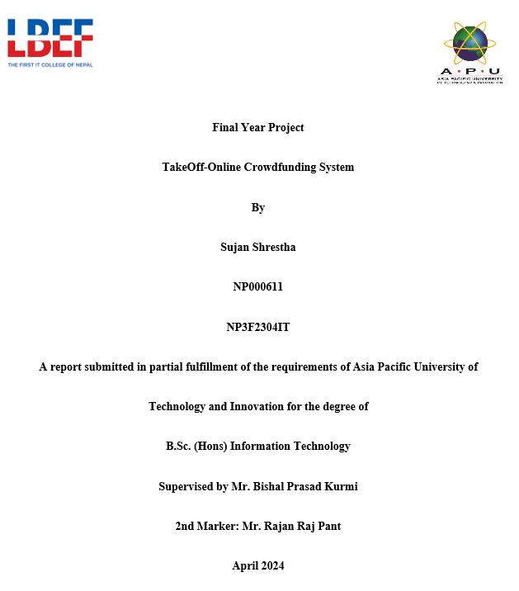

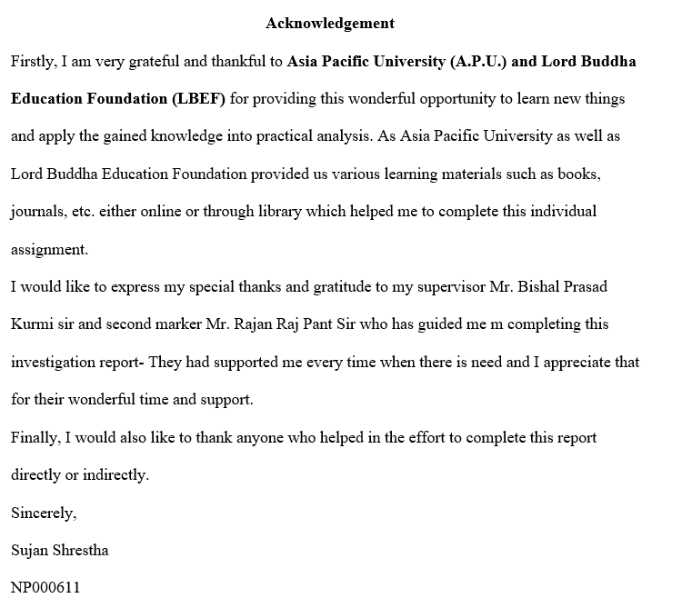

**Abstract**

This document emphasizes the development of a comprehensive online crowdfunding platform along with its critical evaluation which was designed to empower and encourage the investors and creators. The project went through meticulous research, iterative design, and rigorous testing after which the platform can offer a feature-rich environment for project creation, investment opportunities, and reward system. Key functionalities of the Takeoff crowdfunding platform include secure investment handling, user creation, project analysis, and robust resources for creator and investor. The project’s development solely focused on its usability, security, and ability to meet the requirements of users within the crowdfunding environment. Moving forward, further research and refinement will confirm the platform remains very effective and relevant in facilitating and helping crowdfunding campaigns.

Keywords: Crowdfunding, project creation, investment opportunities, usability, functionality, security.

**Table of Contents**

**Chapter 1: Introduction to the study** 1

Introduction 1

Background of the project 1

Problem Context 2

Rationale of the Study 3

Potential Benefits 3

***Tangible Benefits*** 3

***Intangible benefits*** 4

Target Users 4

Scope and Objectives 5

***Aim*** 5

***Scope*** 5

***Objectives:*** 5

***Deliverables*:** 7

Overview of Report and Project Plan for Final Year Project 8

**Chapter 2: Literature Review** 12

Introduction 12

Research Domain 12

Technical Research 19

Similar Systems 21

**Chapter 3: System Development Methodology** 24

Introduction 24

Comparison of System Development Methodology 25

Selection of Waterfall Methodology as System Development Methodology 27

***Waterfall Methodology*** 27

**Chapter 4: Research Methodologies** 31

Introduction 31

Importance of Data gathering and Analysis 31

Research Method Types: 32

***Qualitative Research*** 32

***Quantitative Research*** 32

***Mixed Research*** 33

Quantitative method as chosen method. 33

Research Design 34

Research Questions 37

Summary 41

**Chapter 5 Requirement Validation** 42

Introduction 42

Analysis of Data 42

**Data analysis through questionnaire** 42

Summary 54

**Chapter 6: System Architecture** 55

Introduction 55

Core Features and Elements of Takeoff crowdfunding platform: 55

System Design 57

***Use Case Diagram*** 57

***Use Case Specification*** 58

***Activity Diagram*** 65

***Class Diagram*** 66

***Entity Relationship Diagram*** 67

***Sequence Diagram*** 68

***Database Table Structures in No SQL (MONGODB) database*** 69

Interface Design 70

***Wireframes*** 70

Development / Deployment 73

***Introduction*** 73

***Selected Programming Languages*** 73

***IDE (Interactive Development Environment) Chosen*** 74

***OS (Operating System Chosen)*** 75

***Summary*** 75

**Chapter 7: Project Plan** 76

Release plan: 76

Test Plan for Unit testing. 77

Test Plan for UAT 79

**Chapter: 8 Implementation** 80

Screenshots of User Interface 80

Code Snippets 94

**Chapter 9: System Validation** 107

**Unit Test** 107

***Test Cases for Unit Testing*** 107

User Acceptance Test 111

***User Acceptance Test Forms*** 111

**Chapter 10: Conclusion and Reflection** 115

**References** 117

**Appendices** 121

Turnitin Report 121

FYP Poster 123

Declaration of Thesis Confidentiality and Library Catalogue Form 124

Meeting Log sheets 126

Project Proposal Form (PPF) 135

Project Specification Form (PSF) 157

Ethical Form 186

Gantt Chart 191

**Table of Figures**

Figure 1: Similar System: Kickstarter 21

Figure 2: Similar System: Indiegogo 22

Figure 3: Similar System: Seedrs 23

Figure 4: Survey Questions Design 1 37

Figure 5: Survey Questions Design 2 38

Figure 6: Survey Questions Design 3 39

Figure 7: Survey Questions Design 4 40

Figure 8 : Pie Chart of Age Group 42

Figure 9: Pie Chart of Gender Distribution 43

Figure 10: Bar Chart of Geographical distribution 43

Figure 11: Pie chart of Occupation Distribution 44

Figure 12: Usage Pie Chart 44

Figure 13: Platform Usage Pie Chart 45

Figure 14: Platform Categorization Usage Pie Chart 45

Figure 15: Chart for Types of Campaigns 46

Figure 16: Chart of Features in Crowdfunding Platform 47

Figure 17: Chart for Factors to support campaign 47

Figure 18: Motivation Chart 48

Figure 19: Pie Chart of Specific Niche in Crowdfunding 48

Figure 20: Pie Chart for notification preference 50

Figure 21: Pie chart for preferred funding model 50

Figure 22: Pie chart for reward distribution 51

Figure 23: Pie chart for reward types 51

Figure 24: Reward types chart 52

Figure 25: Chart for trusting campaigns 53

Figure 26: Chart for duration of campaign 53

Figure 27: Use Case Diagram 57

Figure 28: Activity Diagram 65

Figure 29: Class Diagram 66

Figure 30: Entity Relationship Diagram 67

Figure 31: Sequence Diagram 68

Figure 32: Tables Structure in MongoDB 69

Figure 33: Wireframe of Login Page 70

Figure 34: Wireframe of Sign-Up page. 70

Figure 35: Wireframe of Dashboard 71

Figure 36: Wireframe of Projects Page 71

Figure 37: Wireframe of User Profile 72

Figure 38: Home Page of Takeoff 80

Figure 39: Registration Page of Takeoff 81

Figure 40: Email Verification page of Takeoff. 81

Figure 41: Login page of Takeoff. 82

Figure 42: Campaign Creation Page of Takeoff 83

Figure 43: Campaign Creation Form of Takeoff 83

Figure 44: Project Details Page of Takeoff 84

Figure 45: Reward Tab 84

Figure 46: Story Tab 85

Figure 47: Updates Tab 85

Figure 48: Comments Tab 86

Figure 49: About Creators Tab 86

Figure 50: Investment Process Page 87

Figure 51: Esewa Snapshot 1 88

Figure 52: Esewa Snapshot 2 88

Figure 53: Esewa Snapshot 3 89

Figure 54: Esewa Snapshot 89

Figure 55: Esewa Snapshot 5 90

Figure 56: Successful Investment Page 90

Figure 57: Othe Pages Navigation 91

Figure 58: Admin Dashboard of Takeoff 1 92

Figure 59: Admin Dashboard of Takeoff 2 92

Figure 60: Admin Campaign Status and Reporting Tab 93

Figure 61: Registration HTML Code Snippets 94

Figure 62: Code Snippets of Login and Token Handling 98

Figure 63: Code Snippets of Project Creation 101

Figure 64: Code Snippets of Investmnet 104

Figure 65: Code Snippets of Media Assets Upload 106

Figure 66: UAT Form 1 111

Figure 67: UAT Form 2 112

Figure 68: UAT Form 3 113

Figure 69: UAT Form 4 114

Figure 70: FYP Poster 123

**Table of Tables**

Table 1: Project Plan of Final Year Project 1

Table 2: Comparison of System Development Methodologies 18

Table 3: Questionnaires 27

Table 4: Use Case Specification of Campaign Analytics 49

Table 5: Use Case Specification of Campaign Status Management and Campaign Reporting 50

Table 6: Use Case Specification of Login and Registration 51

Table 7: Use Case Specification of Campaign Lunch 52

Table 8: Use Case Specification of Invest on Campaigns 53

Table 9: Use Case Specification of Campaign Rewards 54

Table 10: Use Case Specification of Campaign Updates and Feedback Management 55

Table 11: Test Plans for Unit Testing 69

Table 12: Test Cases for Unit Testing 98

# **Chapter 1: Introduction to the study**

## **Introduction**

Through the developing age of technology, every kind of activity and operation has undergone a transformative evolution and evolved with the advent of online mediums to the activities and operations. Everything has moved to the global internet facility which makes things accessible for everyone throughout the globe. During this transformation, the landscape of fundraising and financial support has also taken a major turn with transformative evolution with options of online crowdfunding platforms. A traditional way to raise funds has been challenging to access of so many creators out there, the online crowdfunding platforms have evolved as a dynamic and inclusive alternative, decreasing the hassle of going through traditional way of raising funds for projects and startups.

With the vision to revolutionize the way individuals and organizations can raise capital, this final year project dives into the implementation of hassle-free online crowdfunding platforms which can make the fundraising scenario more dynamic and inclusive in this sophistical era of innovation, the online crowdfunding platform can act as an economic elevation platform for many individuals and organizations out there wandering with different world changing ideas.

## **Background of the project**

With a vision to empower Nepalese innovators and visionaries, this project aims to establish a dynamic online crowdfunding platform that not only catalyzes the realization of creative ideas but also fosters sustainable startup ventures. By bridging the gap between visionary creators and enthusiastic investors, an online crowdfunding platform sets out to be the catalyst for transforming imaginative concepts into tangible successes.

In a country where budding creators often struggle to find avenues for showcasing their innovative ideas, this crowdfunding platform in Nepal emerges as a beacon of opportunity. Our platform serves as a nexus for synergies between creators and investors, resulting in a harmonious convergence of visionary ideas and capital infusion.

## **Problem Context**

Nepal's innovation ecosystem faces a pivotal challenge in the absence of a dedicated platform connecting creators with potential backers. Aspiring entrepreneurs struggle to showcase their inventive ideas, hindering their access to necessary funds. Simultaneously, investors lack a streamlined channel to discover and support promising projects. The conventional funding process is cumbersome, lacking efficiency and accessibility. Addressing these calls for an intuitive online crowdfunding platform, that bridges this gap, enabling creators to access funds while investors discover and nurture innovation.

Despite being a nation rich with vibrant community of entrepreneurs, social activists, and creative minds, many promising ideas and projects face a common hurdle which is access to adequate funding. These project fails before the start of the innovation as traditional financial mediums in Nepal often have stringent criteria which makes it challenging and difficult for innovations and ideas to secure necessary funds to thrive.

Moreover, the geographical barriers, diversity and dispersed population also poses additional challenges for creators to reach broader audience for raising capital. Many innovative plans and projects struggle to gain visibility beyond their small and immediate surroundings. In this modern era of technology, a good crowd funding platform can help individual creators or organizations to tap into a deep and vast network of investors or potential backers.

## **Rationale of the Study**

The most prioritized reason of the study done on the landscape of fundraising and financial support to projects is to examine the accessibility of an emerging project to its capital. Many innovative and creative projects fail to make it to the market due to lack of funds to raise the scale of production. This study attempts to integrate modern technology and tools in the field where there are only traditional methods to gain access to the funds and audience for the creators.

## **Potential Benefits**

The implementation of the online crowdfunding platform comes with numerous benefits as it directly implies on the economic status of certain parties. Involved parties can profit with various tangible and intangible benefits such as:

### ***Tangible Benefits***

Access to Fund

Creators with effective ideas that can change or disrupt the market can gain valuable access to a wider pool of potential investors which increases the chances of securing the capital needed for their project.

Global Recognition

As the platform is of online nature, it can reach the global market or audience eradicating the geographical barriers that can interrupt the visibility of project. The online platforms will provide different sources of funding and foster a more inclusive and supportive base for projects.

Cost Effective Capital

When compared to traditional fundraising techniques, the online crowdfunding platform will have lower overhead costs, making the fundraising process more efficient and maximize the funds to be invested in the project.

### ***Intangible benefits***

Validation and Market Testing

A successful campaign on an online crowdfunding platform can provide valuable information regarding the validation of specific project ideas and categories in the market. The platform will help creators to know if their ideas or project can outstand the projects already available in market.

Brand exposure and marketing

With successful campaigns on online crowdfunding platforms, it can generate attention of markets to the project as it will build brand awareness and reputation, attractive attentions from public and potential backers.

Empowerment

These kinds of platforms can help empower individuals and organizations to pursue their goals within the reach of the internet. It will help to democratize the access to funding, by levelling the playing field for diverse projects and creators.

## **Target Users**

The target users for the online crowdfunding platform projects basically includes two kinds of users: Creators and Backer. A creator refers to the users who have certain ideas or creative projects that will be showcased in the crowdfunding platforms to gain attention of the backers or investors. Another target user will be the backer who will have the ability to invest in the ideas or project created by the creators to gain valuable rewards where the funding and completion of the project will be the main objectives of both kind of users to be fulfilled.

## **Scope and Objectives**

A detailed view of the aims, scope and objectives of the project is mentioned below:

### ***Aim***

The primary goal of this platform is to establish an inclusive and dynamic online crowdfunding platform that fosters innovation, fuels entrepreneurship, and accelerates the growth of Nepal's creative economy. By providing creators with a dedicated space to showcase their ideas and by connecting them with interested investors, the platform aims to democratize the funding process and propel visionary concepts towards tangible success.

### ***Scope***

The system attempts to impact overall economic dynamics of the nation by evaluating and evolving the growth of projects and ideas that can disrupt the global and local market with its introduction. It elevates and encourages both creators and backers to work and create a community with support of each other to elevate their economic status and recognition of projects in the market where a boarder connection of network for both type of users can be beneficial even in the future moves. The platform will establish an inclusive and dynamic online crowdfunding platform that fosters innovation, fuels entrepreneurship, and accelerates the growth of Nepal's creative economy.

### ***Objectives:***

Empower Startups: Facilitate startup ventures in Nepal by providing them with a user-friendly platform to present their innovative ideas and secure the necessary funding for launch and growth.

Enhance Access to Funding: Eliminate traditional barriers to funding by offering a streamlined online channel that allows creators to present their projects directly to a wide range of potential backers.

Boost Creativity: Encourage creators to test the market with their ideas by offering a space where they can gather feedback, refine their concepts, and refine their pitches to attract investors.

Connect Creators and Investors: Forge connections between creators and investors from diverse backgrounds, fostering an ecosystem of collaboration and support that enhances the potential for success.

Facilitate Informed Decision-Making: Provide investors with comprehensive project details, enabling them to make informed investment choices based on well-documented business pitches.

Promote Economic Growth: Contribute to the expansion of Nepal's creative economy by nurturing innovation, generating employment opportunities, and fostering a culture of entrepreneurship.

Catalyze Social Impact: Support projects that have the potential to make positive social changes by facilitating funding and exposure, aligning with the broader developmental goals of Nepal.

Encourage Cross-Industry Collaboration: Create a platform that spans various sectors, allowing creators and investors from technology, art, design, and other domains to come together for mutual growth.

Continuous Enhancement: Evolve the platform over time by incorporating user feedback and industry best practices, ensuring that this platform remains a relevant and effective catalyst for innovation and entrepreneurship in Nepal.

### ***Deliverables*:**

Fully Functional Crowdfunding Platform: Develop and deploy a user-friendly online crowdfunding platform accessible to creators and investors.

User Profiles and Authentication System: Implement a secure user registration and authentication system for creators and investors, ensuring privacy and data protection.

Project Creation Interface: Design an intuitive project creation interface allowing creators to present their ideas, showcase prototypes, and set funding goals.

Project Discovery and Browsing: Develop a user-friendly project browsing and discovery system that allows investors to explore a diverse range of creative ideas.

Project Funding Mechanism: Create a secure and transparent funding mechanism that enables backers to contribute funds to selected projects.

Payment Gateway Integration: Integrate a secure payment gateway to facilitate seamless financial transactions between backers and creators.

Communication and Feedback Tools: Incorporate features such as messaging and comments to enable interaction between creators and backers, fostering engagement and feedback.

Creator-Backer Connection: Design tools for creators to communicate with their backers, providing updates on project progress and fostering a sense of involvement.

Dashboard and Analytics: Develop personalized dashboards for creators and investors, offering insights into project performance, funding progress, and engagement metrics.

Responsive Design: Ensure the platform is accessible and user-friendly across various devices, including desktops, tablets, and smartphones.

Testing and Quality Assurance: Conduct rigorous testing to identify and rectify any bugs, glitches, or security vulnerabilities.

## **Overview of Report and Project Plan for Final Year Project**

This document emphasizes the development of a comprehensive online crowdfunding platform along with its critical evaluation which was designed to empower and encourage the investors and creators. The project went through meticulous research, iterative design, and rigorous testing after which the platform can offer a feature-rich environment for project creation, investment opportunities, and reward system. Key functionalities of the Takeoff crowdfunding platform include secure investment handling, user creation, project analysis, and robust resources for creator and investor.

Overall project plan includes the structure of work breakdowns for the preparation and implementation of Investigation report for the final year project.

Table 1: Project Plan of Final Year Project

|  |  |  |  |  |  |
| --- | --- | --- | --- | --- | --- |
| Task ID | Task Name | Start Date | Duration | End Date | Status |
| 1 | Introduction to the study | 2023-10-03 | 3 | 2023-10-06 | Completed |
| 1.1,1.2 | Introduction, Background to the project | 2023-10-03 | 3 | 2023-10-06 | Completed |
| 1.3 | Problem context | 2023-10-07 | 3 | 2023-10-10 | Completed |
| 1.4 | Rationale | 2023-10-11 | 2 | 2023-10-13 | Completed |
| 1.5 | Potential benefits | 2023-10-14 | 1 | 2023-10-15 | Completed |
| 1.6 | Target User | 2023-10-16 | 1 | 2023-10-17 | Completed |
| 1.7 | Scope and objectives | 2023-10-18 | 3 | 2023-10-21 | Completed |
| 1.8 | Overview of this IR | 2023-10-21 | 1 | 2023-10-22 | Completed |
| 2 | Literature Review | 2023-10-22 | 2 | 2023-10-23 | Completed |
| 2.1 | Introduction | 2023-10-22 | 1 | 2023-10-23 | Completed |
| 2.2 | Similar System | 2023-10-24 | 3 | 2023-10-27 | Completed |
| 2.3 | Domain Research | 2023-10-28 | 3 | 2023-10-31 | Completed |
| 3 | Technical Research | 2023-11-01 | 2 | 2023-11-02 | Completed |
| 3.1 | Introduction | 2023-11-01 | 1 | 2023-11-02 | Completed |
| 3.2 | Chosen Software development (SDK) | 2023-11-03 | 2 | 2023-11-05 | Completed |
| 3.2.1 | Comparison between similar SDK | 2023-11-06 | 2 | 2023-11-08 | Completed |
| 4 | System Development Method | 2023-11-09 | 3 | 2023-11-10 | Completed |
| 4.1 | Introduction | 2023-11-09 | 1 | 2023-11-14 | Completed |
| 4.2 | System Development Methodology Chosen | 2023-11-11 | 3 | 2023-11-17 | Completed |
| 4.3 | Agile Methodology for Proposed App | 2023-11-15 | 2 | 2023-11-17 | Completed |
| 5 | Research Method | 2023-11-18 | 2 | 2023-11-20 | Completed |
| 5.1 | Introduction | 2023-11-18 | 2 | 2023-11-20 | Completed |
| 5.2 | Research Design | 2023-11-21 | 2 | 2023-11-23 | Completed |
| 5.2.1 | Research Questionnaire | 2023-11-24 | 2 | 2023-11-26 | Completed |
| 6 | Requirement Validation | 2023-11-26 | 1 | 2023-11-27 | Completed |
| 6.1 | Data Analysis | 2023-11-28 | 1 | 2023-11-30 | Completed |
| 7 | Conclusion | 2023-12-1 | 1 | 2023-12-02 | Completed |
|  |  |  |  |  |  |

|  |  |  |  |  |  |
| --- | --- | --- | --- | --- | --- |
|  |  |  |  |  |  |
| 8 | System Architecture | 1/3/2024 | 15 | 1/19/2024 | Completed |
| 9 | Project Plan | 1/22/2024 | 7 | 1/29/2024 | Completed |
| 10 | Implementation | 2/5/2024 | 18 | 3/9/2024 | Completed |
| 11 | System Validation | 3/10/2024 | 10 | 3/19/2024 | Completed |
| 12 | Conclusion and Reflection | 3/20/2024 | 2 | 3/23/2024 | Completed |

# **Chapter 2: Literature Review**

## **Introduction**

A literature review refers to the process of summarizing, synthesizing, and critiquing the result of a literature search based on the context of primary research project. It is a systematic approach for assessing and summarizing the work of professionals and academics in a specific field. For the literature review regarding the online crowdfunding platform certain research domains and sources have been examined and summarized below:

## **Research Domain**

1. According to research done by (Althoff, 2015), “many crowdfunding platforms which interact over internet allow specific kinds of projects to be funded by targeting large number of people to contribute. With critical analysis of online crowdfunding systems such as fundraiser, DonorsChoose.org and others, it is stated that the success of crowdfunding communities depends upon recruitment and continued engagement of donors. With these popular online platforms having donor attrition rate over 70%, the challenge rises due to problem of donor retention for both online and offline crowdfunding platforms. According to research conducted on DonorsChoose.org, it concluded the main problem of these platforms is donor retention as only 26% of the first donors ever return and donate second time”.
2. Another research conducted by (Stiver, 2013) states that “the relationship between a crowdfunding and online community not only limits to financial terms but many non-financial benefits such as networking, collaboration, and feedback. The crowdfunding platform creates a strong community, network and pool of creators and investors whose collective efforts can have huge impact on both social and economic factors of the involved. Online exploration and advertisement with just a few clicks are one of the impactful benefits any organization or starters can get through online crowdfunding platform over the traditional offline method”.
3. According to the research done by (Bin Gu, 2019), the new technology and advancements being made in information technology will open more doors of success to platforms like online crowdfunding by enabling new business models and new market mechanisms. Online crowdfunding doesn’t only allow creators to access a place to raise funds, but it also acts as a venue for them to obtain demand information before the production and rethink their intention with the product. There is no doubt that a profit driven entrepreneur earns more than that of product driven entrepreneurs on average, as their advantages are limited by their crowdfunding platforms.
4. Research conducted by (Gabor Kiss, 2014), examined 3169 technology related projects among which 170 projects were successfully funded products which tested different hypothesis regarding crowdfunding platform aiming to find the degree of significance of received funds, total investors, and number of pre-sales. The research concludes that the projects which were categorized under the technology category had received higher number of fundings which generally costs high during product development. The research also showed that reward-based online crowdfunding platforms attracted high number of investors on average while compared to other type of online crowdfunding platforms when examined over technology-based products.
5. Similar to the above research, in the research done by (Winarno, 2018), it is stated that “any business regardless the size whether it is micro, small or medium can involve in online campaign for crowdfunding as long as they are familiar with the differences between the crowdfunding modes. The success of crowdfunding heavily depends upon its funding target, total number of backers and sum of investment, which is gradually higher in equity-based crowdfunding on average according to this research”.
6. Rachel E. Wheat and Jai Ranganathan describe “the dynamics of a success of a crowdfunding project depending heavily upon a successful outreach campaign. The success comes from successful outreach campaigns where the larger crowds refer to more money raised. Various online platforms such as social media platforms and advertisements can easily reach out and channel these investors directly to a proposal online. They have also stated that there is a common myth that these sorts of crowdfunding platforms are only for charismatic projects. But, according to Rachel E. Wheat and Jai Ranganathan, this assumption is completely wrong as the name of the project doesn’t attract investors, the ability or chance of the project being successful does” (E & Wheat, 2013).
7. According to the research conducted by (Xiaochen Liu, 2022), “product sampling can be considered a great way to test the efficiency and scalability of the product in Reward-based crowdfunding. Online product sampling has been gaining popularity as an effective way of promoting instruments for the creators in fund raising platforms. The analysis was done upon a unique dataset of total of 4027 campaign observations which was collected from a well-known JD crowdfunding platform. The outcome of this research states that adopting the technique of online product sampling is highly beneficial to crowdfunding websites as it increases the number of potential backers, total number of fundraising amounts, total average amount of funds raised per investors, and mainly the possibility of success of fundraising campaign”.
8. With objective to collect further information on the working dynamics of the crowdfunding platforms, Goran Calic and Jialiang Yang researched on the topic of “How multimedia shapes the crowdfunding outcomes” by observing 13,622 technology campaign on one of the most known crowdfunding platform “Kickstarter”. The redundant use of media can negatively impact on potential backers as the study suggests (Jialiang Yang, 2020).
9. According to the research conducted by (Stanko, 2017), “the total amount of raised during the funding campaign in crowdfunding platform does not have a significant impact on later performance of the product on the market but the total number of potential backers attracted effects the later performance of products. This output is generated by analyzing the data of crowdfunded projects from the Kickstarter website to better understand the effects of crowdfunding elements in the subsequent market”.
10. Research conducted by (Eunjun Jung, 2022), “the novelty of a project or the product directly affect the crowdfunding campaign’s success. This research used a deep learning-based novelty detection model combined with statistical data is used to analyze 7406 crowdfunding. The result supports the hypothesis proposed by the researcher as the output reveals that the novelty of the product increases and attracts numbers of potential backers and project’s success. Two-sided communication in crowdfunding platform helps to stimulate investor”.
11. Elizabeth M. Gerber, Julie S. Hui, Pei-Yi Kuo from Norwestern University conducted research which included analyzation of survey regarding Why People Are Motivated to Post and Fund Projects on Crowdfunding Platforms. The result of analyzation was depicted as A funder considers whether to fund a project on Kickstarter, a crowdfunding platform. Initial findings suggest that people are motivated to launch and fund projects on computer-mediated crowdfunding platforms because of social interactions and feelings of connectedness to a community with similar interests (Elizabeth M. Gerber, 2010)
12. According to research conducted by Peter Konhausner, Bing Shang and Dan Dabija “relating to the growth of online crowdfunding platforms in Comparative Perspective of Germany and China, the result of the research came in as the growth of the online crowdfunding volume has become one of the fastest types of global financial innovation. Crowdfunding is not only used for raising monetary funds, but also as an instrument for implementing the marketing strategy of an organization. In different countries and regions, crowdfunding project owners have adopted several practical marketing tactics based on their business models and strategic objectives, like online webinars, social media marketing, and offline events” (Peter Konhausner, 2021).
13. Jascha-Alexander Koch organized research on the Phenomenon of Project Overfunding on Online Crowdfunding Platforms and analyzed the drivers of overfunding and found out in reward-based crowdfunding, massive overfunding can lead to severe problems for project founders when vast amounts of rewards must be delivered. Some people even argue that the amount of money that leads to overfunding should be pledged to good but undervalued projects that fail to reach their funding goal. However, it is also a powerful mean to generate publicity and to sell products (Koch, 2016).
14. In 2016, Michael Siering along with Jascha-Alexander Koch worked together on research titled “Crowdfunding Success Factors: The Characteristics of Successfully Funded Projects on Crowdfunding Platforms”. The research had some definitive implications as it depicts “Analyzing a sample of projects of the crowdfunding platform Kickstarter, we find that the project description, related images, and videos as well as the question of whether the founder has previously backed other projects influence funding success. Our results are of high interest for the stakeholders on crowdfunding platforms. (Michael Siering, 2016)”
15. [Endrit Kromidha](https://ieeexplore.ieee.org/author/37085806575) conducted a research analysis on comparative analysis of online crowdfunding platforms where she generally analyzed different platforms from USA, Europe and Asia and found out that regardless of a degree of system standardization, smaller online crowdfunding platforms can impose themselves as obligatory passage points locally and regionally by providing more differentiated services compared to standard best-practices like Kickstarter, taking into consideration the specific needs and characteristics of the communities and regions where they are based. An important indicator suggested by this study to evaluate online crowdfunding platforms and networks is the funding (Kromidha, 2015).
16. According to the research conducted by [Gloria Gómez-Diago](https://link.springer.com/chapter/10.1007/978-1-4471-6681-8_10#auth-Gloria-G_mez_Diago) on the base of communication of crowdfunding online platforms, she summed up This revolution has utterance at different contexts of the citizens’ lives. Searching for a job, being in touch with people who are far away, being informed about issues of interest, streaming videos, listening to music, buying and or reading books and cocreating documents are all activities now performed online by most of the 40 % of the world population who have internet connection. Collective creation can be done with ease on the cyberspace by using any of the multitude of devices and options available to revolutionize fund raising (Gómez-Diago, 2015).
17. In 2020, [Kabil Nageswarakurukkal](https://www.tandfonline.com/author/Nageswarakurukkal%2C+Kabil), [Paulo Gonçalves](https://www.tandfonline.com/author/Gon%C3%A7alves%2C+Paulo), [Mohammad Moshtari](https://www.tandfonline.com/author/Moshtari%2C+Mohammad) together conducted research on Improving Fundraising Efficiency in Small and Medium Sized Non-profit Organizations Using Online Solutions. Their research depicts the benefits that can be raised from implementing modern online fund-raising platform over the traditional fund-raising techniques where some key benefits were global reach and recognition along with mass connectivity (Kabil Nageswarakurukkal, 2018).
18. According to [Gongbing Bi,](https://www.emerald.com/insight/search?q=Gongbing%20Bi)[Qinghua Xiang,](https://www.emerald.com/insight/search?q=Qinghua%20Xiang)[Botao Geng,](https://www.emerald.com/insight/search?q=Botao%20Geng)[Qiong Xia](https://www.emerald.com/insight/search?q=Qiong%20Xia), they found out In the basic model, when the product quality level is exogenous, the optimal price increases in the product quality level and decreases in the difficulty level of the project, while the corresponding expected profit is a unimodal function of the product quality level and the difficulty level. In the endogenous case, the optimal price is exactly twice the unit cost. With the influence of platforms, platforms with higher CS tend to help the creator to lower the prices and to achieve higher profitability. Moreover, platforms with higher CS usually help the creator to offer higher quality products and to charge higher prices after conducting research on Decision strategies in reward-based crowdfunding: the role of crowdfunding platforms (Gongbing Bi, 2019).
19. Chris Richter b, Alexander Brem c, Cheng-Feng Cheng d, Man-Ling Chang conducted research on Strategies for reward-based crowdfunding campaigns where they found out Practical implications of crowdfunding strategies are derived and are dependent on the required sales effort and the project added value. The terms communicator, networker and self-runner are important for crowdfunding strategy to allow entrepreneurs to extract best practice for increasing the probability of successful crowdfunding projects (Alexander Brem c, 2016).
20. Wheat, Wang, Byrned and Ranganathan describe the video as the most important part of the funding appeal to potential project backers. Videos should touch the heart of backers and tell a real story about their own project. Mollick identifies the lack of a video as extremely negative, stating how “producing a video is a clear signal of at least minimum preparation”. They make another important point: the video is an opportunity to introduce the project owner or team. They found out that a personal, emotional relationship between the project owner and the backers is not positively related to the investment in a crowdfunding project (Rachel E. Wheat, 2012).

## **Technical Research**

1. A study was conducted by Mannan and Li, which explored the potential integration of blockchain technology in order to boost the transparency, security and efficiency of different crowdfunding platforms. They investigated on streamlining payment processing with blockchain and verifying project authenticity and enable decentralized crowdfunding (Mannan, 2018).
2. Research from Greenberg and Mollick in 2017 investigated the application of machine learning algorithms which predict the success of campaigns in crowdfunding platforms. This research explored the use of machine learning with its feature such as project description, creator profile, and social media engagement to build predictive models for campaign outcomes (Greenbaerg, 2017).
3. A study was conducted to examine the use of smart contracts, self-executing contracts with agreement terms directly provided in code, in online crowdfunding platforms. This study explored how smart contracts can be used to automate project funding, reward distribution, and dispute resolution (Biryukov, 2017).
4. Another research conducted by Mollick explored the relationship between crowdfunding campaigns success and social media networks. It investigated on the size and engagement level of a creator’s integration of social media influencing campaign performance, funding dynamics and other factors (Mollick, 2014).
5. Another study examined the regulatory problems faced by online crowdfunding platforms, particularly in terms of investor protection, and compliance with security rules and regulations (Hornuf, 2018).

## **Similar Systems**

1. Kickstarter (International):

Kickstarter is among the most well-known platforms for crowdfunding in the world. It allows creators to share their original work to a large audience, covering everything from art and design to technology and cinema. Backers may contribute money to projects in return for perks or early access to the project. If the endeavor meets its financing objective within a particular period, the money is collected, and the project moves forward. Kickstarter's user-friendly interface and various project categories have made it a favorite among entrepreneurs looking for financial help (Jensen, 2018).

Figure 1: Similar System: Kickstarter

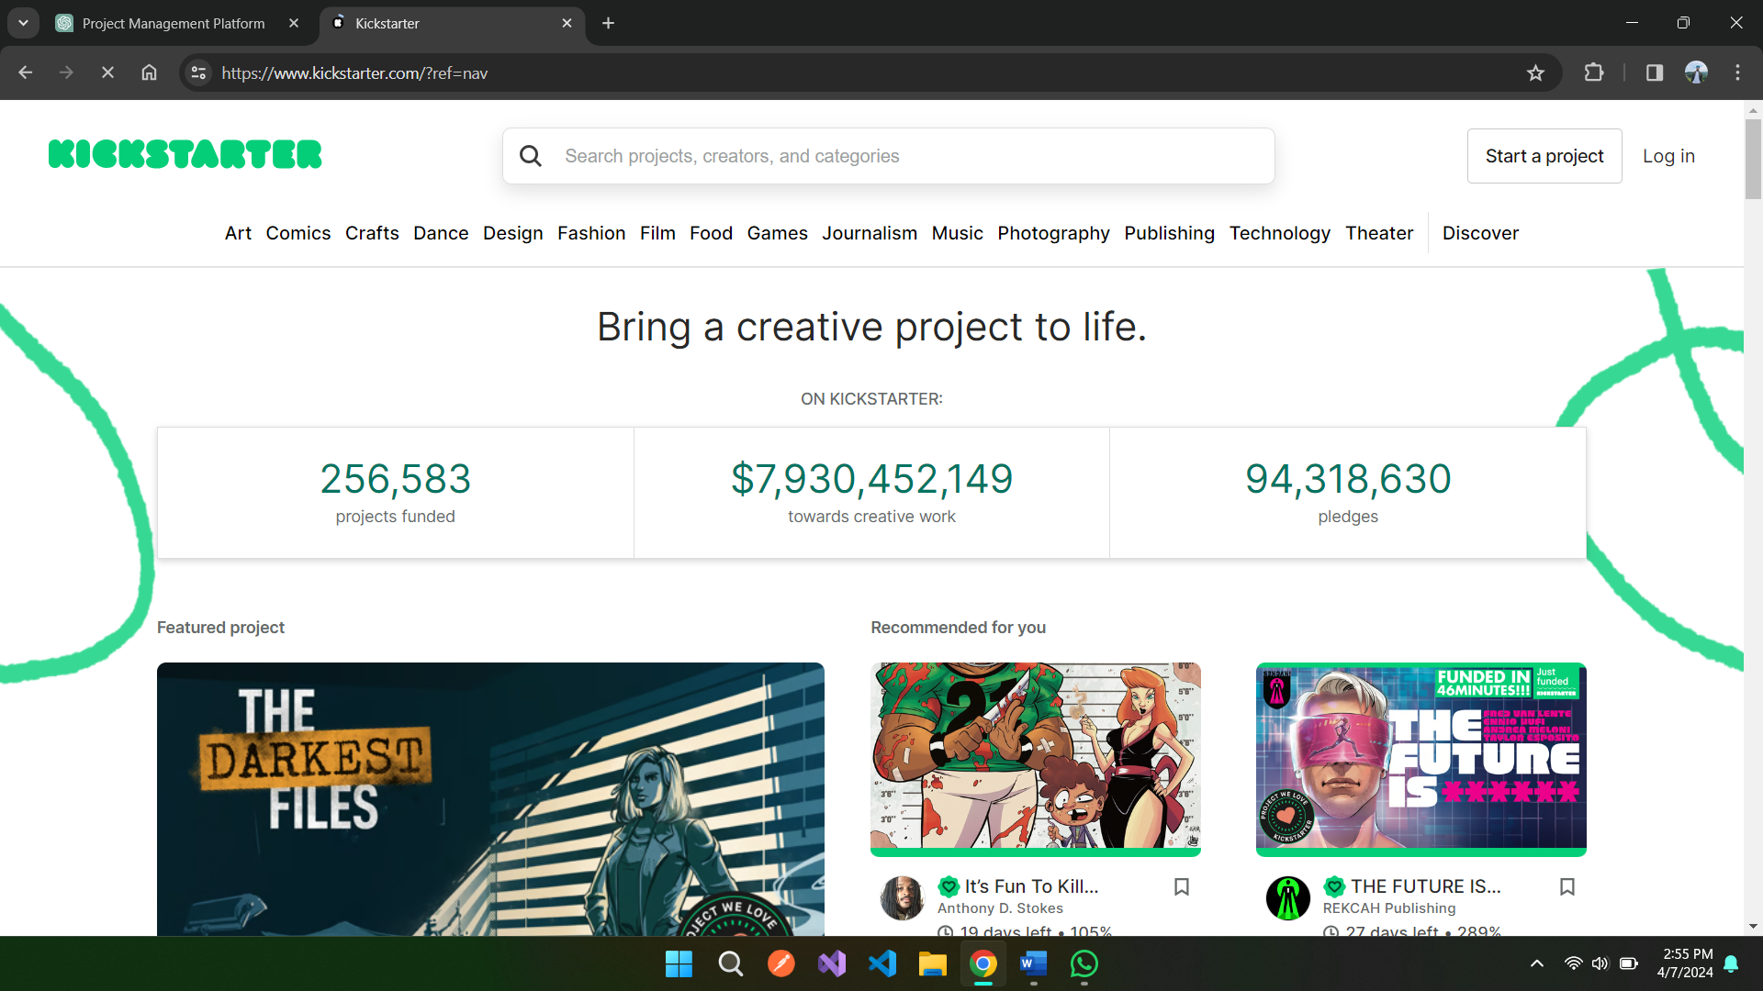

2. Indiegogo (International):

Indiegogo is another renowned global fundraising platform which promotes a variety of projects ranging from innovations in technology to helping others. It provides numerous funding options, enabling initiatives to obtain monies even if they fall short of their entire funding goal. Indiegogo additionally provides designers opportunities to interact with supporters, offer prototypes, and give feedback. Its adaptability and global accessibility render it an appealing alternative for creators seeking funding for a variety of projects (Gallemore, 2019).

Figure 2: Similar System: Indiegogo

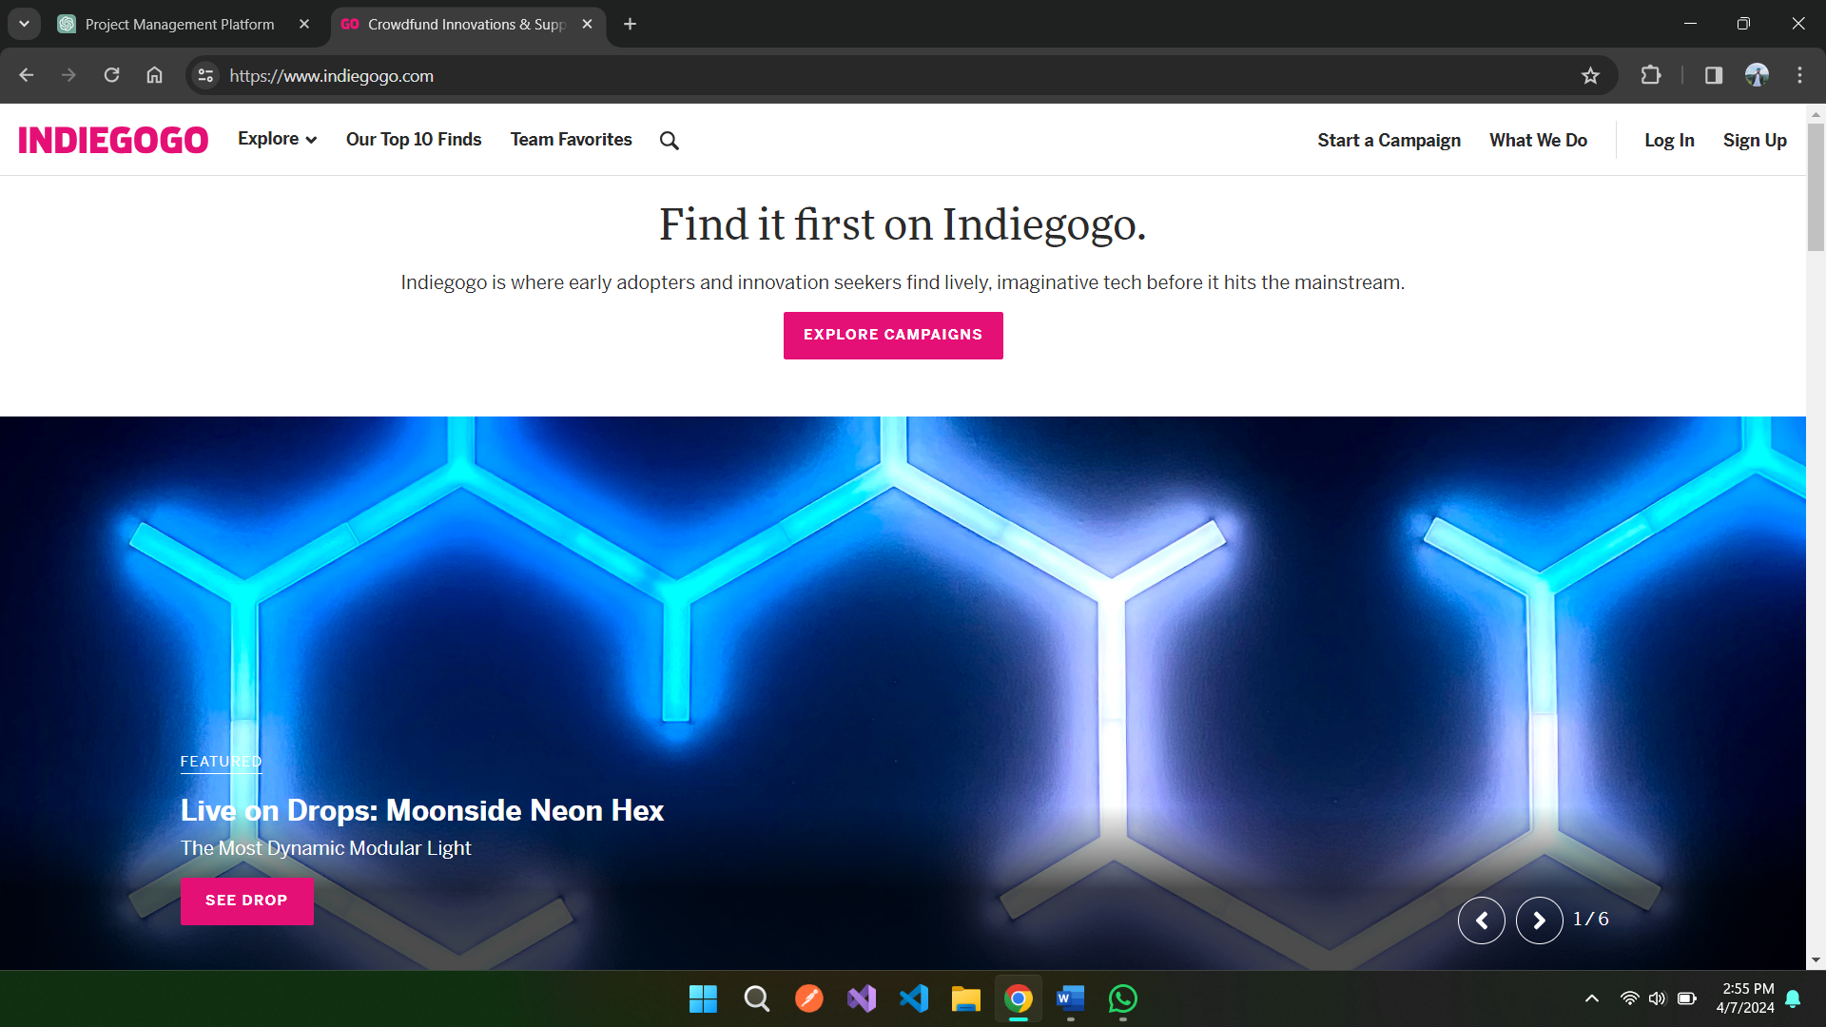

3. Seedrs (International):

Seedrs is an online service for stock-based fundraising which enables anyone to participate in ventures and early stages businesses as a substitute for equity shares. Seedrs, unlike other fundraising sites, allow supporters to turn into investors and potentially obtain financial ownership in the businesses they support. This concept develops a stronger bond between supporters and creators and matches their goals (Coakley, 2022).

Figure 3: Similar System: Seedrs

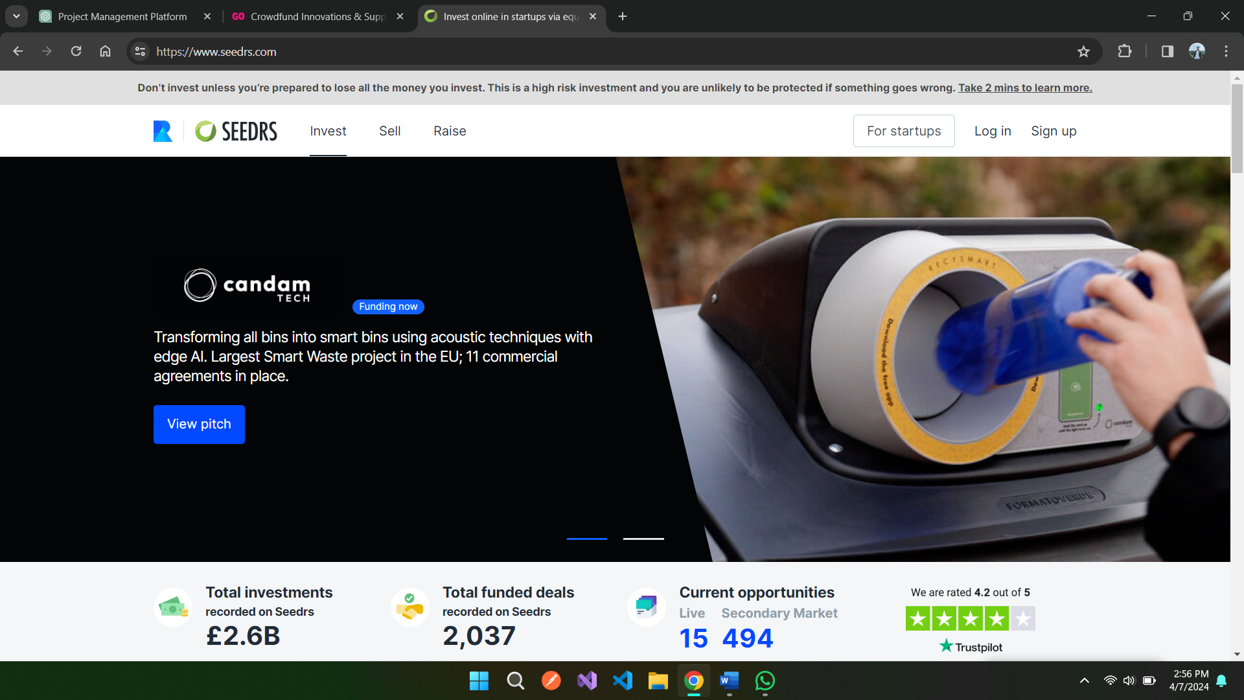

In Nepal, the absence of dedicated crowdfunding platforms tailored to local needs is apparent. Unlike international markets, there is no central platform that allows creators and entrepreneurs to showcase their ideas and access essential funds. This gap hinders innovation, restricts exposure for creative projects, and impedes the growth of startups. The lack of such platforms limits the collaborative ecosystem necessary for success and stifles Nepal's entrepreneurial potential.

# **Chapter 3:** **System Development Methodology**

## **Introduction**

A standard process mapped in an organization to implement all the necessary steps to analyze, design, develop, implement, and maintain an Information System. It is a methodology that helps to systematically organize the best methods and mediums to develop and implement a system. This includes a description of minute processes that need to be addressed during the development and implementation process of the system. There are different kinds of System Development Methodologies such as Agile methodology, Spiral methodology, Waterfall methodology, Rapid Application Development methodology, Extreme Programming and so on.

## **Comparison of System Development Methodology**

Here, a comparison among three different system development methodologies is shown below:

Table 2: Comparison of System Development Methodologies

|  |  |
| --- | --- |
| Methodologies | Overview |
| Waterfall Methodology | Sequential Process:  A linear and sequential process is followed by the waterfall model which asserts that certain remaining tasks must be completed before moving on to the next task making it easy to understand and manage works.  Rigidity:  It is challenging to accommodate to a change once a certain phase is marked completed. Therefore, this methodology is suitable for projects with well-defined scope and requirements. |
| Agile Methodology | Iterative and Incremental:  This methodology provides an adaptable approach to change in requirements according to frequent client feedback as it emphasized iterative development with small and incremental changes.  Collaborative and Adaptive  Well, suited for projects containing multiple teams as it encourages collaboration among the cross functional and technical teams and can handle changes even in later phases. |
| DevOps Methodology | Development and Operations integration  This methodology aims to automate processes by reducing deployment duration via collaboration of development and operational teams.  Continuous Integration with Continuous Development:  It’s all about enhancement in quality and schedule of deployment times through continuous emphasis on automation of building, testing, and deploying codes. |

## **Selection of Waterfall Methodology as System Development Methodology**

After analyzing the requirements and nature of Online Crowdfunding platform project, along with the comparison among the above three suitable methods, the preferred methodology or this project is selected to be Waterfall Methodology as it aligns with the nature of the project. Selection of this methodology will be beneficial over the selection of other methodology as it depicts the behavior required for the development of the project. Both Agile and DevOps methodologies would have higher impact if the project of Online Crowdfunding System had involved multiple teams working on it. But as the project is being developed with minimal human resources, Waterfall methodology will be more suitable for this project.

### ***Waterfall Methodology***

Waterfall Methodology refers to a sequential development methodology which as the name suggests flows like a waterfall through different phases of the project. These phases may include analyzation, design, development and testing along with others where one phase will be wrapped up to move to the upcoming phase. The Waterfall methodology provides more accurate estimation of schedule and depicts great time management as the majority if the research is done during the initiation stage of the implementation.

#### **Reason to Choose Waterfall Methodology upon other Methodology for this Online Crowdfunding system are explained below:**

Clear Requirements

The waterfall methodology is said to be effective when a project has a well-defined and clear requirement from the initial stage. This is due to the reason that the methodology follows a sequential process where initiation of each later phase depends upon the completion of the previous phase.

Predictable Timeline:

This methodology defines a structure and predictable timeline which assists in planning and management of system or project in later stages. This will help developers to create a clear roadmap of the project.

Comprehensive Documentation:

Waterfall methodology produces a comprehensive document of the project which can be very beneficial for the future reference, audits, or compliance requirements as it emphasizes strongly on documentation of each stage of the project.

Less Complex Project Management

It is less complex in terms of management of project as compared to other methodologies like Agile which consist for frequent iterations and integrations. This can be very beneficial to projects which have well-defined requirements from the beginning.

#### **Different Phases of Waterfall Methodology**

Requirement Gathering and Analysis

In the initial phase of the waterfall methodology, requirement gathering, and analysis is taken into consideration through stakeholder interactions. The major goal of this phase is to identify the explicit and implicit requirements, collect views on the required features, preferences, and functionality to be involved in the overall system.

Design Phase

The design phase in the Waterfall Methodology is implemented for creation of a comprehensive system blueprint which consists of user interfaces, structure of data and architecture of system to be developed. Various parties involved in the project collaborated to make decisions regarding the design and implementation of data flows and architecture for efficient data management and development of the system.

Implementation Phase

This phase generally refers to the development phase where the coding step is done through involvement of translating specifications of the design into a working code through programming, assembling, and compiling. The conceptual designs are converted into executable systems through coding.

Testing Phase

After the software development process, the waterfall methodology moves on to the testing phase which involves extensive testing to identify bugs or any lacking in the functionality, readability and efficiency of the system that is developed. Different kinds of testing such as unit testing, integration testing and system testing are done to verify the developed system meets the requirements of the user.

Deployment Phase

This phase in waterfall methodology aims to produce a final product to the user or customer, which involves the installation, setup, and operationalization. In this phase, user needs are set up though customization, correct configuration is ensured through installation, and operation fixes problems and provides informed information and instruction regarding the operation of system.

Maintenance phase

The maintenance phase in the waterfall methodology focusses on regular system checkups, updates, and dependencies update. This phase tends to accept any issues or bugs reported by the users to facilitate effective interaction with users and the development team. Any kind of issues and bugs are fixed and solved promptly to bring stabilization and seamless operation of the system.

# **Chapter 4: Research Methodologies**

## **Introduction**

In the Waterfall methodology, the starting phase of the model is Requirement Gathering and analysis, which requires a variety of research methods to be employed to collect and analyze the data. The base for the project begins with effective data collection and analysis which will also help to make informed decisions in future. The project’s success depends highly on these methods as this method integrates the analysis factors through which the project outcomes will become clearer, and implementation becomes more efficient. Following points underscore the importance of data gathering and analysis in this project:

## **Importance of Data gathering and Analysis**

Informed Decision Making

Educated project decisions can be made only through data collection and analysis as thorough information and data collection and assessment will pave path of insightful knowledge that aligns with project’s scope, objectives.

Improved Deliverable Applicability

An extensive and accurate research technique ensures that the listing of deliverables is highly aligned with the project’s scope and requirements. Gathering efficient and accurate data enables thorough understanding of the specifications of a project which will facilitate the creation of a list of deliverables which will align and fully satisfy the project’s requirements

Better Resource Optimization and Planning:

Data analysis provides an insightful view of project components which is essential for the success of the project as it will allow the most effective use of the available resources. This helps to generate strategic preparation during the initial stages which will lead to effective project execution.

## **Research Method Types:**

There are various research methods which involve their own way of gathering and handling data for better understanding and analyzation of information.

### ***Qualitative Research***

It is an exploratory whose objective is to understand the fundamental attitudes, motives and behaviors of individuals or organizations towards an object. Qualitative Research does not associate itself with numerical data but uses non-numerical data like observations, photos, or words. Participant observation, focus groups, content analysis, and interviews are some common techniques included in qualitative research.

### ***Quantitative Research***

The quantitative research methodologies use numerical data with an aim to determine trends, correlations, and repercussions with the help of rational thinking and quantitative data. Techniques such as experiments, surveys and statistical evaluation are used under this methodology to generate data or information. The major goal is to find relevant results by ensuring a comprehensive understanding of matter through investigation theories, disseminate findings.

### ***Mixed Research***

As the name itself suggests, mixed research methodology refers to the combination of both quantitative and qualitative elements in single research to gain much more valuable and deeper understanding of the issue. Both quantitative and qualitative information are analyzed simultaneously or parallel to develop a more comprehensive understanding of the research topic by combining the strengths and weaknesses of both quantitative and qualitative research results.

## **Quantitative method as chosen method.**

In the case of the Online Crowdfunding System Project, the selection of quantitative research methods is chosen over other available methods to involve direct participation of users for their quick and numerical responses. The major aim of using methods from quantitative research techniques is to generate numerical information which can be analyzed numerically and statistically for better examining of data.

Questionnaire Survey as Chosen Method

Among the various available methods, I have decided to use questionnaire as the most appropriate one for Online Crowdfunding Platform as it is ideal for discovering and generating accurate problems through participation of other stakeholders. The questionnaire will be conducted via the internet or online to make it accessible for many groups to get numerous responses. The reasons to choose this method over others are explained below:

* Effective Data Collection
* Standardization
* Quantitative Data Collection
* Anonymity
* Ease of Analysis

## **Research Design**

Through the utilization of Google Forms, a survey named Online Crowdfunding platform is created with all the required questionnaires with intention to gather all the necessary information and data in the initial stage. Likert Scale, short-answer questions, and multiple-choice questions are among the open-ended and closed-ended types used in the 20-question survey. The primary objectives are to understand user perspectives on mental health chatbot usage and to identify any impediments experienced by users. For clarity and comprehension, the survey questionnaire design is provided.

Table 3: Questionnaires

|  |  |  |
| --- | --- | --- |
| S.N. | Questions | Scope |
| 1 | What is your age? | User Geography |
| 2 | What is you gender? |  |
| 3 | What is your address? |  |
| 4 | What is your occupation? |  |
| 5 | Have you ever used Crowdfunding Platform before? | Crowdfunding platform usage |
| 6 | If yes, please specify which crowdfunding platforms you have used: |  |
| 7 | What types of projects or campaigns do you typically support on crowdfunding platforms? |  |
| 8 | What were the crowdfunding platform based on? |  |
| 9 | What features do you consider essential in an online crowdfunding platform? | Preference and Expectation |
| 10 | How important are the following factors when deciding to support a crowdfunding campaign? |  |
| 11 | What motivates you to support a crowdfunding campaign? |  |
| 12 | Would you prefer a crowdfunding platform that specializes in a specific niche (e.g., technology, arts, charity) or a platform that covers a wide range of categories? |  |
| 13 | What improvements or additional features would you like to see in an online crowdfunding platform? | Platform Improvement Suggestion |
| 14 | How do you prefer to be notified about the progress of a crowdfunding campaign you've supported? |  |
| 15 | What is your preferred funding model on crowdfunding platforms? |  |
| 16 | Would you be more likely to support a campaign that offers early-bird rewards or exclusive perks for early backers? |  |
| 17 | What types of rewards or incentives do you find most appealing as a backer? |  |
| 18 | Would you be more likely to back a project that offers a physical product as a reward or a digital/online experience? |  |
| 19 | What factors contribute most to your trust in a crowdfunding campaign? |  |
| 20 | What is your preferred duration for a crowdfunding campaign? |  |

## **Research Questions**

Figure 4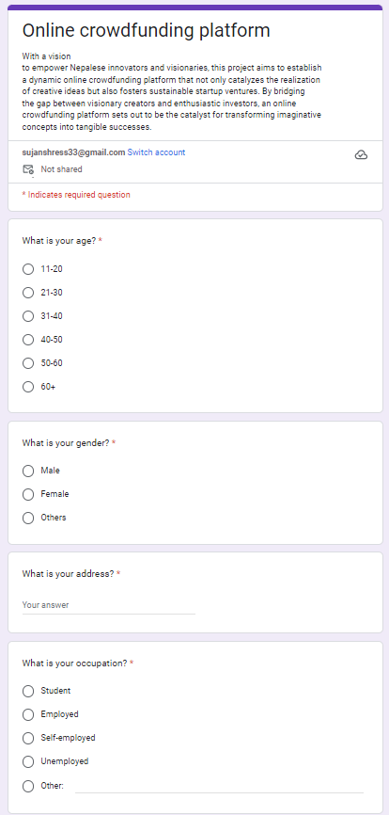: Survey Questions Design 1

Figure 5: Survey Questions Design 2

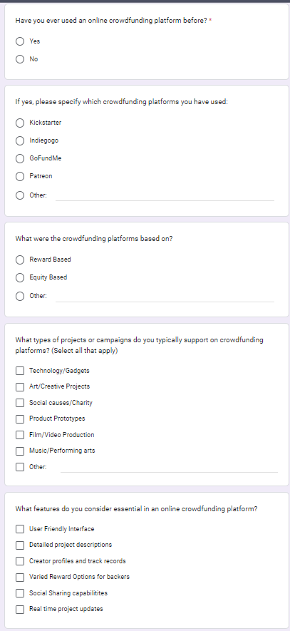

Figure 6: Survey Questions Design 3

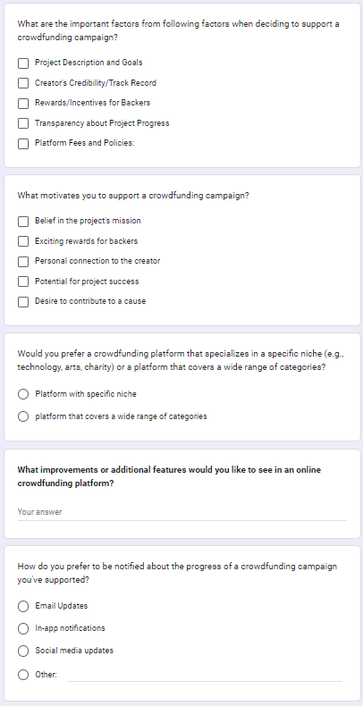

Figure 7: Survey Questions Design 4

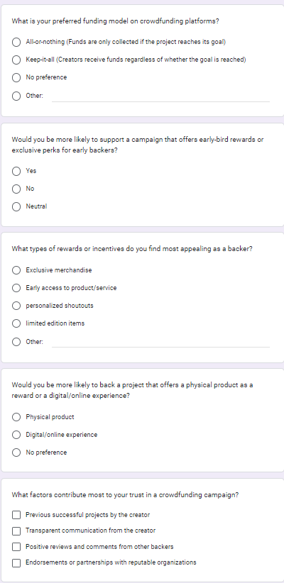

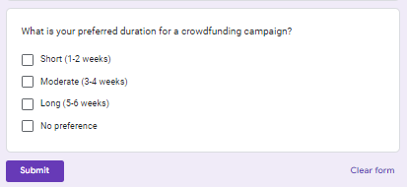

## **Summary**

The questionnaire contains various questions regarding different aspects of Online Crowdfundind platform such as User geofraphy, Crowdfundinig platform usage, Preference and Expectation regarding online crowdfunding system, platform improvement suggestions and so on. These questions reflect the required information and data needed for analyzation in the initial stage of the project planning of an online crowdfunding platform. These questions were provided to fillers through the medium of google forms.

# **Chapter 5 Requirement Validation**

## **Introduction**

Requirement Validation is an essential phase for the success of the projects as it helps to assure the accuracy of the system that confirms the project meets all the requirements. Proper analyzation of the data and requirement validation helps to make sure that the project accurately meets the requirements of the project. The requirement validation will help to improve the overall quality of the project by eradicating execution of inappropriate designs and development processes.

## **Analysis of Data**

### **Data analysis through questionnaire**

|  |  |
| --- | --- |
| Question 1:  Result: | Figure 8 : Pie Chart of Age Group |
| Analysis | The above chart displays the age range of the users or respondents who had participated in the survey of the online crowdfunding platform. Most of the participants are of age 21-30 with 75% and others with 15% and 10% |
| Question 2  Result: | Figure 9: Pie Chart of Gender Distribution |
| Analysis | The above chart displays the gender types of the users or respondents who had participated in the survey of the online crowdfunding platform. Most of the participants are male with 80% and female with 20%. |
| Question 3  Result: | Figure 10: Bar Chart of Geographical distribution |
| Analysis | The above histogram shows the geographical distribution of participants who took part in the survey. Here, we can see majority of the participants are from Kathmandu and rest are spread all over Nepal. |
| Question 4 | Figure 11: Pie chart of Occupation Distribution |
| Analysis | The above chart displays the occupation types of the users or respondents who had participated in the survey of the online crowdfunding platform. Most of the participants are students with 50% and 40% of them are employed and rest unemployed. |
| Question 5 | Figure 12: Usage Pie Chart |
| Analysis | The above chart displays whether the users or respondents who had participated in the survey of the online crowdfunding platform have used any online crowdfunding before or not. Most of the participants have not used any other crowdfunding platforms before. |
| Question 6 | Figure 13: Platform Usage Pie Chart |
| Analysis | According to the above chart, 60% of participants who have used crowdfunding platform before had used Kickstarter and with Indiegogo and GoFundMe having equal share of 20% both. |
| Question 7 | Figure 14: Platform Categorization Usage Pie Chart |
| Analysis | According to the above chart, all of the participants who have used crowdfunding platform before had only used Reward Based platforms it may be due to lack of legal options and actions in Nepal with foreign platform. |
| Question 8 | Figure 15: Chart for Types of Campaigns |
| Analysis | The above diagram shows that the projects related to arts/creativity and technology/gadgets are the most popular to get fundings in crowdfunding platforms as majority of participants has voter these two categories with 85% and 80% of participants respectively. Social Cause or charity projects remain the lowest with only 30% of participants being interested. |
| Question 9 | Figure 16: Chart of Features in Crowdfunding Platform |
| Analysis | Real asked about the essentials features that should be in the Crowdfunding platform, the User-friendly interface and detailed project descriptions along with real time project updates are the features to get top number of votes. These three features have 89.5%, 84.2% and 84.2% of total participants respectively. |
| Question 10 | Figure 17: Chart for Factors to support campaign |
| Analysis | The above chart shows that many of the participants or backers consider project description and goals as the topmost priority or factor while investing in the project. Along with this factor, creators’ credibility, or track record along with rewards for backers are another two major factors considered by backers while investing in certain ideas or projects. |
| Question11 | Figure 18: Motivation Chart |
| Analysis | 85% of the total participants get motivation to support a funding campaign in crowdfunding because of the exciting rewards for backers. Another top scoring factor is the belief in project’s mission along with some personal connection with the creator of the project. |
| Question 12 | Figure 19: Pie Chart of Specific Niche in Crowdfunding |
| Analysis | The above chart shows that 90% of the participants prefer crowdfunding platform that covers wide range of categories rather than specializing in a specific niche. |
| Question 13 | **What improvements or additional features would you like to see in an online crowdfunding platform?**  8 responses  Robust payment system  Additional employment opportunities  More categories  Transparency in policy  Technology based platform.  Add more rewards options.  More social imparting projects  More single niche-based platforms. |
| Analysis | Here, eight different kinds of extra features or additional improvements are provided by participants as feedback to the proposed system which can be improved or added to the system for further system enhancements. |
| Question14 | Figure 20: Pie Chart for notification preference |
| Analysis | When asked about preference to be notified about the progress of a crowdfunding campaign, 80% of the participants have voted notification through email-updates as their choice and rest 20% with in-app notifications. |
| Question 15 | Figure 21: Pie chart for preferred funding model |
| Analysis | The above chart shows that 70% of the total participants has preference of All or nothing funding model when it comes to crowdfunding where 25% has also chosen keep-it-all as their preferred funding model and rest has chosen no preferences as their answer. |
| Question 16 | Figure 22: Pie chart for reward distribution |
| Analysis | The above chart shows that 40% of the total participants has preference of supporting a campaign that offers early-bird rewards or exclusive perks for early backers where 35% has also chosen no as their preference and rest has chosen no preferences or neutral as their answer. |
| Question 17 | Figure 23: Pie chart for reward types |
| Analysis | When asked about types of rewards or incentives, backers will be finding most appealing, the above chart shows that 35% of participants will be appealed through exclusive merchandise and rest 60% through limited edition item and early access to product or service both halves respectively. |
| Question 18 | Figure 24: Reward types chartForms response chart. Question title: Would you be more likely to back a project that offers a physical product as a reward or a digital/online experience? . Number of responses: 20 responses. |
| Analysis | The above chart shows that 60% of the total participants have selected that physical product will appeal them more to back a project and 35% has gone with reward regarding digital or online experience and rest 5% have no preference about the reward. |
| Question 19 | Figure 25: Chart for trusting campaigns |
| Analysis | When asked about the factors that contribute most to their trust in a specific crowdfunding campaign, 95% of the participants have chosen Positive reviews and comments from other backers and 85% has chosen Previous successful projects by the creator and 60% has chosen Transparent communication from the creator and Endorsements or partnerships with reputable organizations caught eye of 50% of participants. |
| Question 20 | Figure 26: Chart for duration of campaign |
| Analysis | The above chart shows that the majority of participants that is 65% prefer moderate duration for a crowdfunding campaign and 40% prefer long term duration along with 20% preferring short duration and rest has no preference over the duration of the campaign. |

## **Summary**

Various information related to different scopes of online crowdfunding platforms are generated through this data analysis. Different data regarding different scopes such as as User geofraphy, Crowdfundinig platform usage, Preference and Expectation regarding online crowdfunding system, platform improvement suggestions and so on are analyzed. These questions reflect on required information and data needed for analyzation in the initial stage of the project planning of online crowdfunding platform.

**Chapter 6: System Architecture**

**Introduction**

“Takeoff”, an online crowdfunding platform that acts as a connecting bridge between the project or campaign creator and the investor. A platform where an idea or startup or any sort of creative campaign can find its way towards a larger audience and a wider marketplace. Takeoff offers a dynamic platform with tailored focus on the needs of the aspiring innovators and creators. This crowdfunding platform places user experience as the priority of its design to fain a seamless and intuitive interaction between the system and users.

A commitment to accessibility and efficiency lies at the heart of Takeoff’s system architecture. With simple interaction with our user-friendly interface, innovators who are willing to bring their projects and ideas to life can efficiently navigate the platform, finding the potential backers and investors and accessing vital resources to propel their projects forward.

In essence, this crowdfunding platform brings user centric designs, proper data synchronization, security, and scalability to build up a perfect crowdfunding platform that is not only dependable but also very transformative and transparent.

## **Core Features and Elements of Takeoff crowdfunding platform:**

Project Creation: Creators can easily launch a campaign about their project or ideas on the platform, providing comprehensive information about their project. They can also attach both images and video multimedia of their projects to grab the attention of the backers.

Investment Opportunities: Investors or backers get the opportunities to browse and discover various unique projects on the platform and invest in those campaigns which they find good for the market. They can pledge a certain amount of funds towards the projects they believe in and gain different rewards according to the project.

Reward System: Creators can provide a certain range of rewards according to the pledged amounts. Investors or backers receive these rewards as a benefit for contributing towards a project when the goal amount of the project is fulfilled. Rewards can be different according to the project such as exclusive merchandise, early access to products, prototype versions of products and so on.

Updates and Feedback: In this platform, creators are encouraged to provide regular updates regarding their campaigns to keep the investors and backers informed about the progress of their project. These updates can contain different things such as milestones, future plans and so on. Also on the other hand, backers can provide campaign creators with their view and perspective about the project. This will help to maintain transparency in the campaign.

Project Analytics: Administrators have access to the more technical and comprehensive sector of the platform as they will be able to view project analytics, allowing them to track key metrics and factors such as funding progress according to categories, campaigns performance, investors engagement and so on.

## **System Design**

### ***Use Case Diagram***

Figure 27: Use Case Diagram

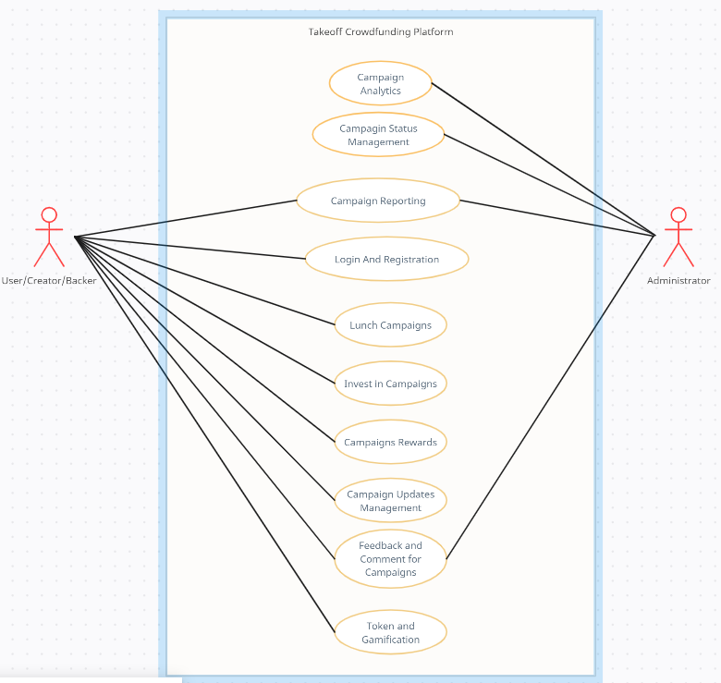

### ***Use Case Specification***

Use case specification of Campaign Analytics

Table 4: Use Case Specification of Campaign Analytics

|  |  |
| --- | --- |
| **Title** | **Campaign Analytics** |
| Description | Allow administrative users to view data analytics of campaigns in the platform |
| Actor | Administrative User |
| Pre-Condition | Request administrative authorization |
| Post-Condition | Provides data analytics of campaigns according to different project categories |
| Main-Flow | 1. Administrative Login 2. Opens Dashboard |
| Alternate Flows | If authentication and authorization error occur in Administrative Login |

Use Case Specification of Campaign Status Management and Campaign Reporting

Table 5: Use Case Specification of Campaign Status Management and Campaign Reporting

|  |  |
| --- | --- |
| **Title** | **Campaign Analytics** |
| Description | Allow administrative users to change status of project according to reporting status |
| Actor | Administrative User |
| Pre-Condition | Request administrative authorization |
| Post-Condition | Changes the status of campaigns, failed, completed, Active or can delete campaigns |
| Main-Flow | 1. Admin opens campaign details page. 2. Admin View Reporting tab of campaign 3. Change Status of Campaign and Submit |
| Alternate Flows | If authentication and authorization error occur in Administrative Login |

Use Case Specification of Login and Registration

Table 6: Use Case Specification of Login and Registration

|  |  |
| --- | --- |
| **Title** | **Campaign Analytics** |
| Description | Allow users to sign up or login to the system |
| Actor | User |
| Pre-Condition | User has login or registration page opened |
| Post-Condition | Logs in or register the user into the system |
| Main-Flow | Login:   1. User fills in the required information. 2. Logins into the system   Registration:   1. User fills in the required information. 2. User verifies email via OTP code. 3. User will be redirected to login page |
| Alternate Flows | If user cancels login and registration process. |

Use Case Specification of Campaign Lunch

Table 7: Use Case Specification of Campaign Lunch

|  |  |
| --- | --- |
| **Title** | **Campaign Analytics** |
| Description | Allow creators to create a campaign for their project |
| Actor | User - Creator |
| Pre-Condition | Registered into the system with verified email |
| Post-Condition | A campaign will be created |
| Main-Flow | 1. User clicks on start a campaign. 2. Terms and Policy agreement 3. Fills all required form data. 4. Creates campaign |
| Alternate Flows | If user cancels campaign creation |

Use case Specification of Invest on Campaigns

Table 8: Use Case Specification of Invest on Campaigns

|  |  |
| --- | --- |
| **Title** | **Campaign Analytics** |
| Description | Allow users to invest into campaigns |
| Actor | User - backer |
| Pre-Condition | Registered into the system with verified email |
| Post-Condition | Create a investment of certain amount on campaign |
| Main-Flow | 1. Users browse and selects campaign to invest in 2. Enters ESEWA details and makes payment. 3. User will be registered as backer for the project |
| Alternate Flows | If user cancels the investment process or any error occurs during payment through ESEWA |

Use case Specification of Campaign Rewards

Table 9: Use Case Specification of Campaign Rewards

|  |  |
| --- | --- |
| **Title** | **Campaign Analytics** |
| Description | Campaigns can contain of certain rewards that will be provided to backers when the campaign is successful |
| Actor | User – backer/Creator |
| Pre-Condition | Campaign Created in System |
| Post-Condition | Provides rewards on campaigns according to campaigns |
| Main-Flow | 1. Creators create rewards on their campaign according to the pledged amount. 2. Backers get rewards after successful completion of a campaign |
| Alternate Flows | If campaign doesn’t have any rewards |

Use Case Specification of Campaign Updates and Feedback Management

Table 10: Use Case Specification of Campaign Updates and Feedback Management

|  |  |
| --- | --- |
| **Title** | **Campaign Analytics** |
| Description | Allow creators and backers to communicate about the ongoing campaign with updates from creator and feedback discussion from both creator and backers |
| Actor | User – creator/backer |
| Pre-Condition | Both users engaged in ongoing campaign |
| Post-Condition | Allows both creators and backers to be informed about project progress and project problems |
| Main-Flow | 1. Creators can directly post updates on updates page which can be later viewed by backers. 2. Backers and creator can directly connect via comment section for feedback management |
| Alternate Flows | If both creator or backer are not engaged in an on-going active campaign. |

### ***Activity Diagram***

Figure 28: Activity Diagram

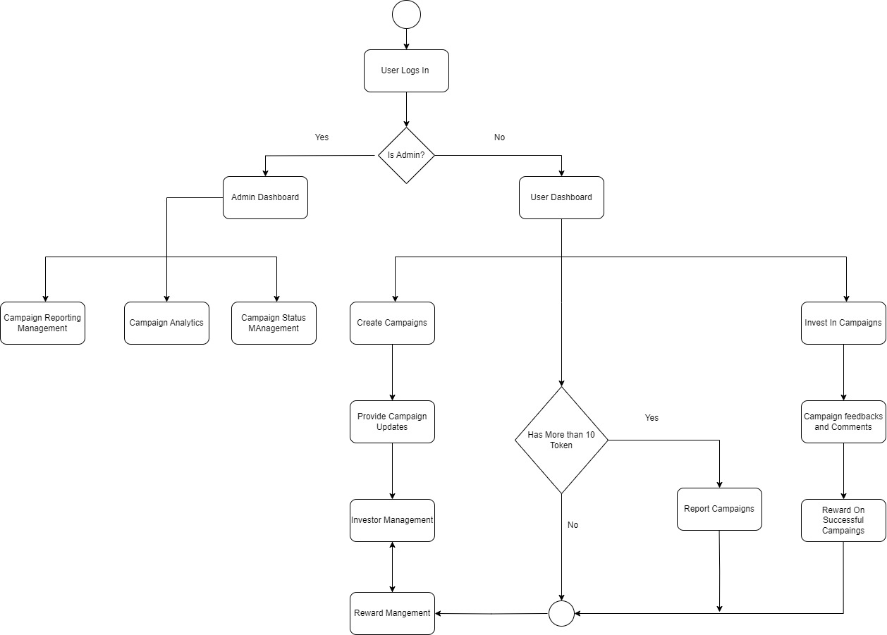

### ***Class Diagram***

Figure 29: Class Diagram

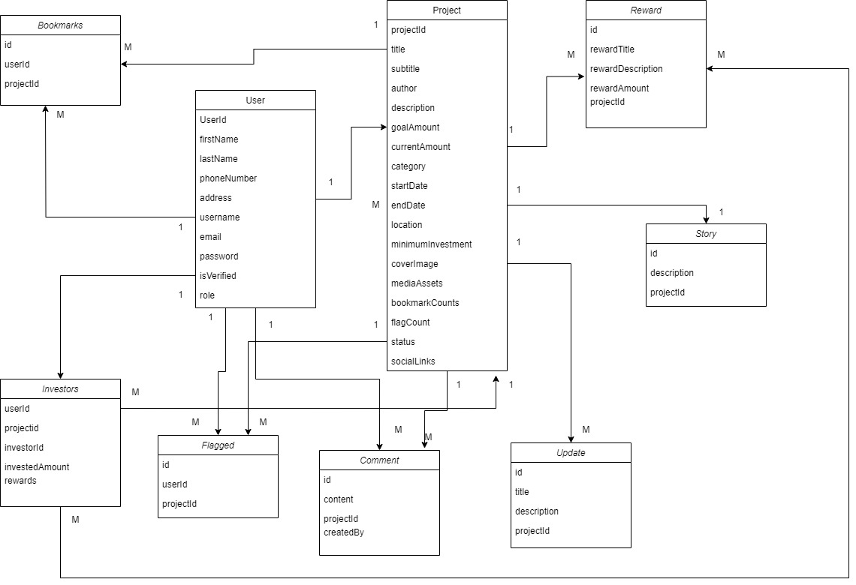

### ***Entity Relationship Diagram***

Figure 30: Entity Relationship Diagram

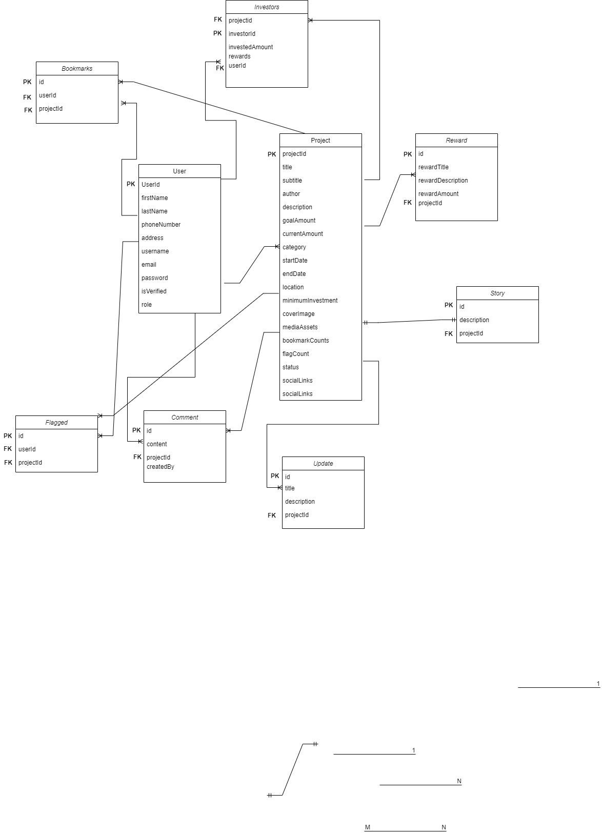

### ***Sequence Diagram***

Figure 31: Sequence Diagram

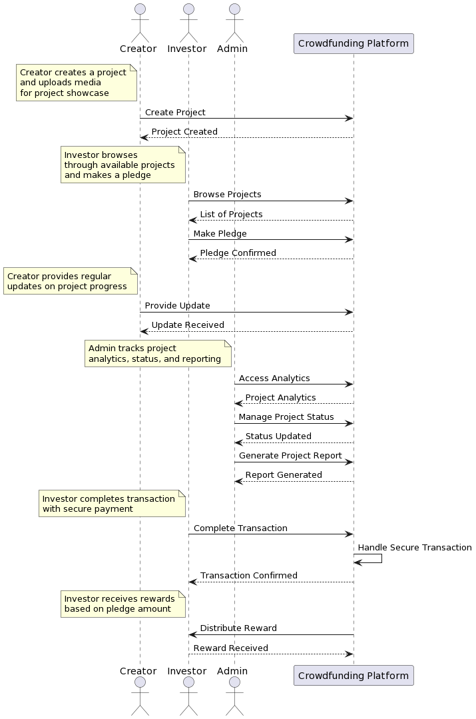

### ***Database Table Structures in No SQL (MONGODB) database***

As the project is developed using MongoDB, A no SQL database, therefore, it does not have any kind of database schema or database architecture. Here are the data structures created for the Takeoff crowdfunding platform in MongoDB.

Figure 32: Tables Structure in MongoDB

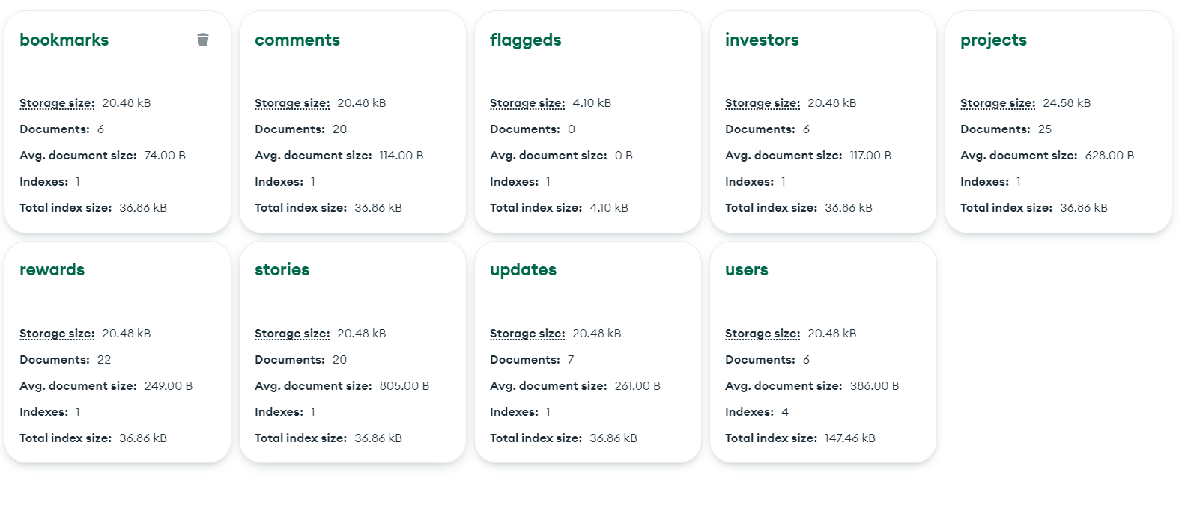

## **Interface Design**

### ***Wireframes***

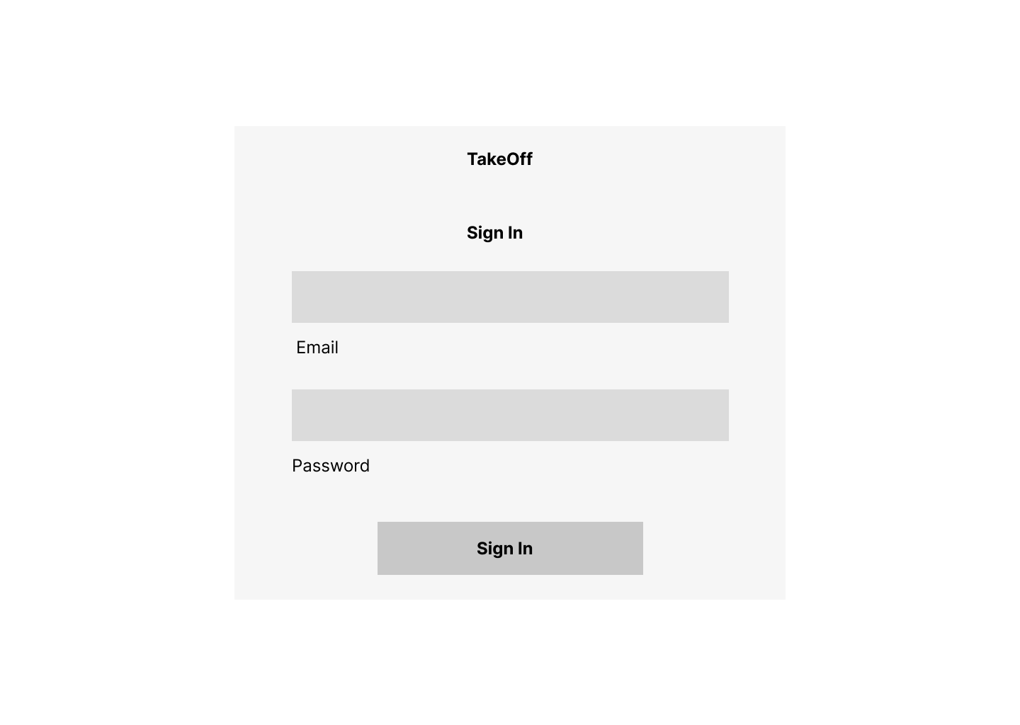Figure 33: Wireframe of Login Page

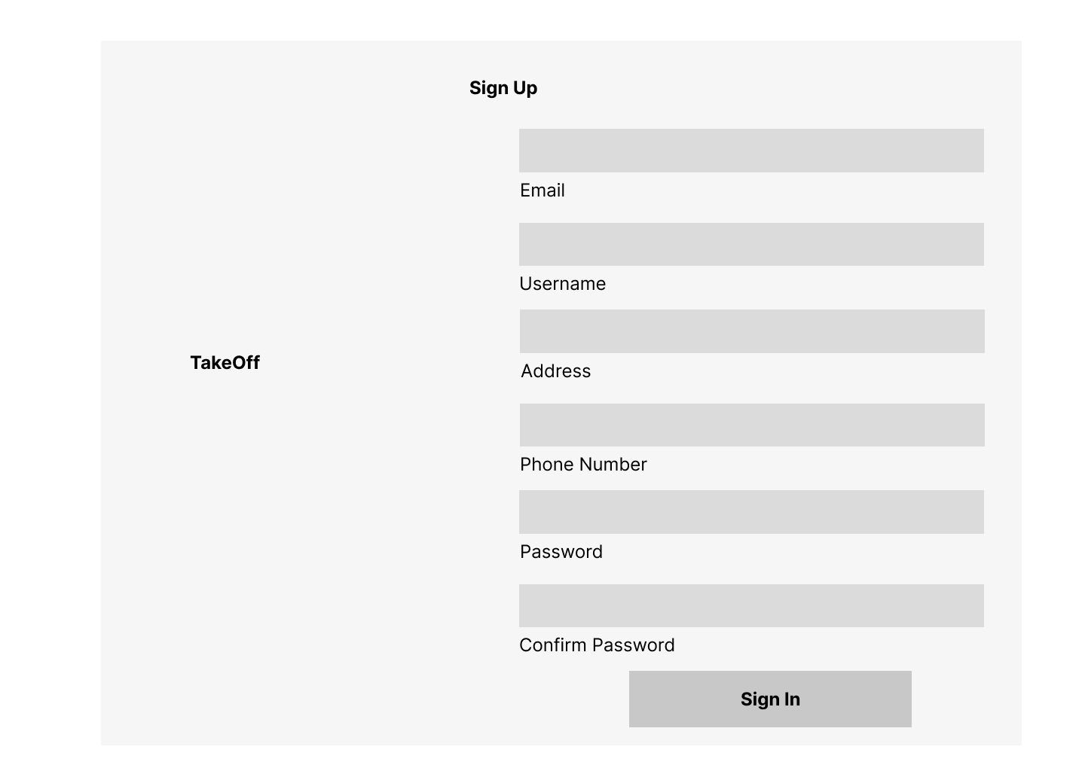Figure 34: Wireframe of Sign-Up page.

Figure 35: Wireframe of Dashboard

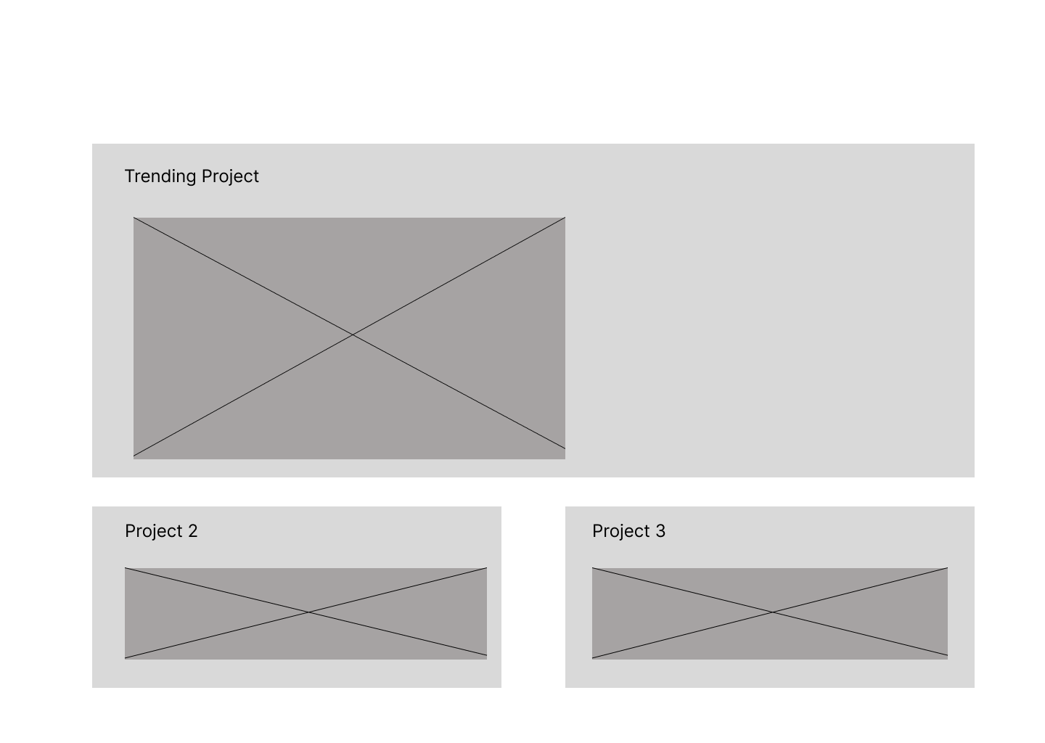

Figure 36: Wireframe of Projects Page

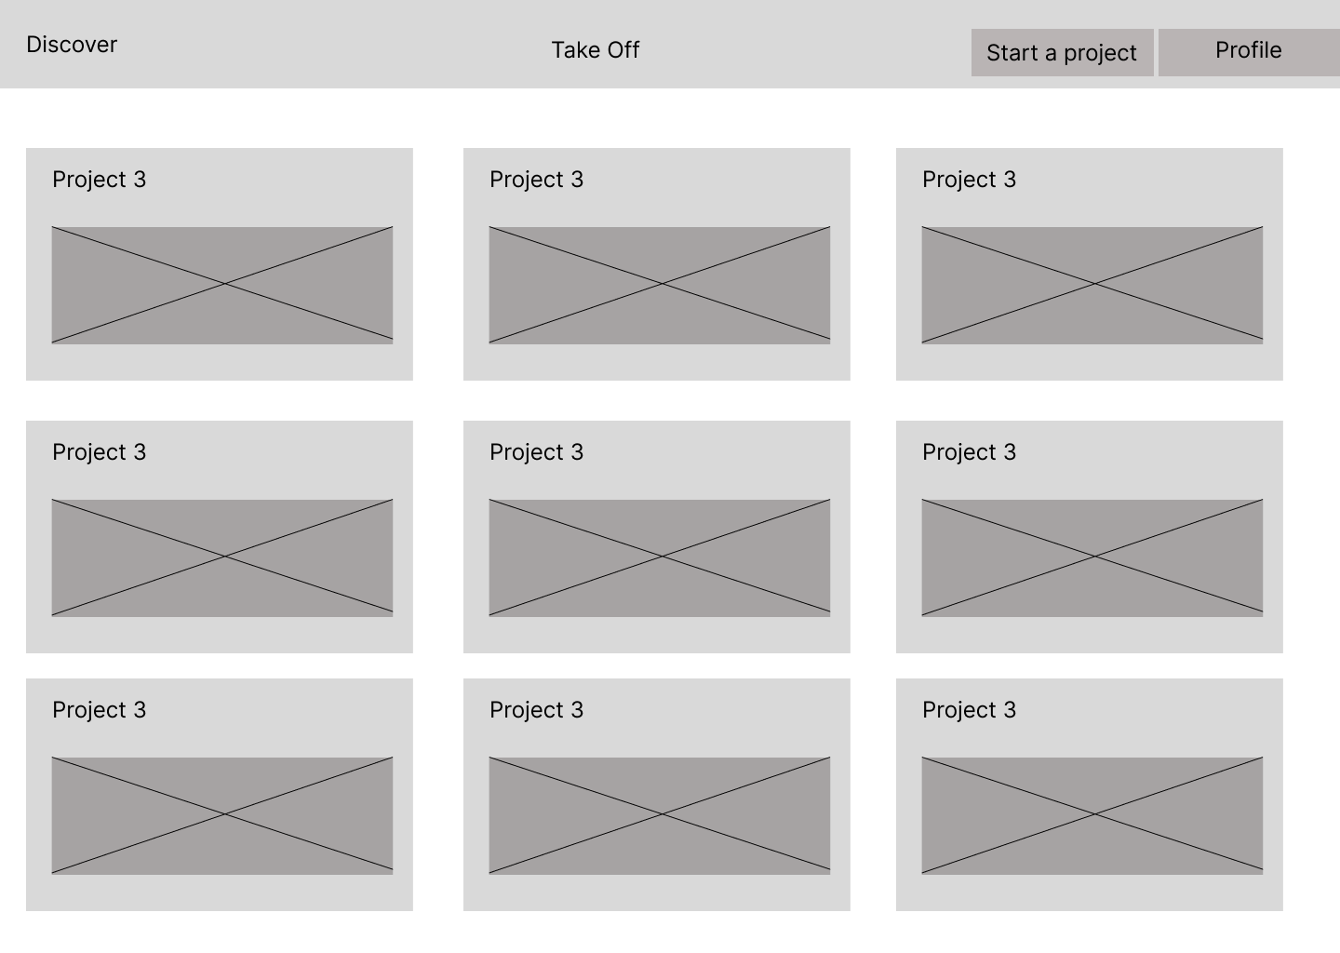

Figure 37: Wireframe of User Profile

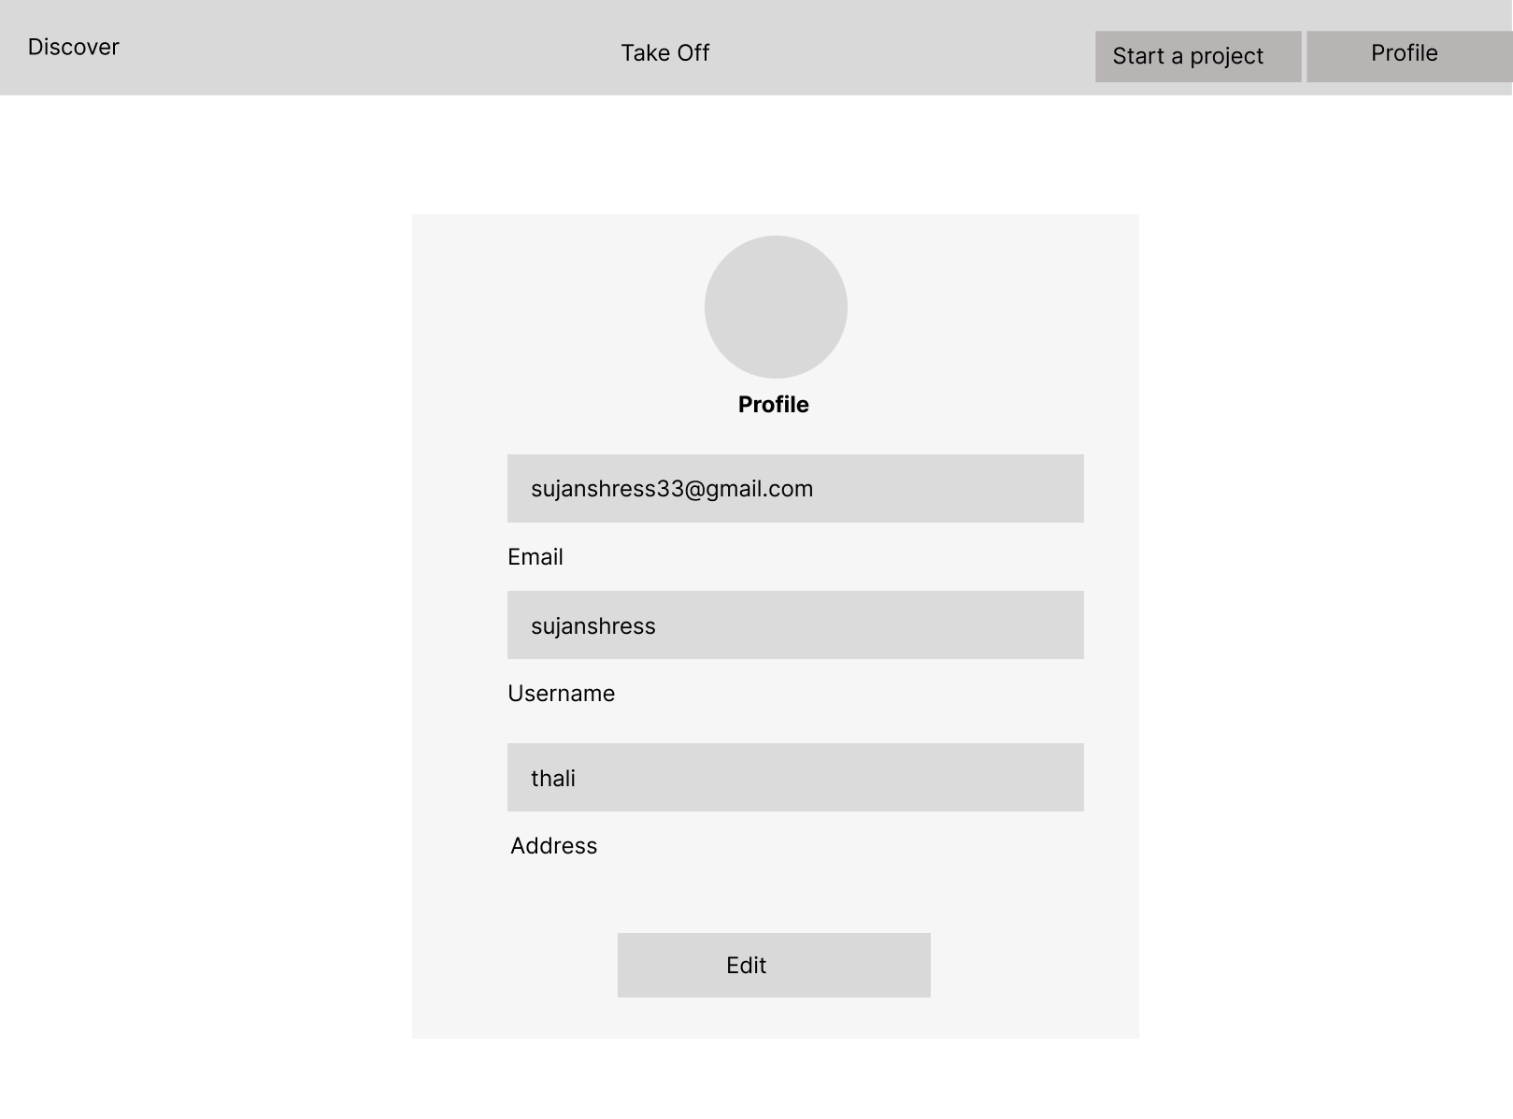

## **Development / Deployment**

### ***Introduction***

Technical research relates to upgrading or improvisation of technological knowledge regarding the technical aspects of the project. Technical research provides guidance for the right selection of technical aspects required by the project itself. All the necessary technical stuff like required SDKs, Programming languages, Database system, hosting platforms comes under this platform. Through technical research, I have explored the different sectors of my project and decided what kind of technology is required by my project.

### ***Selected Programming Languages***

As the online crowdfunding platform is a web-based platform which will be hosted upon servers for users to interact with it efficiently through their browsers. I have decided to go for a MEAN stack selection which is a combination of multiple programming languages and techniques that provides full stack service for web development. The MEAN stack contains Mongo DB as a database, Express JS as a backend tool, Node JS as a server-side execution framework and Angular as the frontend tool. This stack is used by different professionals as it is highly efficient for web development. Overall programming techniques will include HTML, CSS, JavaScript, Typescript and different libraries and frameworks of mentioned programming languages.

I have selected MEAN Stack as it exceeded the overall comparison with the .Net Core technology in the field of web development.

### ***IDE (Interactive Development Environment) Chosen***

To make the development process seamless, optimizing with the best available IDE is a must. There are lots of Interactive Development Environment available globally for development of websites like crowdfunding platforms. As Visual Studio Code comes in as one of the most popular and famous IDEs that supports wide tons of programming languages, tools and techniques. The crowdfunding platform itself will be created or developed using Visual Studio Code.

Visual Studio Code (VS code)

Selection of Visual Studio Code as the preferred IDE for the development of this crowdfunding platform especially when the website is being developed using a MEAN stack is very beneficial. Here are some key reasons to select Visual Studio Code over other IDEs available:

Lightweight and Fast

Visual Studio Code is a well-known IDE for its performance and efficiency as it is very lightweight and provides a responsive and efficient development environment. Therefore, quick iterations and responsive changes in crowdfunding websites can be done efficiently.

Cross Platform compatibility:

VS code is available for multiple platforms like windows, macOS and Linux which allows developers to work through different OS and have consistent development experience.

Extensibility

The rich ecosystem provided by VS Code is unmatched by any other IDEs available currently as there are numerous extensions related to JavaScript, TypeScript, MongoDB, Node JS which will enable developers to enhance the productivity and streamline workflow.

Integrated Terminals:

VS code has the feature of integrated terminal allowing programmers to execute different commands and scripts without leaving the IDE.

### ***OS (Operating System Chosen)***

The OS is an integral part of computing as it regulates the complete I/O process and other resources in operations. The most popular OS available in today’s era are MacOS, Windows and Linux where Windows tends to provide more flexibility and simplicity in communicating with the developers. Support for a wide range of applications and technical tools is provided by windows which depicts the major reason for Windows latest Operating System to be chosen as the preferred Operating System for this project.

### ***Summary***

In summary, the crowdfunding system will be developed with the use of Visual Studio Code IDE. The development will be done using MEAN stack where JavaScript will be the main programming language along with the user of Typescript. Different frameworks such as Angular and Bootstrap will also be used to enhance the development process of this Online Crowdfunding System. The backend part will be handled through the user of Next JS and the server-side handling will be done through Node JS. Coming to the part of database, A NoSQL database i.e. MongoDB will be used, and the development process will be done with the use of Windows Operating System. The system will be able to run across multiple browser platforms and perform efficiently.

# **Chapter 7: Project Plan**

## **Release plan:**

The release plan of the Takeoff crowdfunding platform starts with the initial focus on implementation of core features and functionality. During the first testing, the prioritization will be user profiles and project creation, ensuring creator can easily showcase their ideas while investors will be able to set up their account in the system and browse the projects. Security measures for the transactions of investment will also be given top priority in this release. Moving into the next testing date, subsequent releases will introduce new features like regular updates, a proper reward chaining system to enhance the engagement of both types of users. Each development before any User Acceptance Testing will undergo rigorous unit testing to ensure that all the individual components are reliable. Through this iterative process, we aim to deliver a robust and user-friendly crowdfunding platform after a final UAT before it will be released to the public users.

List of Core Features:

1. Project Creation
2. Investment Opportunities
3. Reward System
4. Campaign Duration
5. Campaign Status
6. Regular Updates
7. Project Analytics
8. User Profiles
9. Tokens
10. Secure Transactions

## **Test Plan for Unit testing.**

Verifying the functionality of each crowdfunding platform component will be the main aim of this unit testing. Every function or method will be tested properly using test cases to make sure that it performs as intended. The components that need to be tested will be separated using certain approaches. Important features such project and user profile creation, investment processing, reward system integration, and safe transaction management will all be tested in this unit testing. Unit tests will be regularly executed as part of the development process using automation. The tests will be iteratively enhanced and broadened to make sure that any kind of additions or modifications do not cause regressions in already-existing functionality as the website keeps on developing.

Test Plans:

Table 11: Test Plans for Unit Testing

|  |  |  |  |
| --- | --- | --- | --- |
| Features | Description | Test Case | Output |
| Login/Registration | Tests Authentication and Authorization part | Login/Registration with proper form details | User creation/User Login |
| Project Creation | Tests the functionality of campaign creation in Takeoff | Create campaign with proper form data | Creation of new campaign |
| Campaign Investment | Test functionality of investing in campaign | Invest in campaigns | User should be created in investor for a campaign |
| Esewa Payment Handling | Test the integration of Esewa payment gateway | During investment process, integration of Esewa payment gateway | Payment successful from Esewa Payment gateway |
| Admin and Data Analytic Functions | Test administrative functions and data analytics | Admin should be able to perform different administrative functions and analyze data through chart | Various administrative function along with accurate data analytics a |

## **Test Plan for UAT**

Confirming that the platform satisfies user needs and requirements will be the main aim of the User Acceptance Testing (UAT) phase. Scenarios, test plans and user stories designed to mimic the real platform interactions will be given to testers. They will try all the various available features, such as project creation, investment options, reward system, and support resources, in terms of their usability, functionality, and overall user experience. Testers will follow up with confirmation that investors can simply navigate through available opportunities, creators can create projects and campaigns with ease, and transactions are safe and easy. Furthermore, testers will also evaluate how well tools like project statistics and frequent updates keep investors informed and involved throughout the crowdfunding process. Our goal is to make sure that the crowdfunding platform offers investors and creators a seamless and easy-to-use experience through extensive testing and end-user validation.

# **Chapter: 8 Implementation**

## **Screenshots of User Interface**

Home Page of Takeoff crowdfunding platform

Figure 38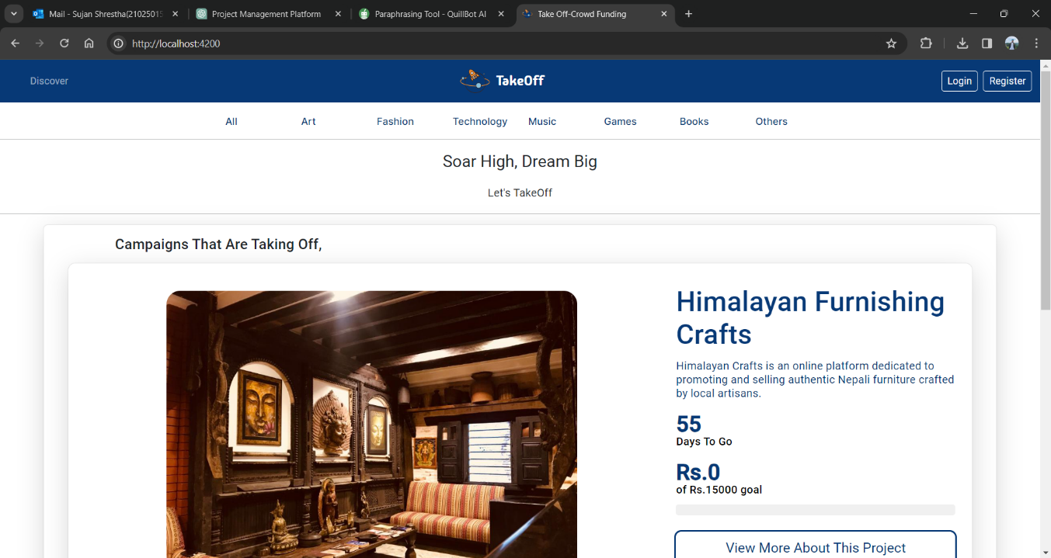: Home Page of Takeoff

The above figure represents the home page of Takeoff crowdfunding platform for both normal user and administrator user before login and registration. This page shows top projects along with certain descriptions about the crowdfunding platform itself.

Registration Page of Takeoff crowdfunding platform

Figure 39: Registration Page of Takeoff

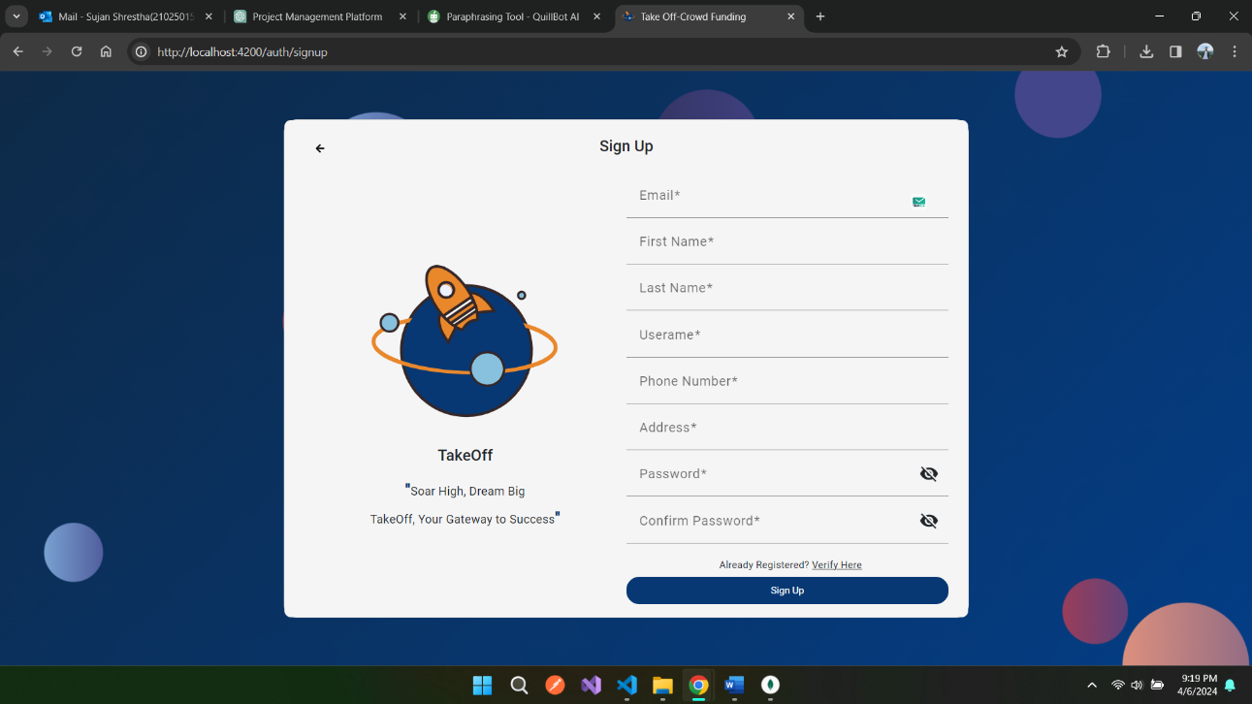

Figure 40: Email Verification page of Takeoff.

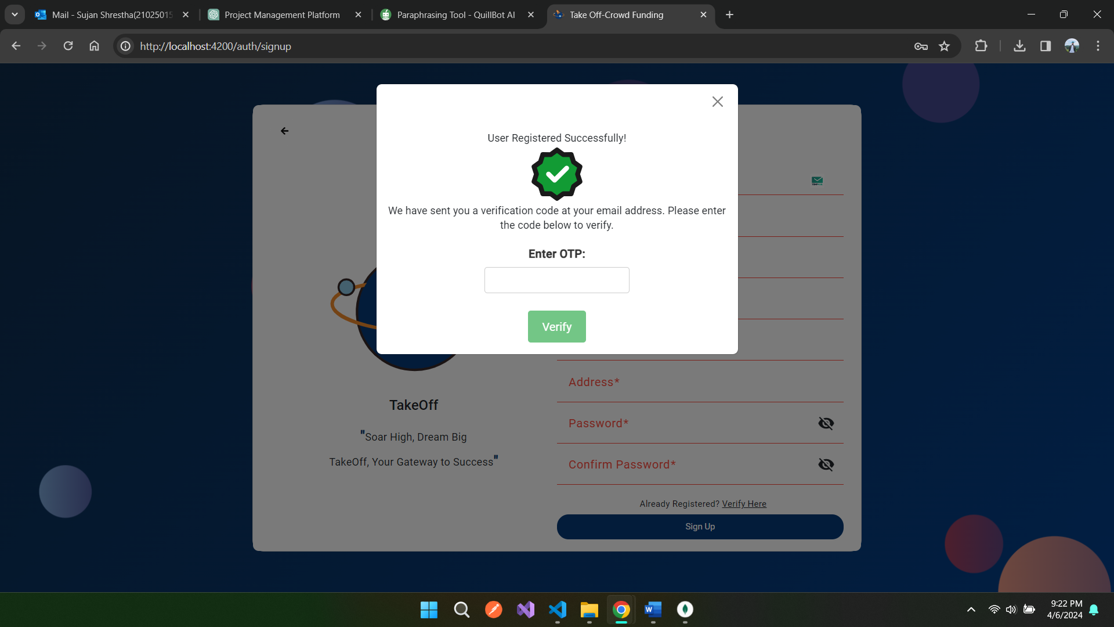

The above image represents a registration page of Takeoff crowdfunding platform where a form can be seen to enter details of the user. The form has multiple validations in order to make sure the data is correct. The second picture shows a field to enter a OTP code sent to the user after successful registration.

Login page of Takeoff

Figure 41: Login page of Takeoff.

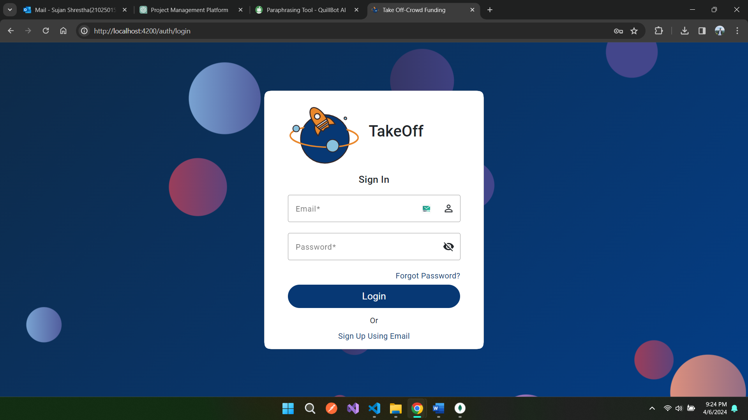

This is a login page of Takeoff where a user can enter his/her email address along with the password in order to login to the system. Furthermore, we can see a forget password button through which users can reset their password.

Campaign Creation page of Takeoff.

Figure 42: Campaign Creation Page of Takeoff

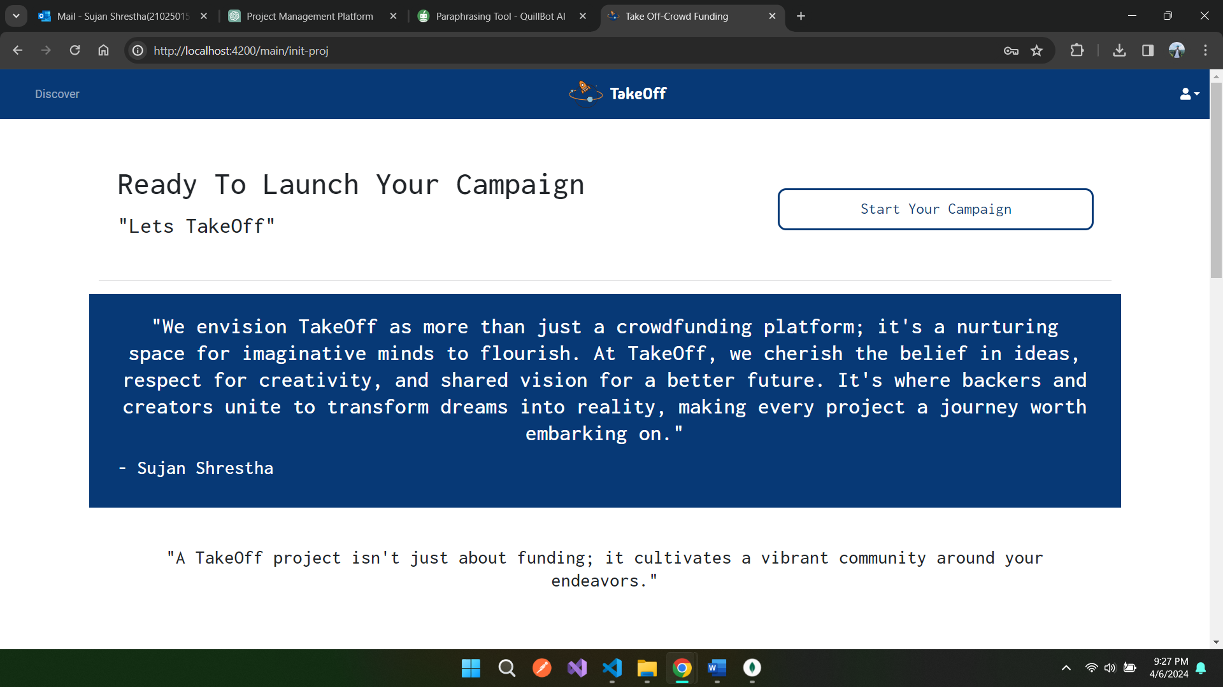

Figure 43: Campaign Creation Form of Takeoff

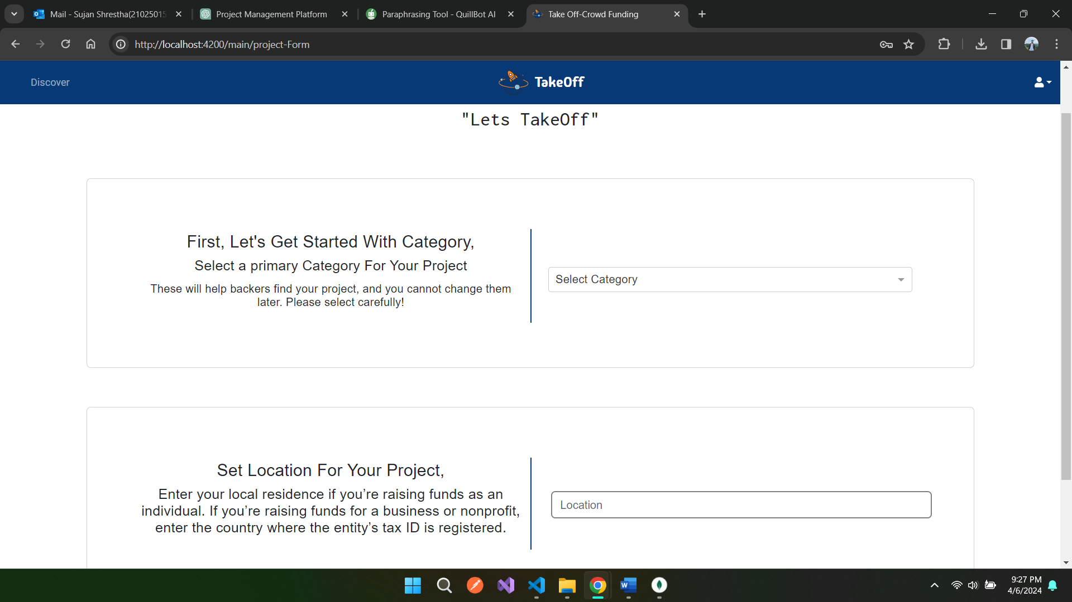

The above two images represent a project creation page where there are numerous fields required to be filled out by the creator. This includes all the major things such as terms and conditions, project titles, story, description, media assets, category and so on.

Project Detail page of Takeoff

Figure 44: Project Details Page of Takeoff

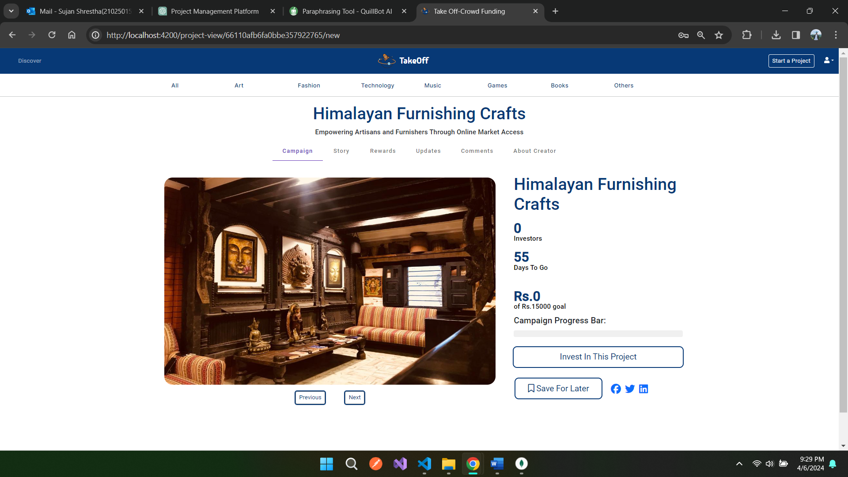

Figure 45: Reward Tab

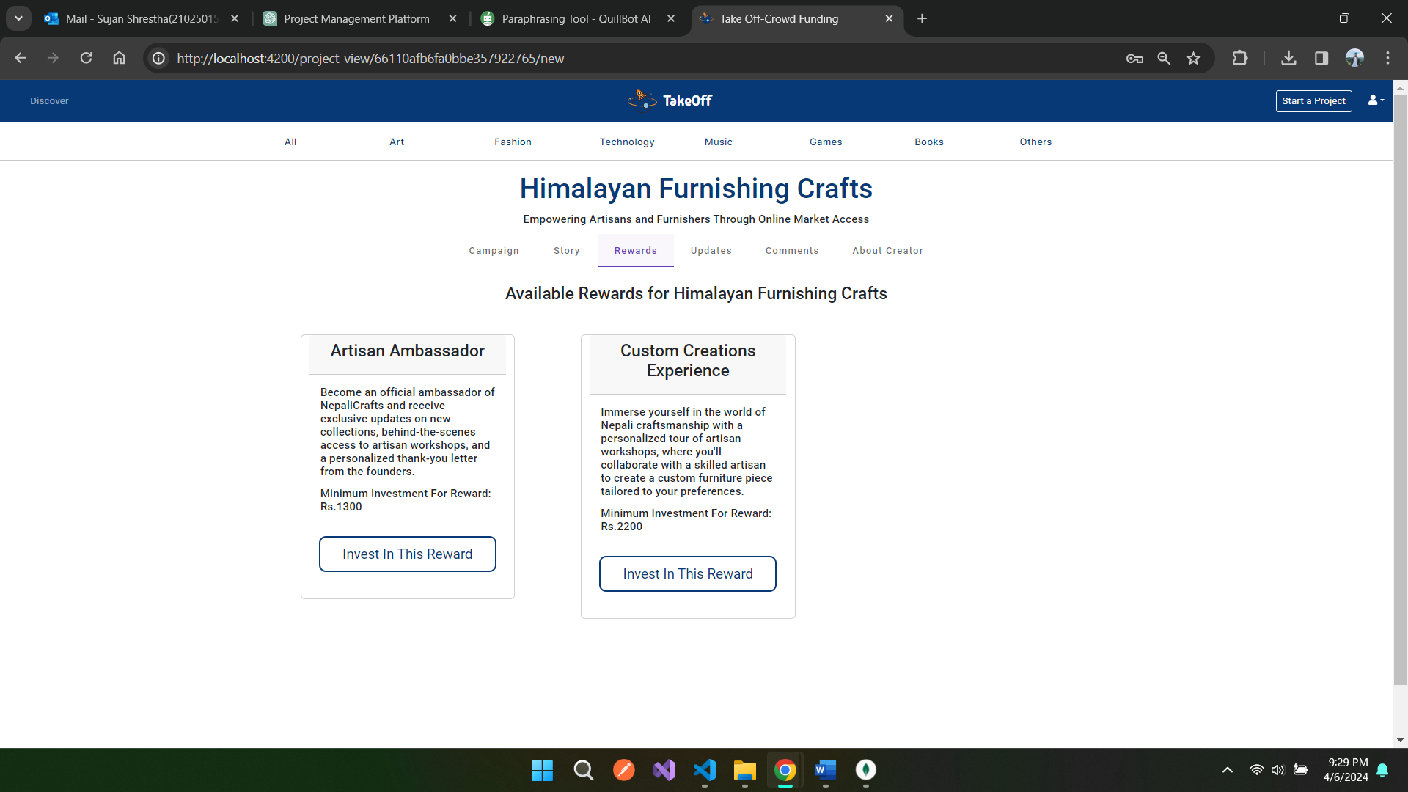

Figure 46: Story Tab

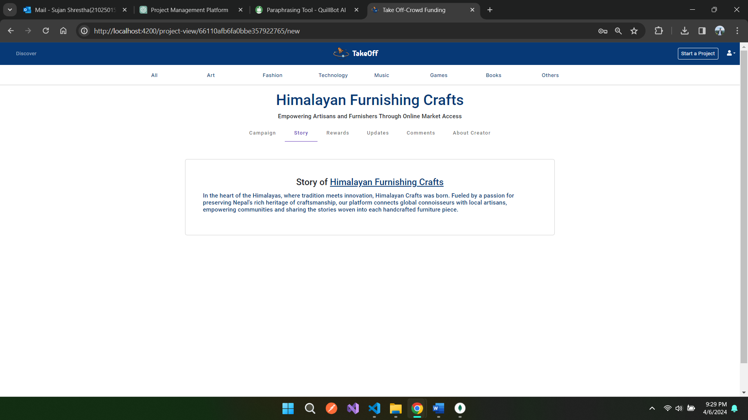

Figure 47: Updates Tab

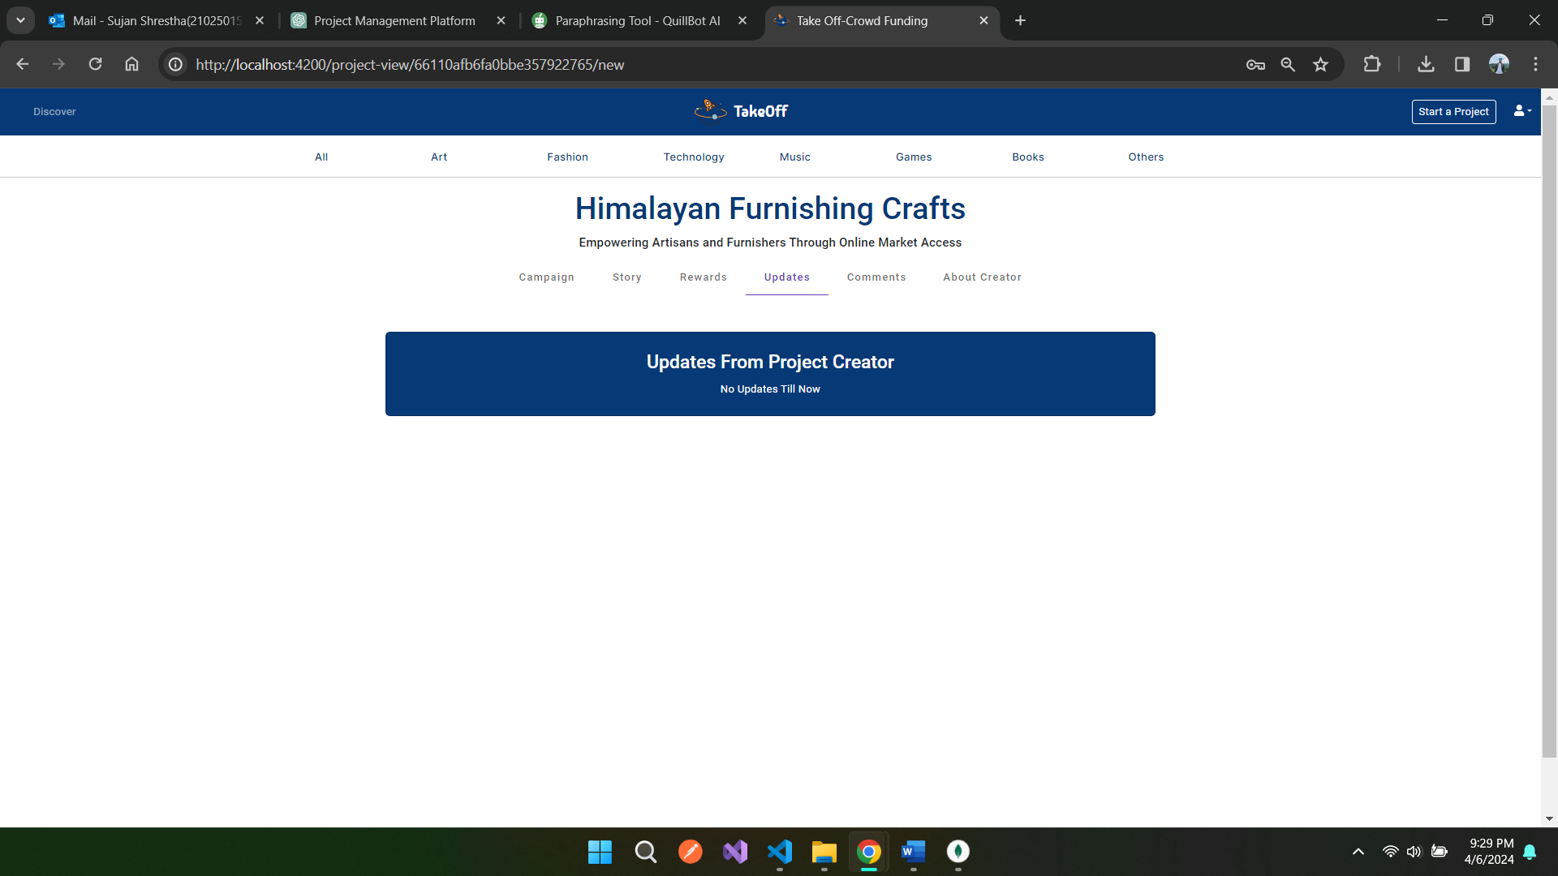

Figure 48: Comments Tab

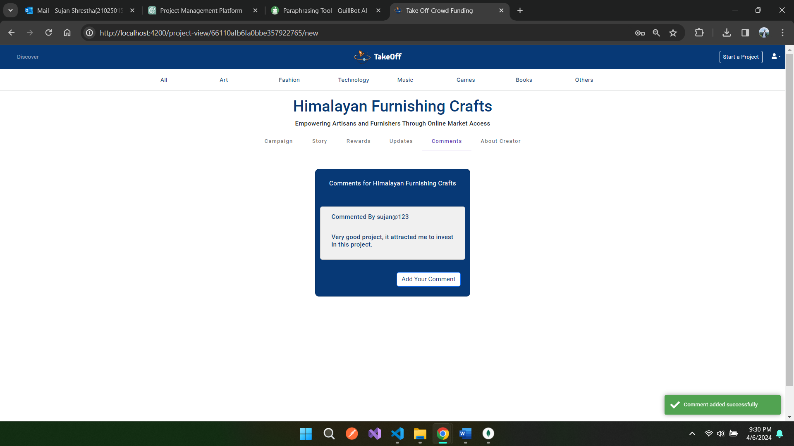

Figure 49: About Creators Tab

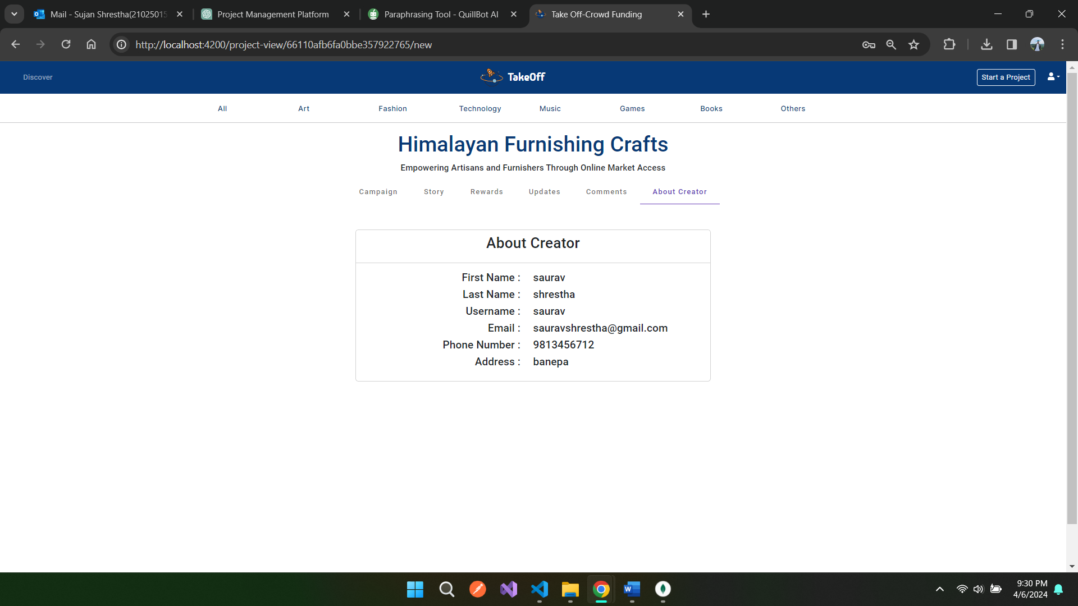

The above images represent a detail view of the project view page in takeoff crowdfunding platform. Here, we can see there a different tabs such as campaign, updates, story, reward and so on providing various information related to the project itself.

Investment Process in Takeoff

Figure 50: Investment Process Page

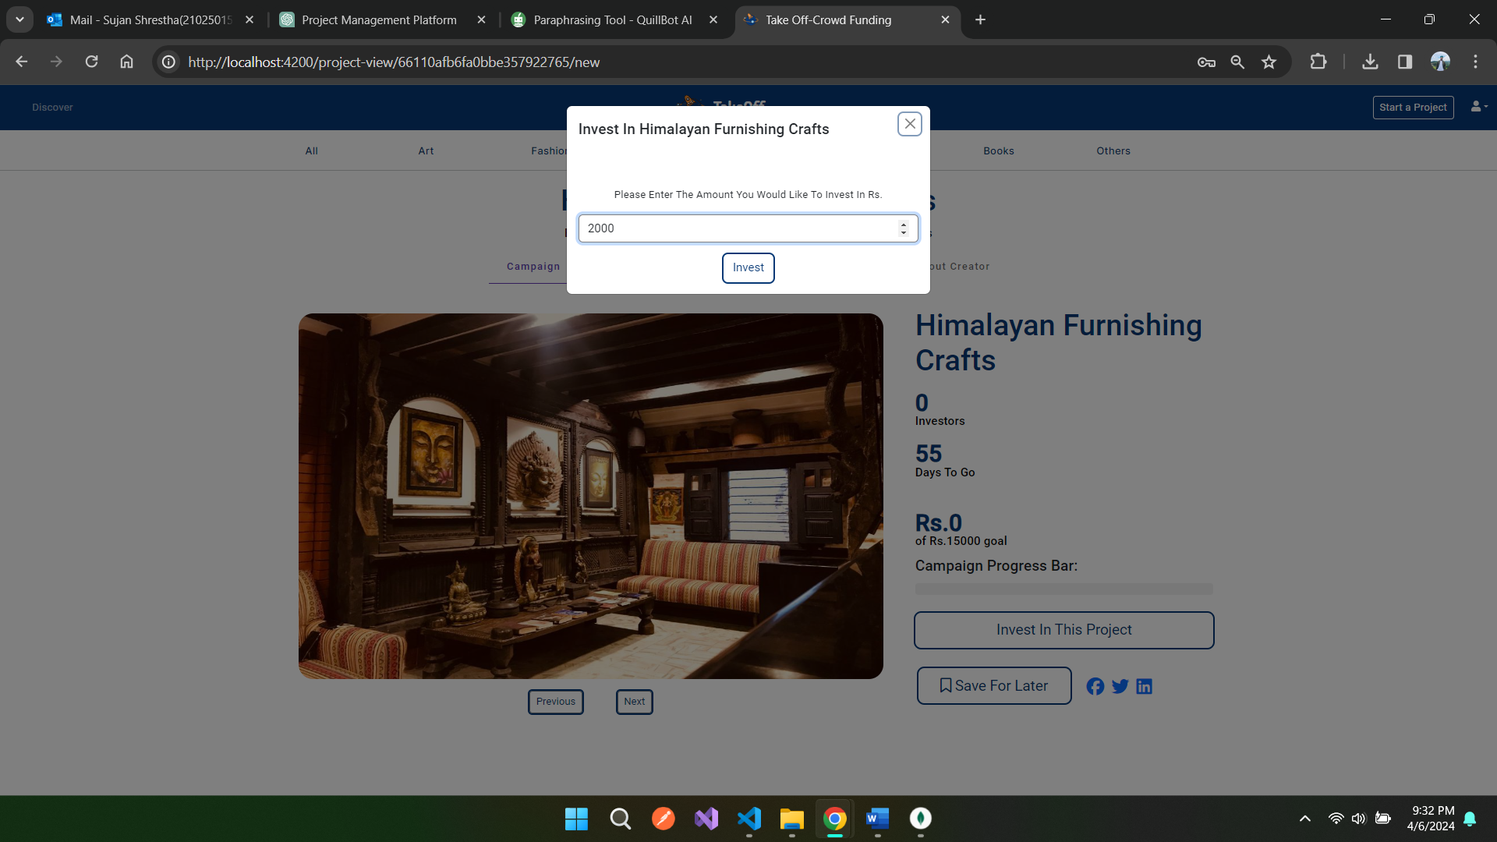

Figure 51: Esewa Snapshot 1

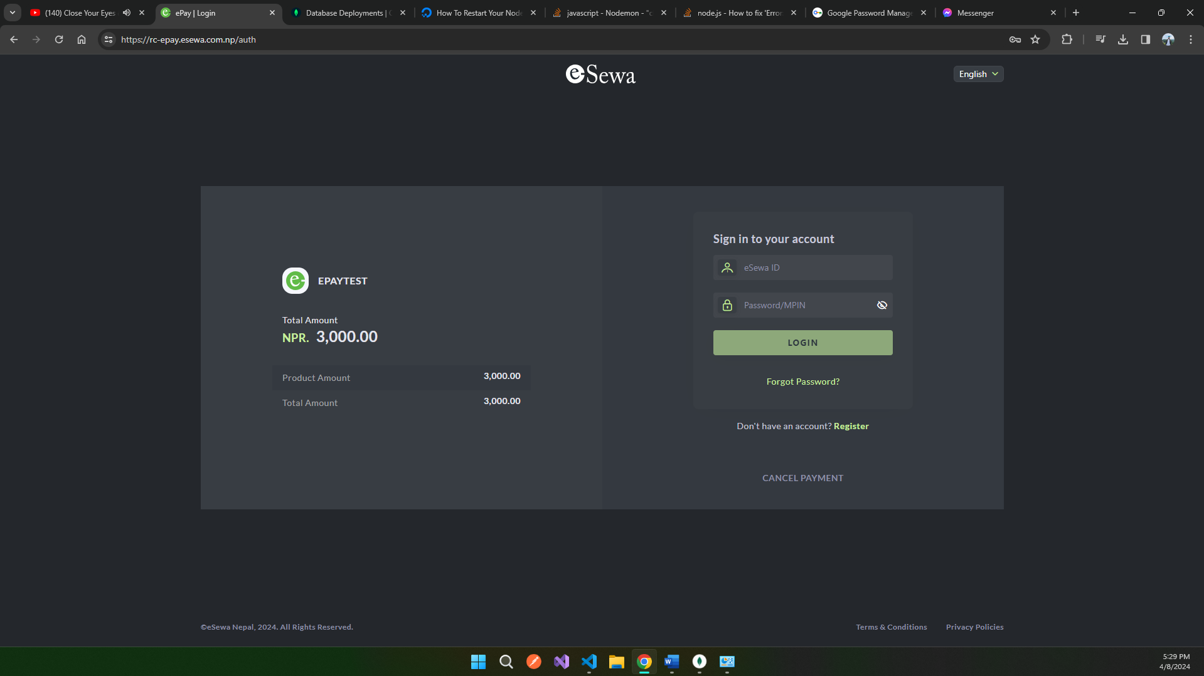

Figure 52: Esewa Snapshot 2

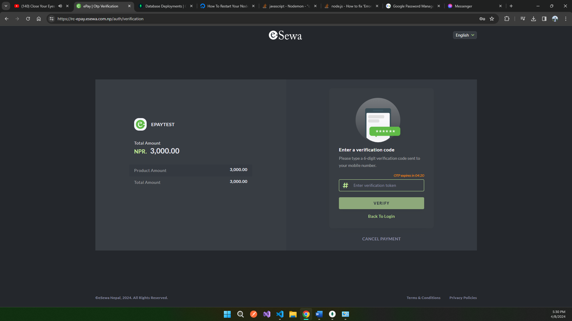

Figure 53: Esewa Snapshot 3

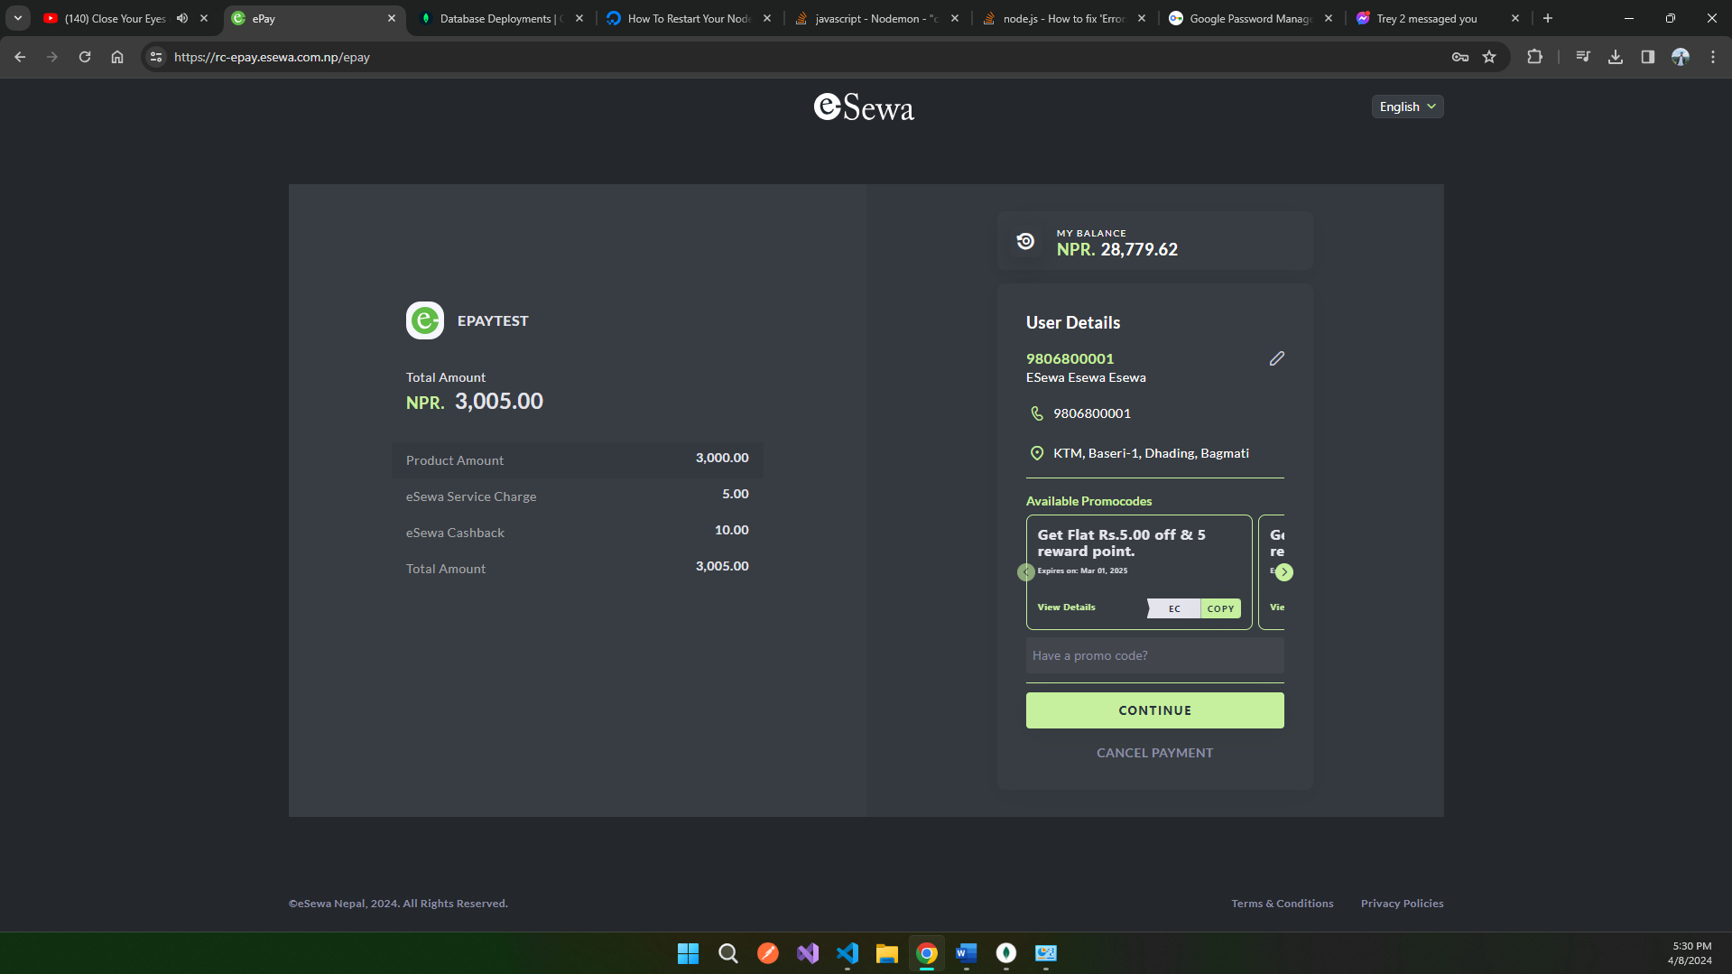

Figure 54: Esewa Snapshot

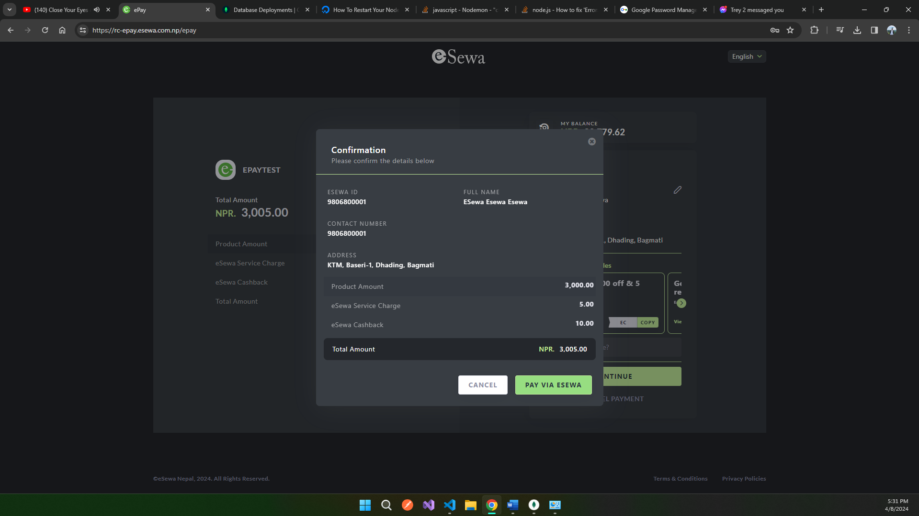

Figure 55: Esewa Snapshot 5

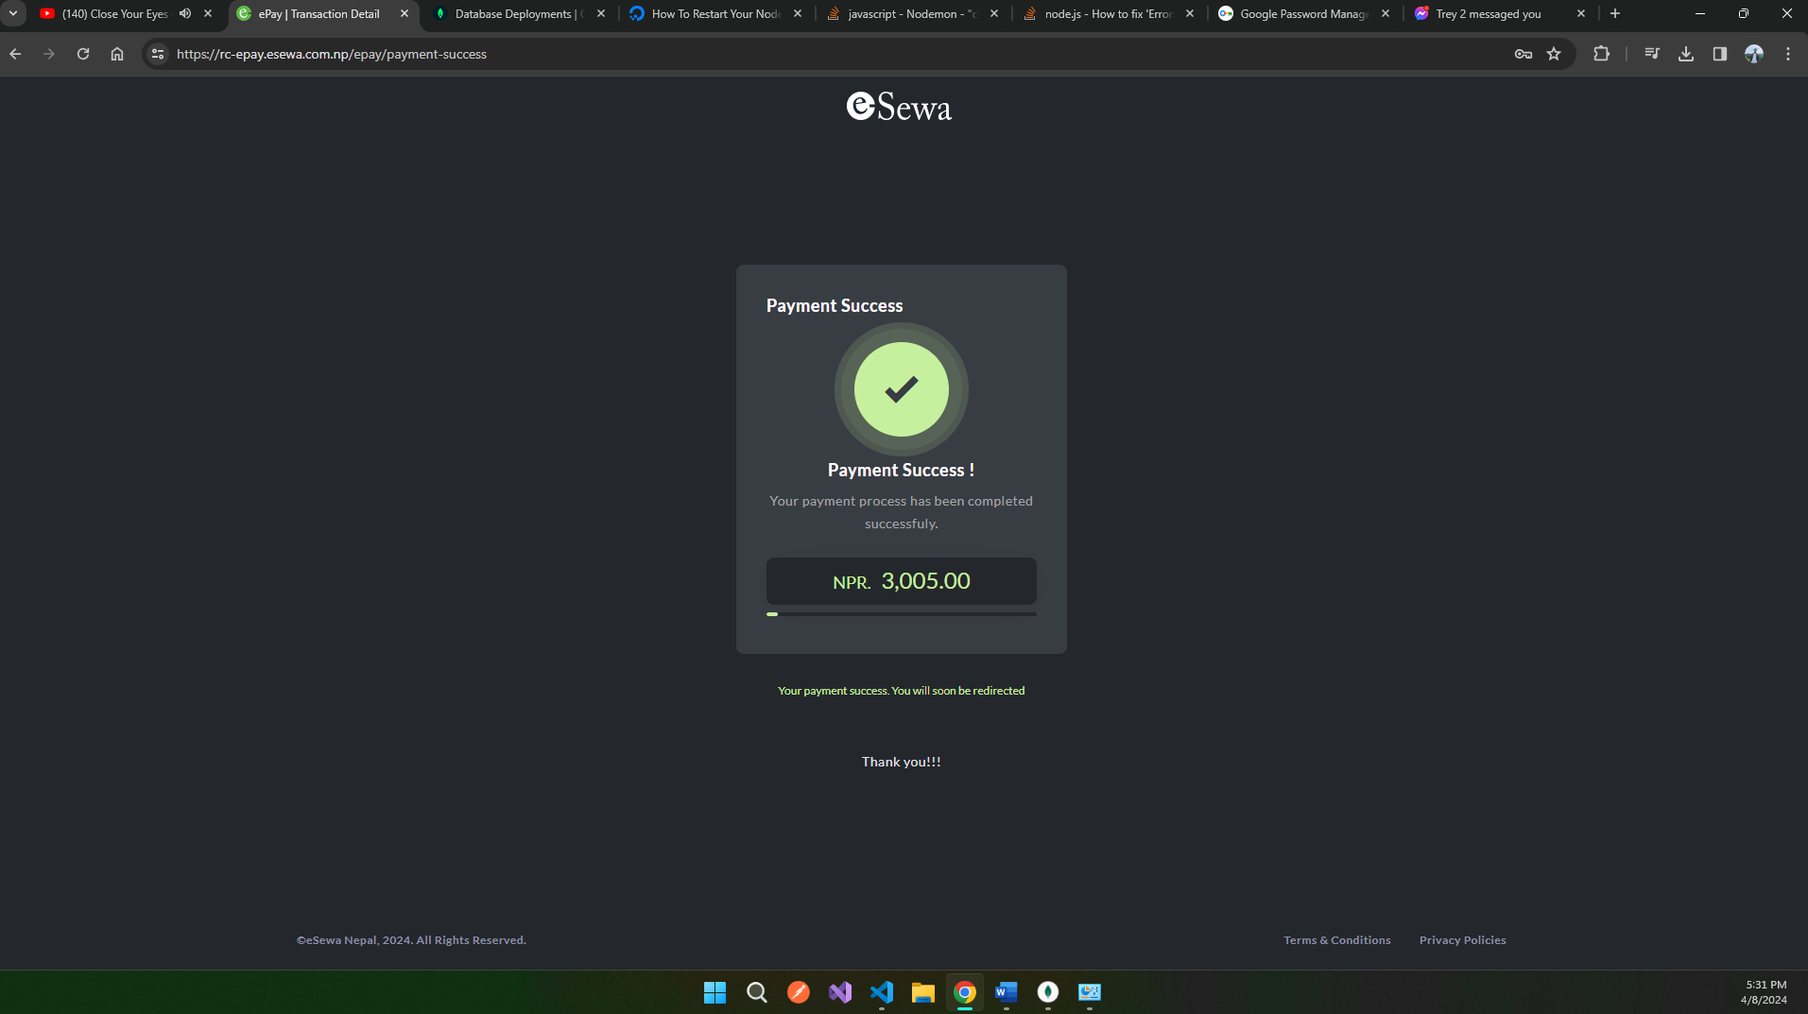

Figure 56: Successful Investment Page

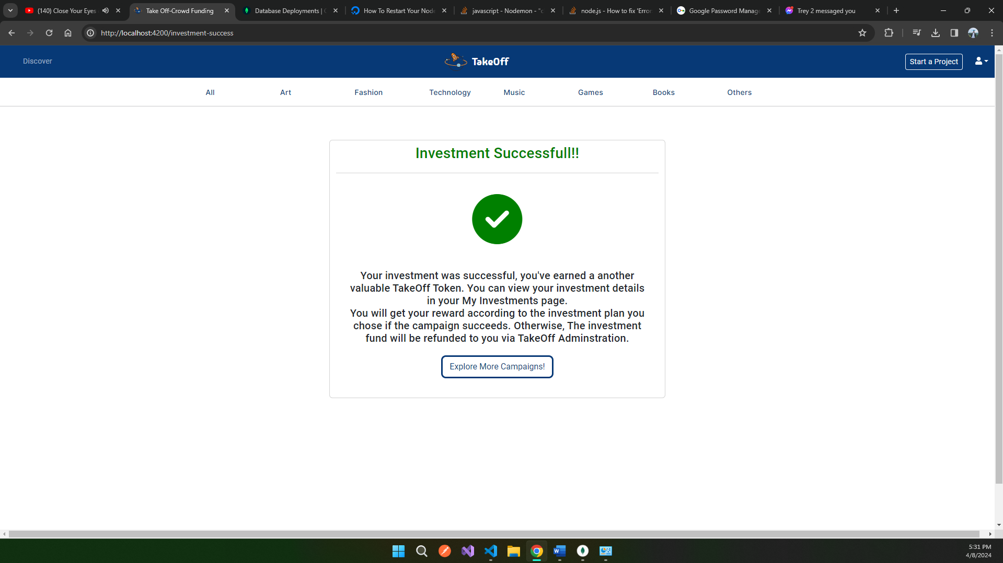

Here, in the above images we can see a prompt which asks for the amount to be pledged for the campaign. When a backer enters a certain amount and clicks on invest, he/she will be redirected to the esewa payment gateway and he/she can enter the esewa payment details to transfer the funds and will be redirected to the payment successful page.

Other Pages of Takeoff

Figure 57: Othe Pages Navigation

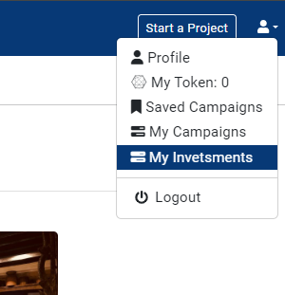

Here, in the above images, we can see there are other numbers of pages where users can visit their profile and check out the number of tokens. The site also contains pages to view the saved campaigns, created campaigns and investments of the user and see the status of every investment he/she has made.

Admin Dashboard of Takeoff

Figure 58: Admin Dashboard of Takeoff 1

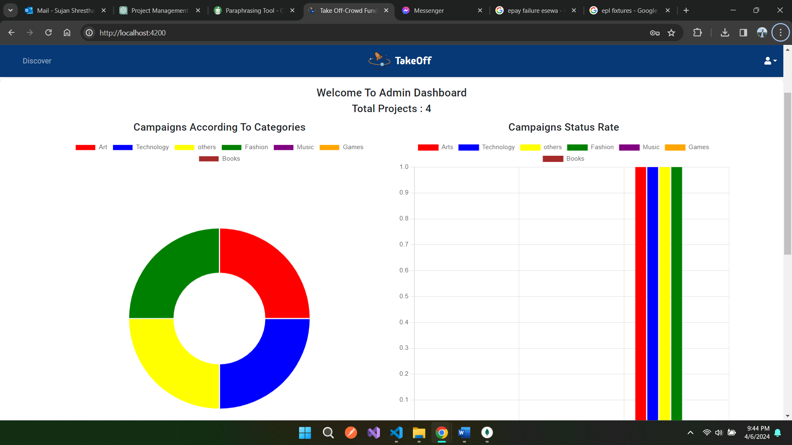

Figure 59: Admin Dashboard of Takeoff 2

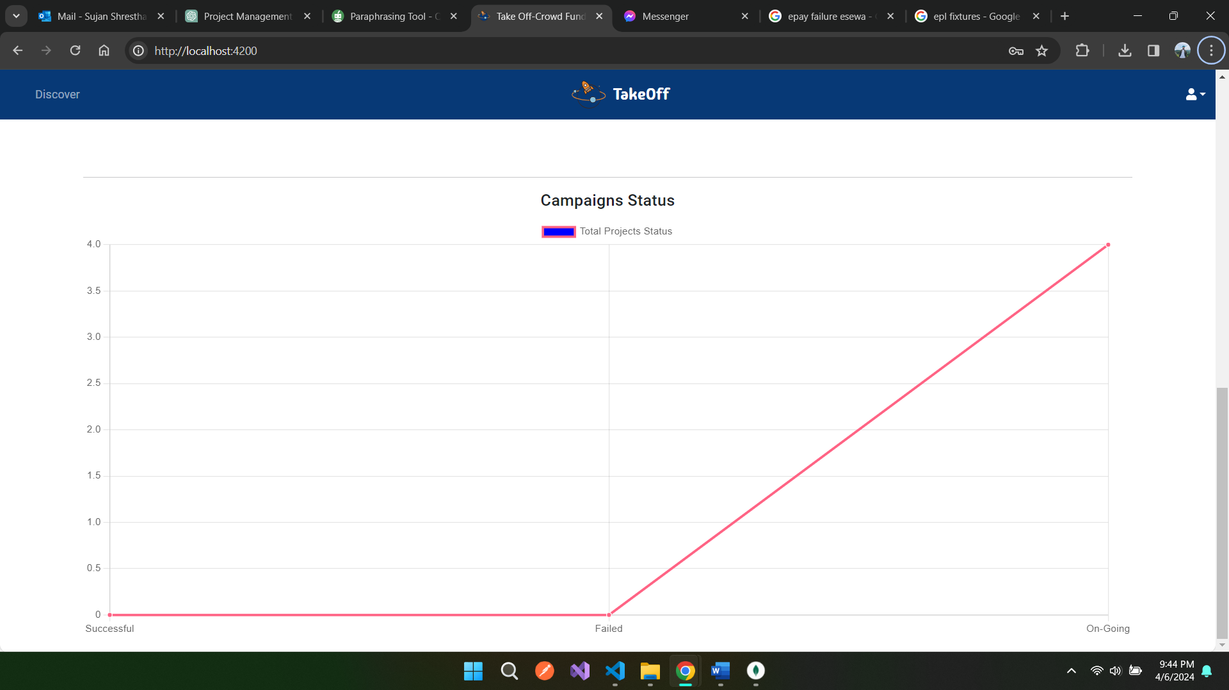

Here, the images above represent the admin panel/dashboard of the Takeoff crowdfunding platform, where we can see various data analytics charts which provide admin with numerous deep insights of the project or campaigns operating on the platform.

Admin Campaign Status and Reporting Tab

Figure 60: Admin Campaign Status and Reporting Tab

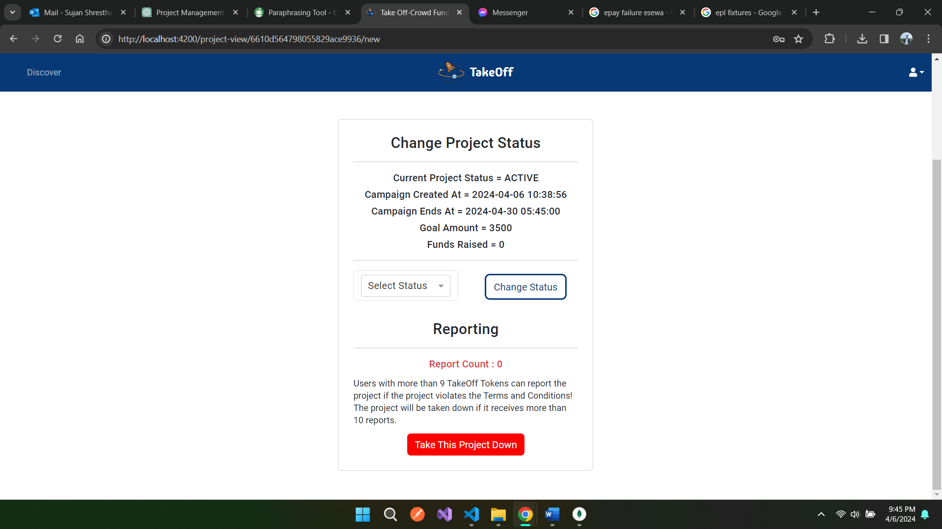

Here, we can see the page through which administrators can see the status and change the status of the whole campaign. Here, the reporting counts can also be seen which helps them in taking down fraudulent projects

## **Code Snippets**

Code Snippets of Registration

Figure 61: Registration HTML Code Snippets

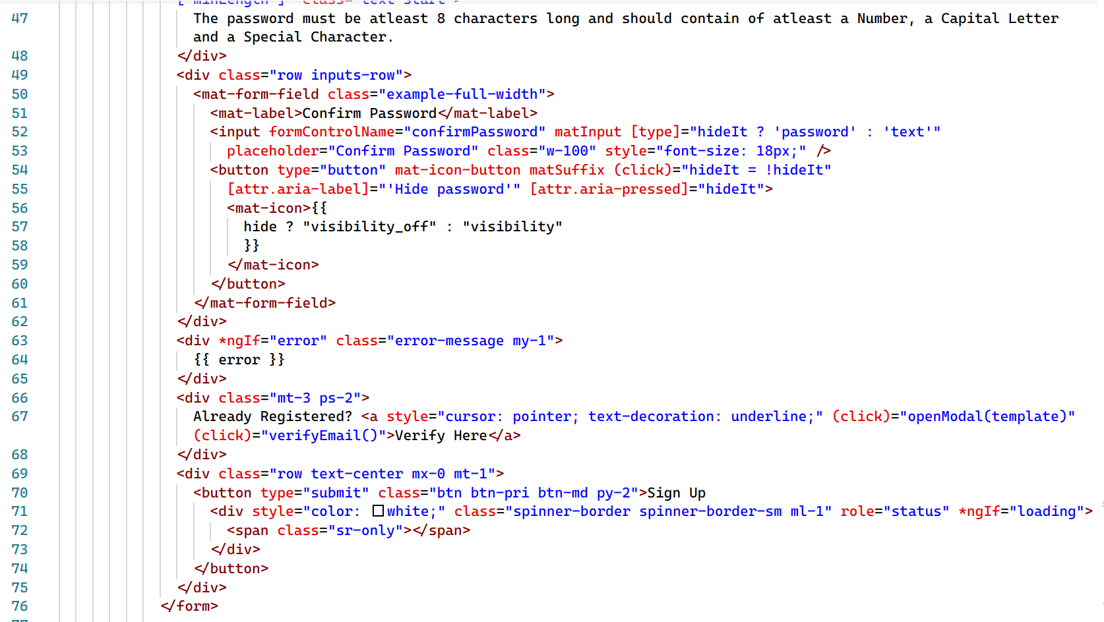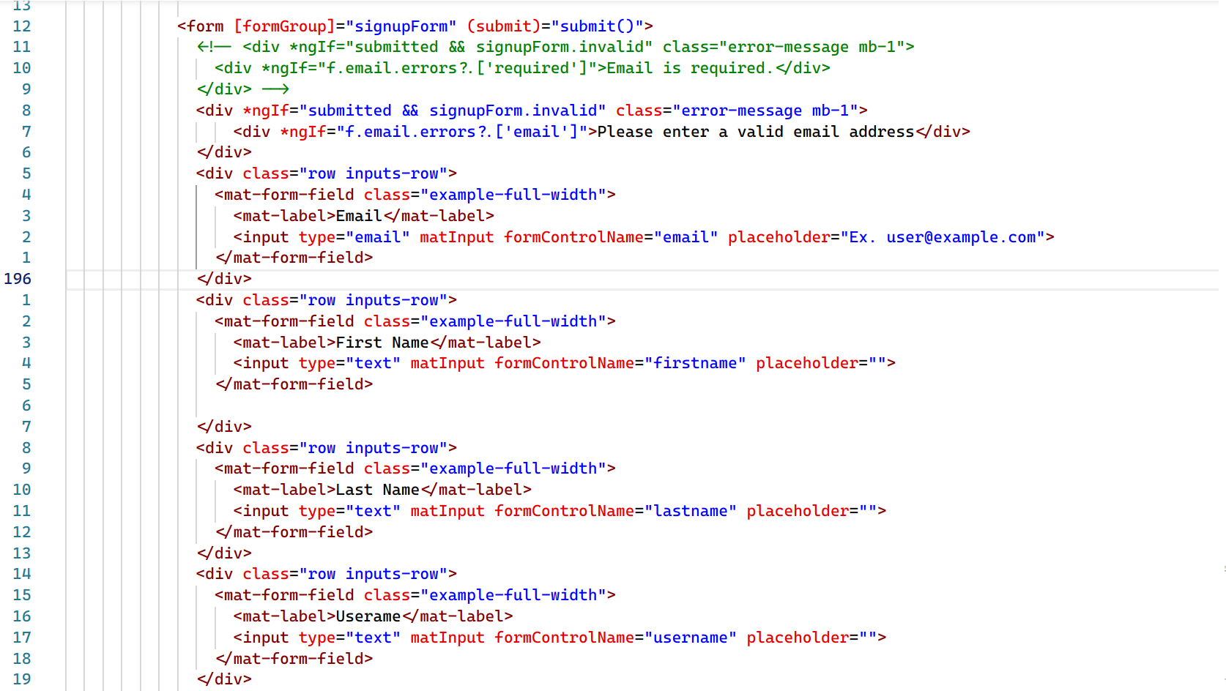

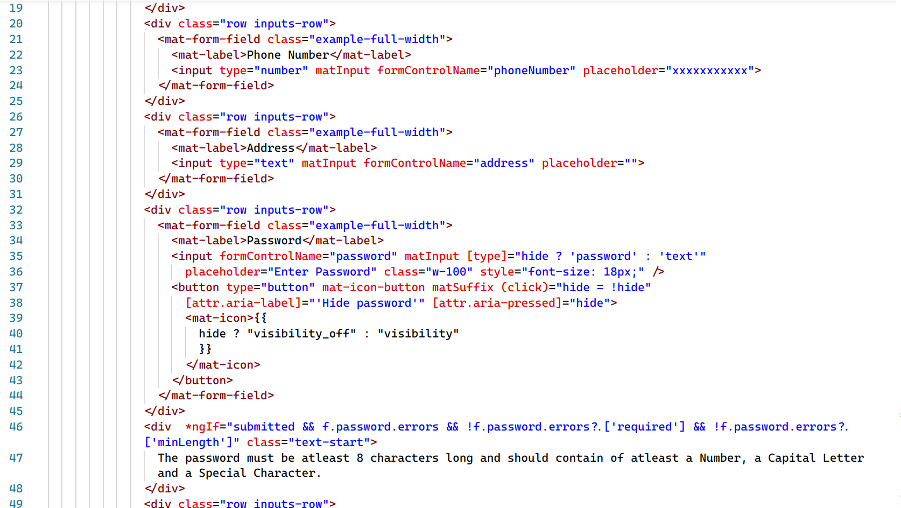

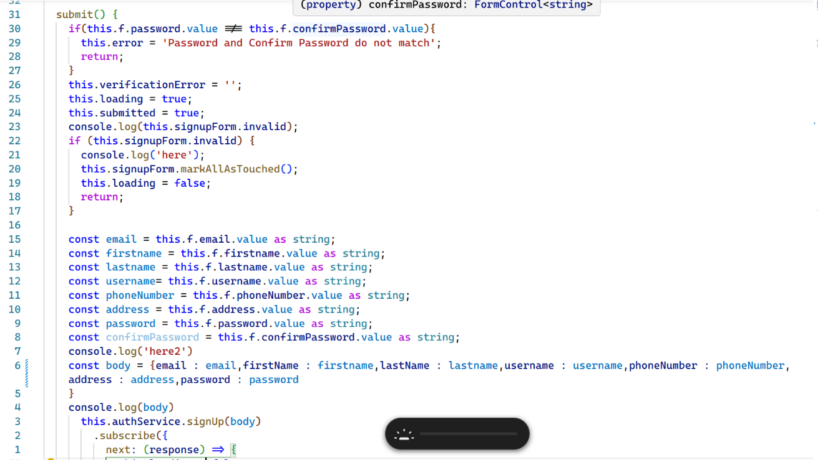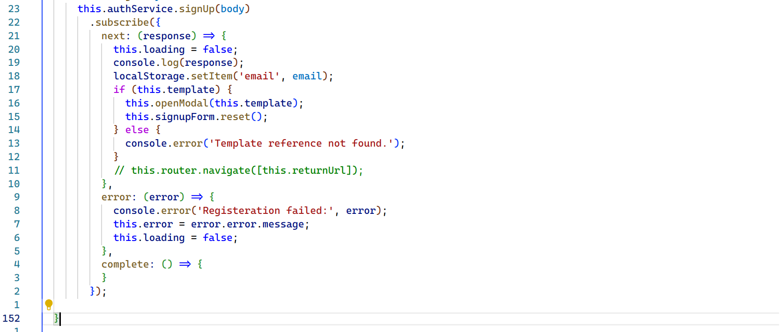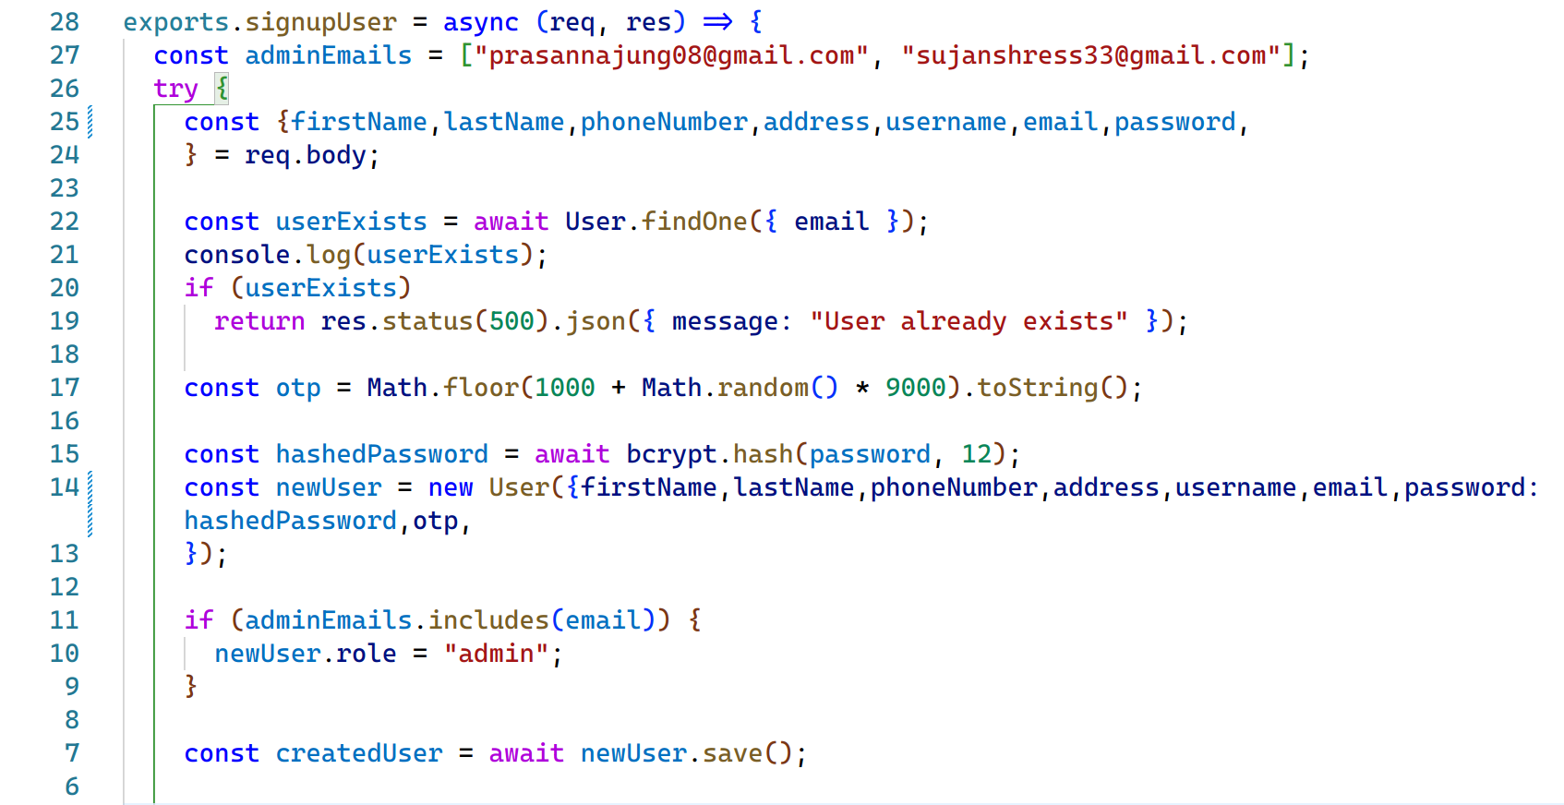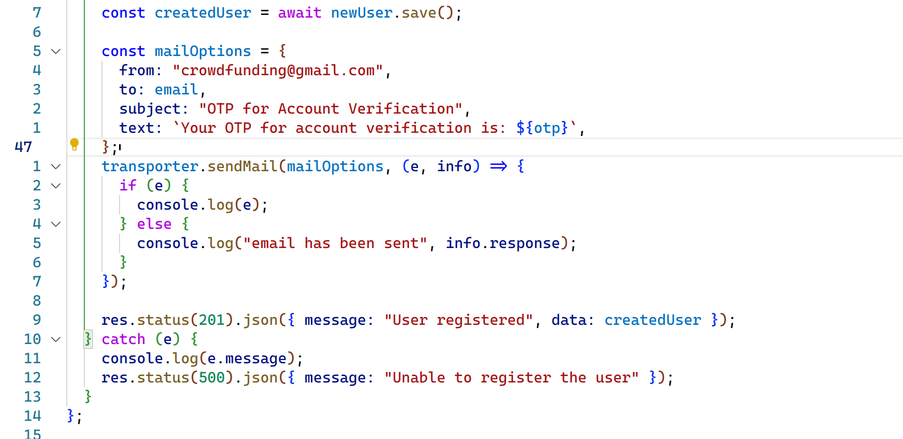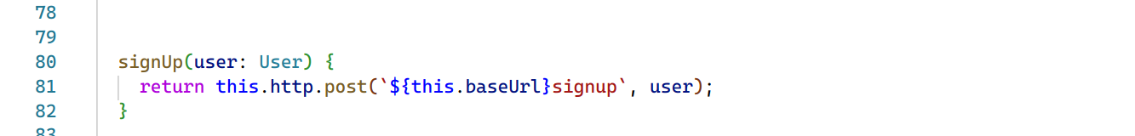

The snippets above represent codes related to the registration of User in Takeoff written in MEAN. The snippets above contain all the code written for registration from sending a form data to backend then sending a verification mail to the user.

Code Snippets of Login and Token Handling

Figure 62: Code Snippets of Login and Token Handling

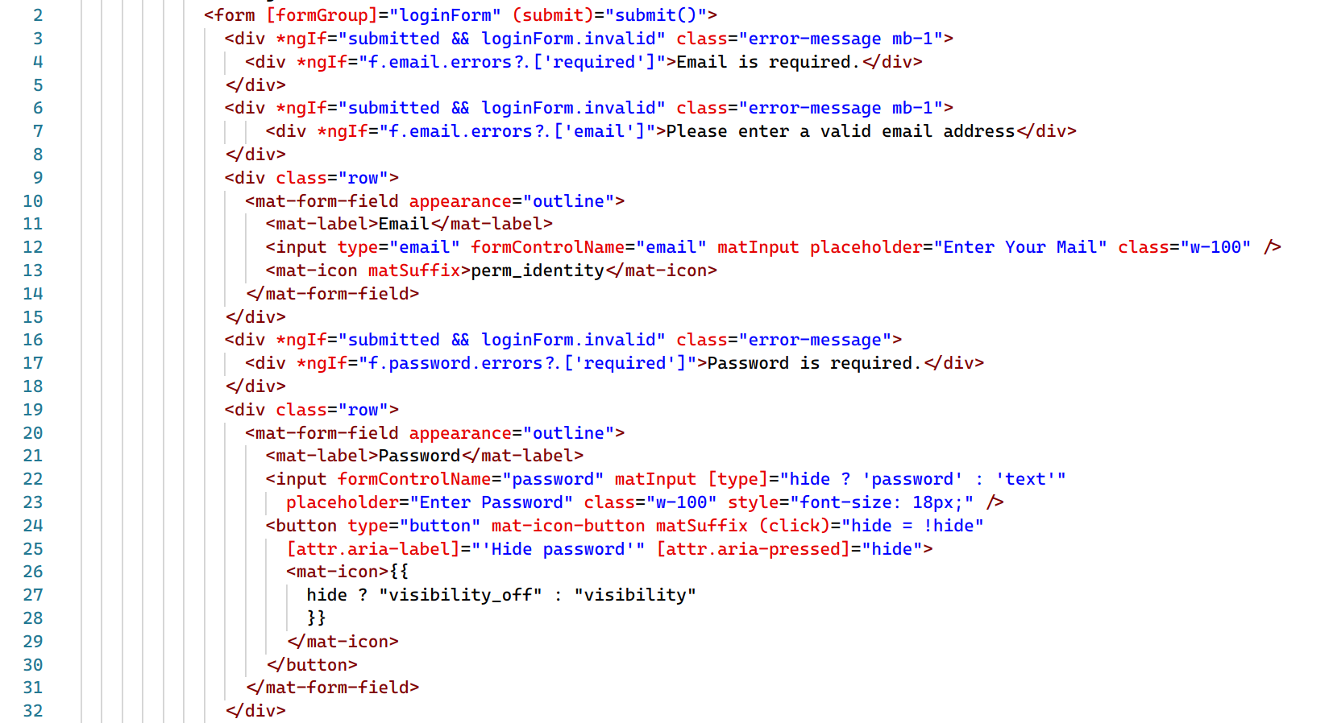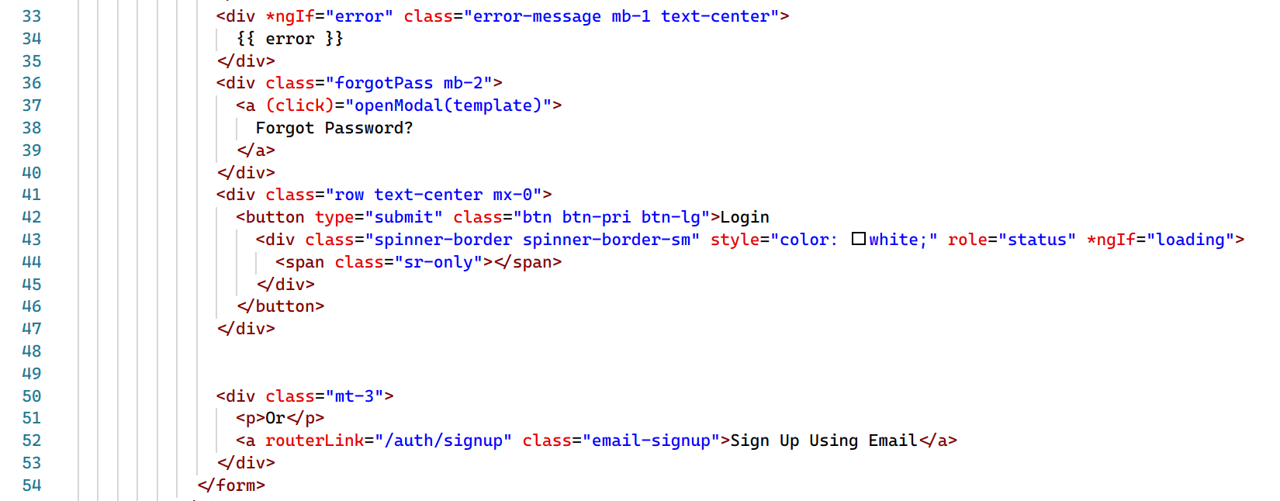

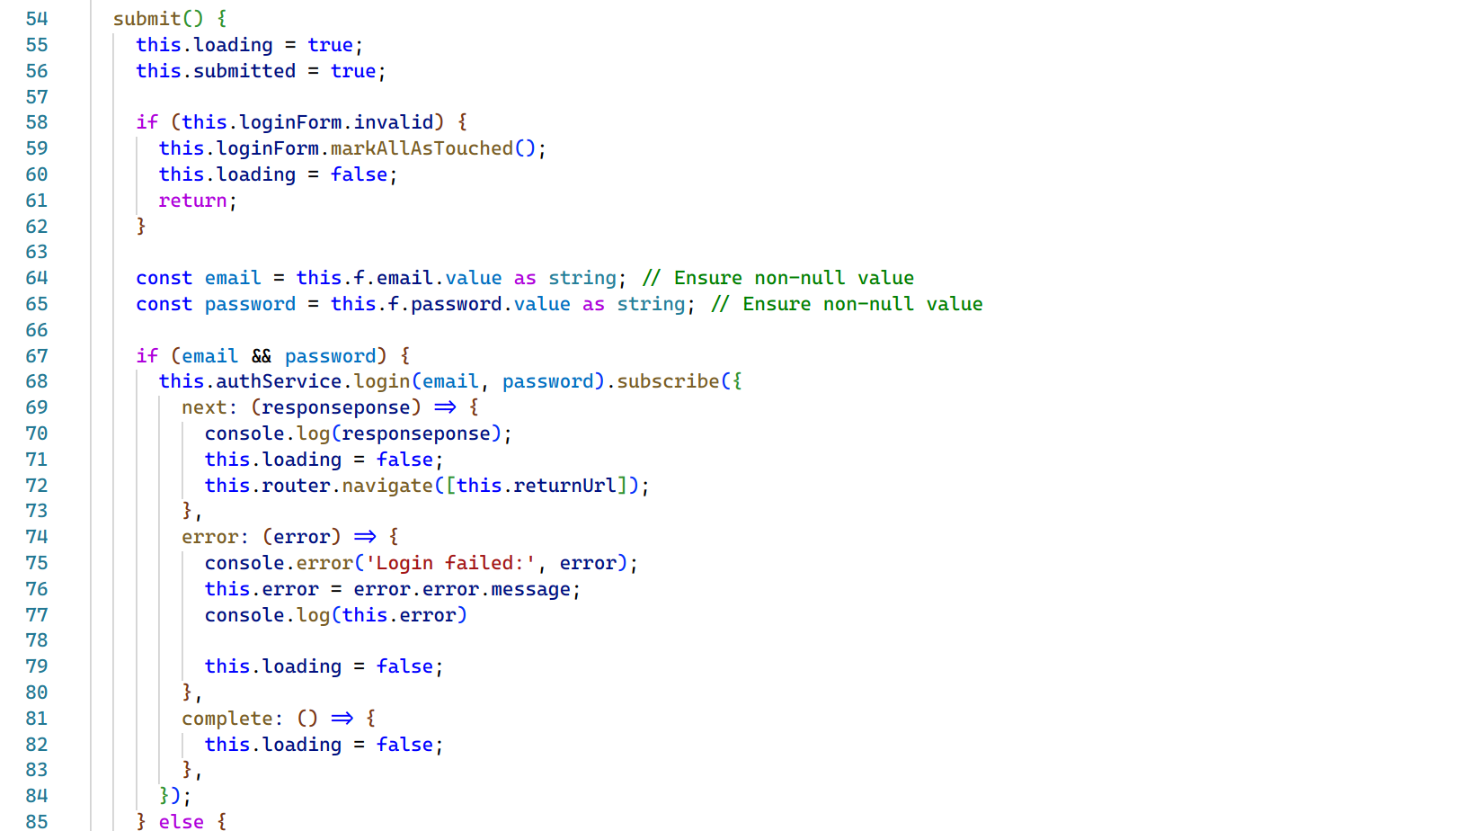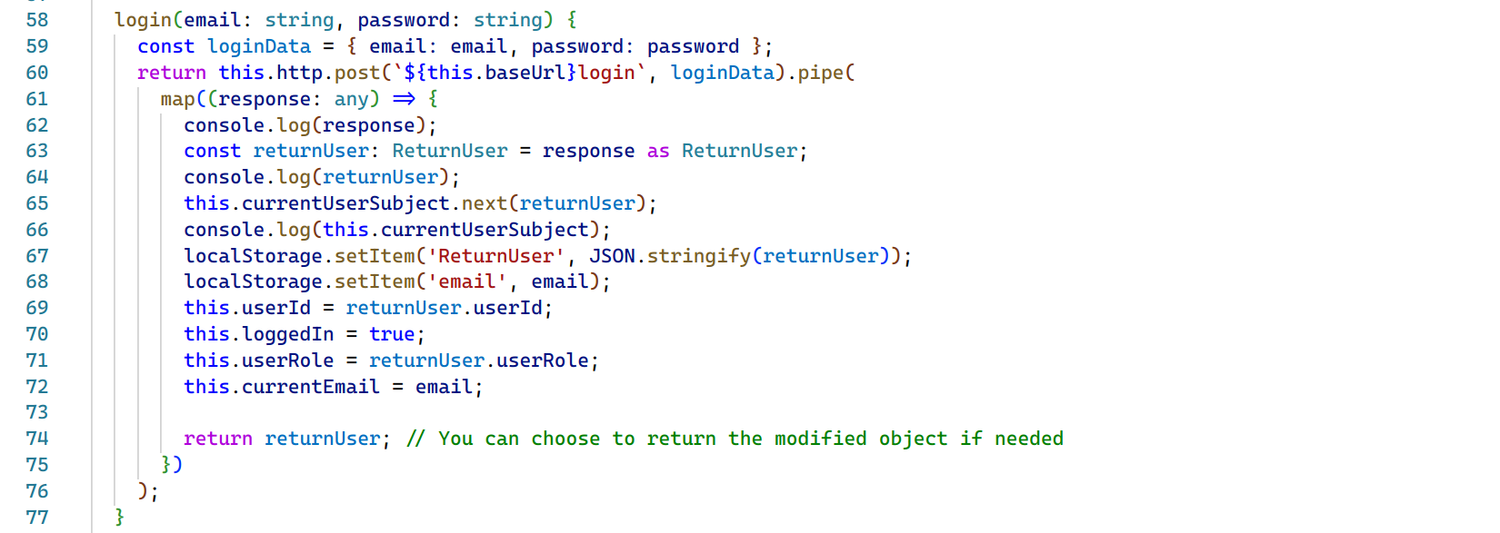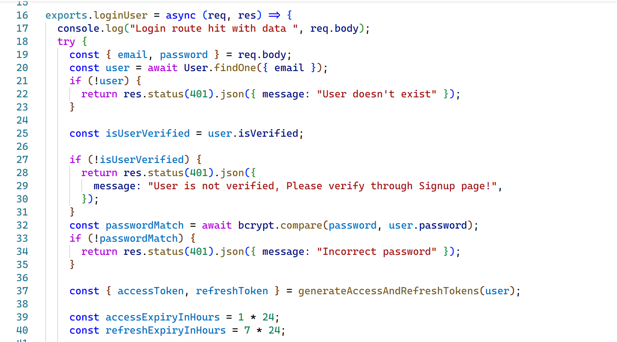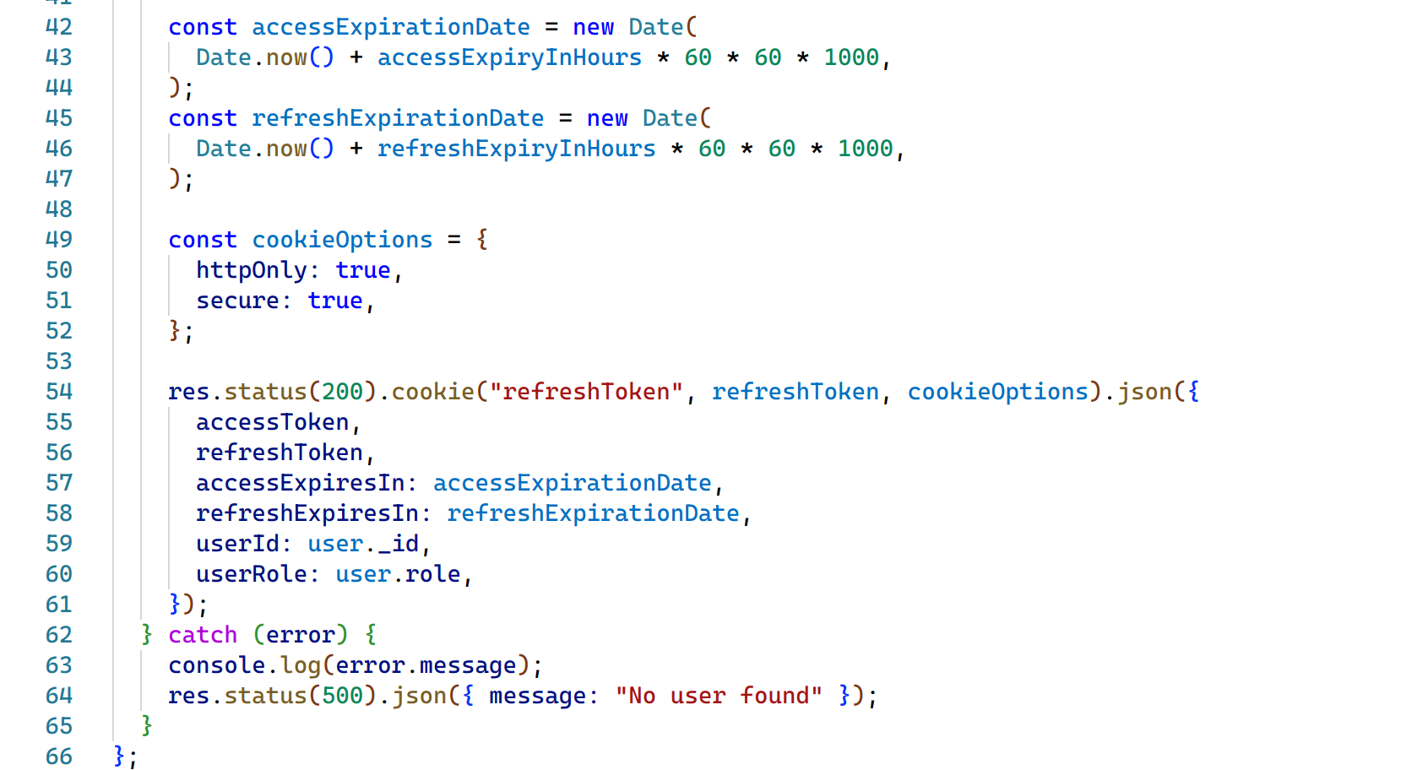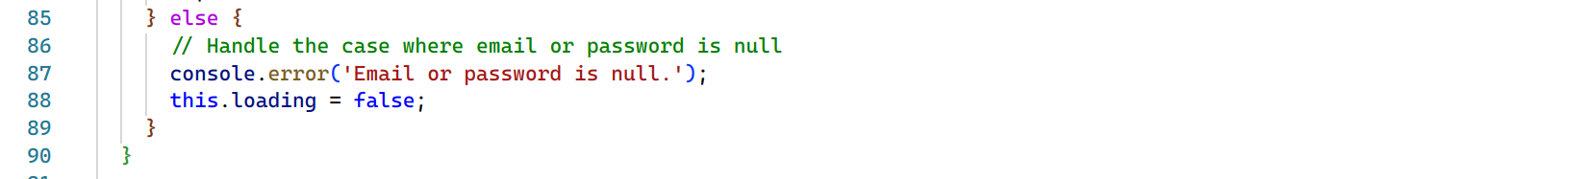

The above code snippets represent the codes written for Login or authentication of the user in Takeoff. Here, we can also see the token creation code and how token system works in Takeoff.

Project Creation Code Snippets

Figure 63: Code Snippets of Project Creation

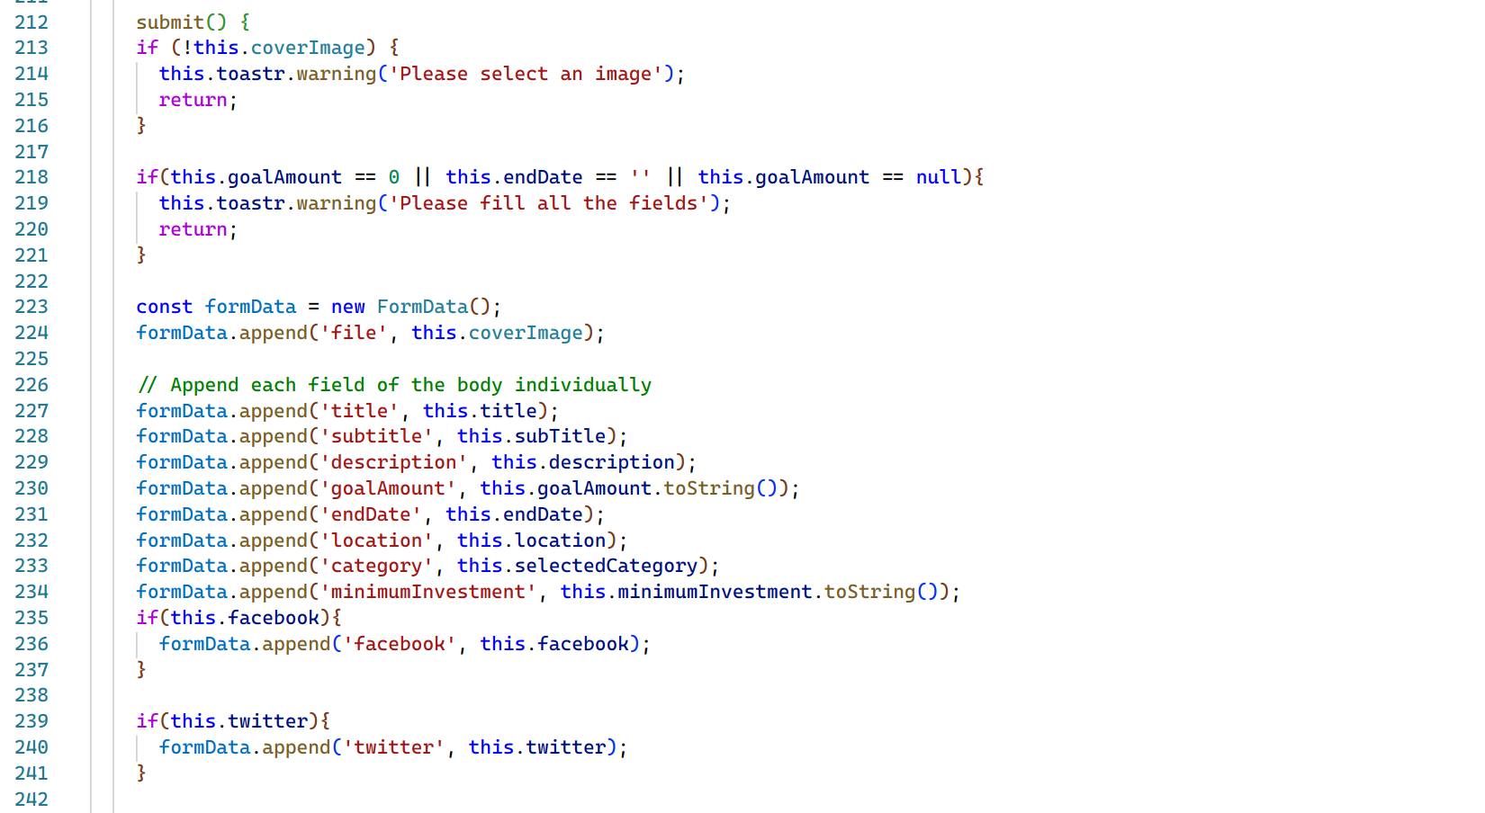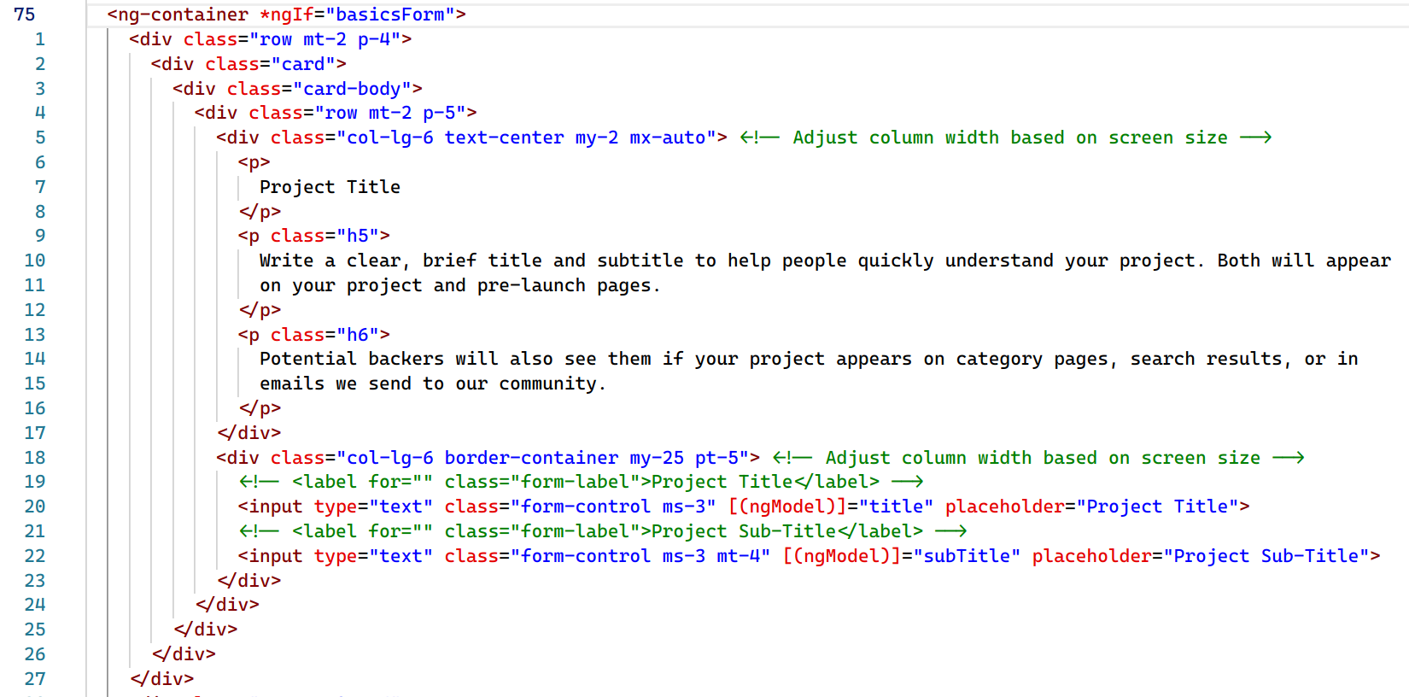

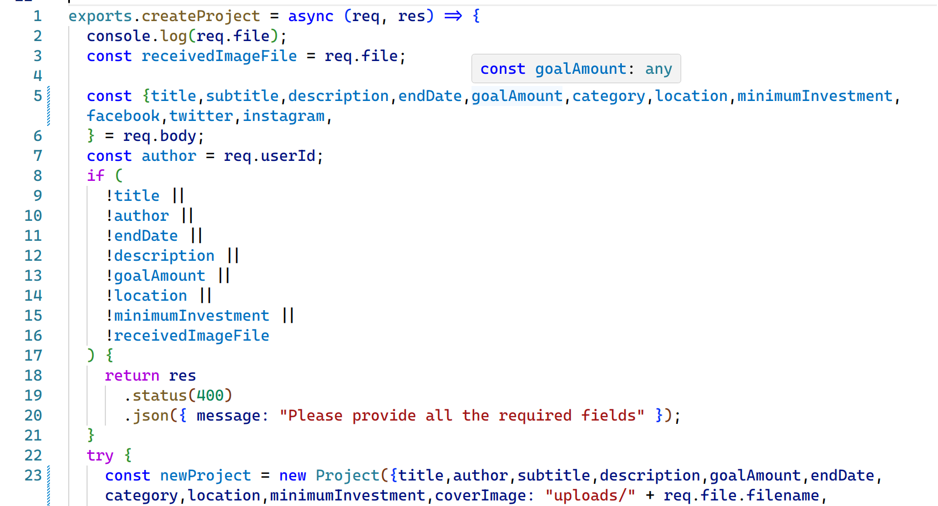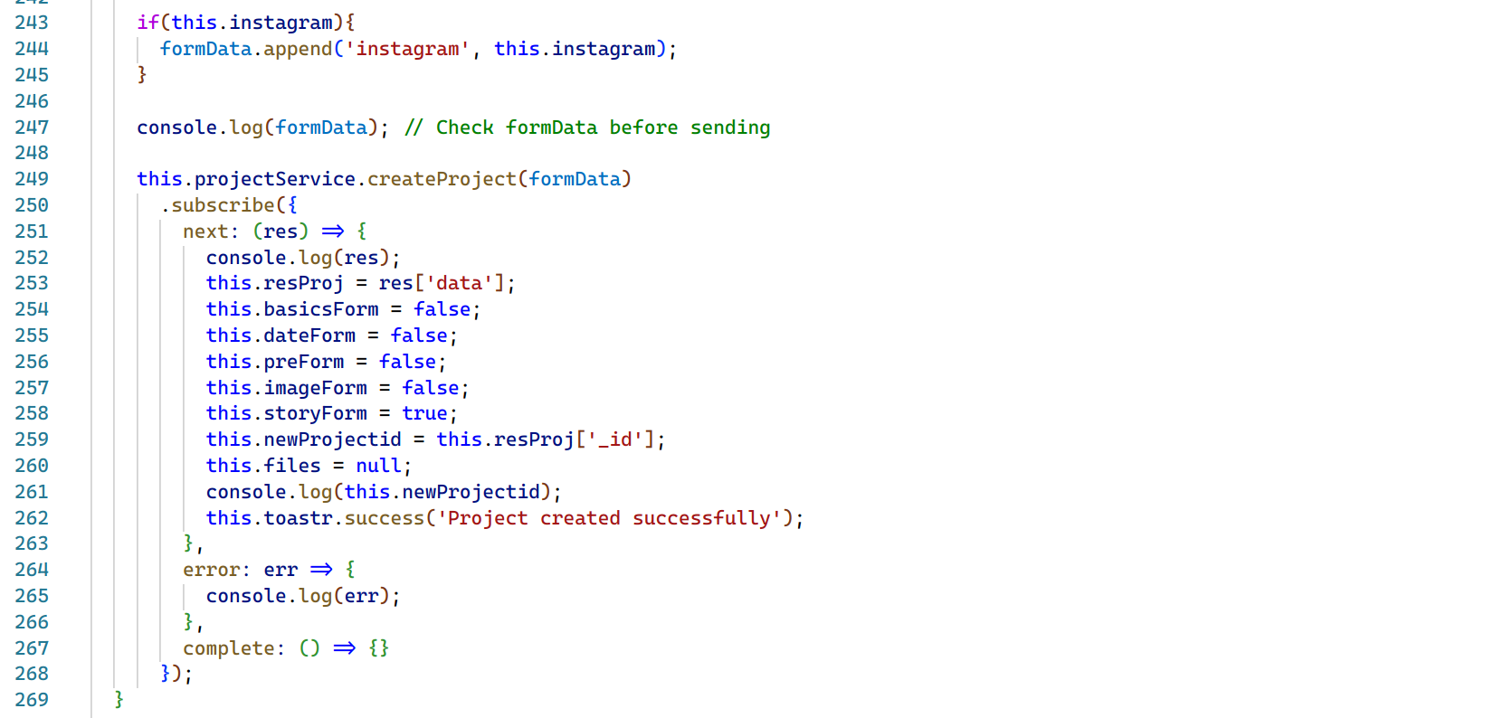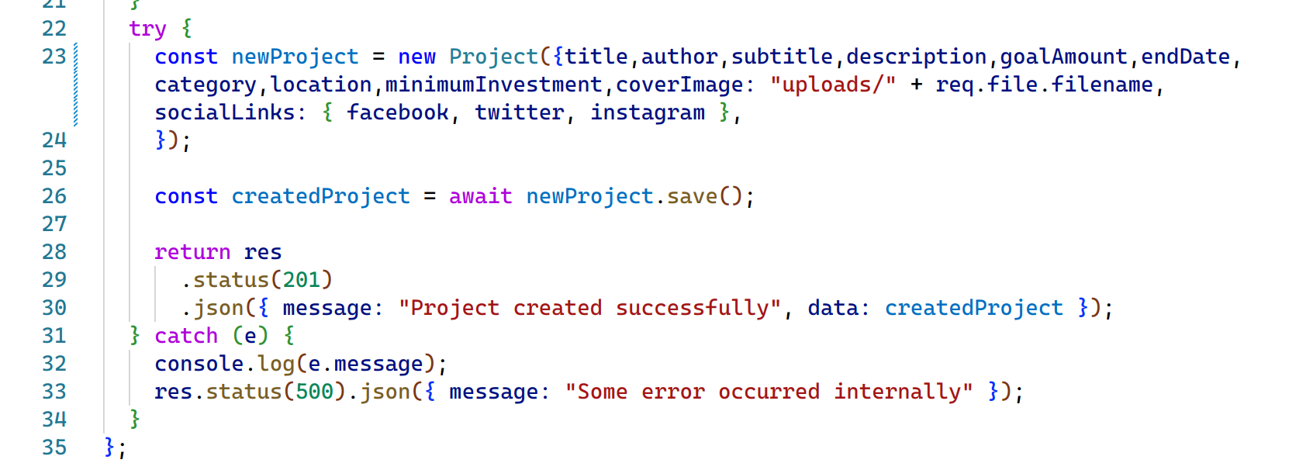

Above snippets show the overall code of how a user will be allowed to create project. Here we can see how the form data is passed through API between the Client and Server in order to store the project in our database and return it while getting the projects.

Investment Code Snippets

Figure 64: Code Snippets of Investmnet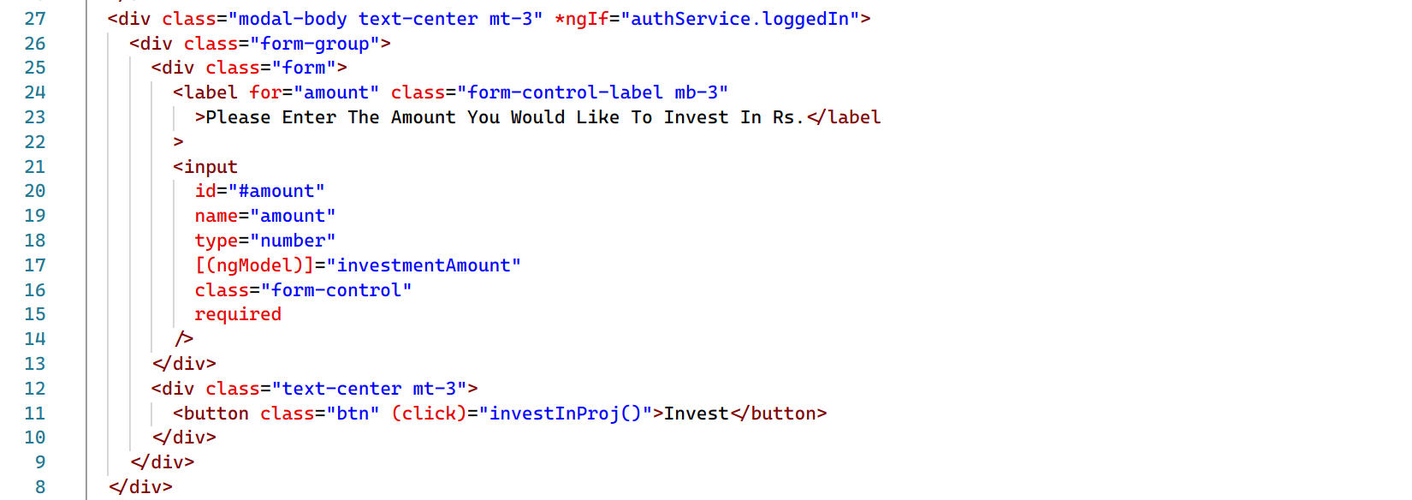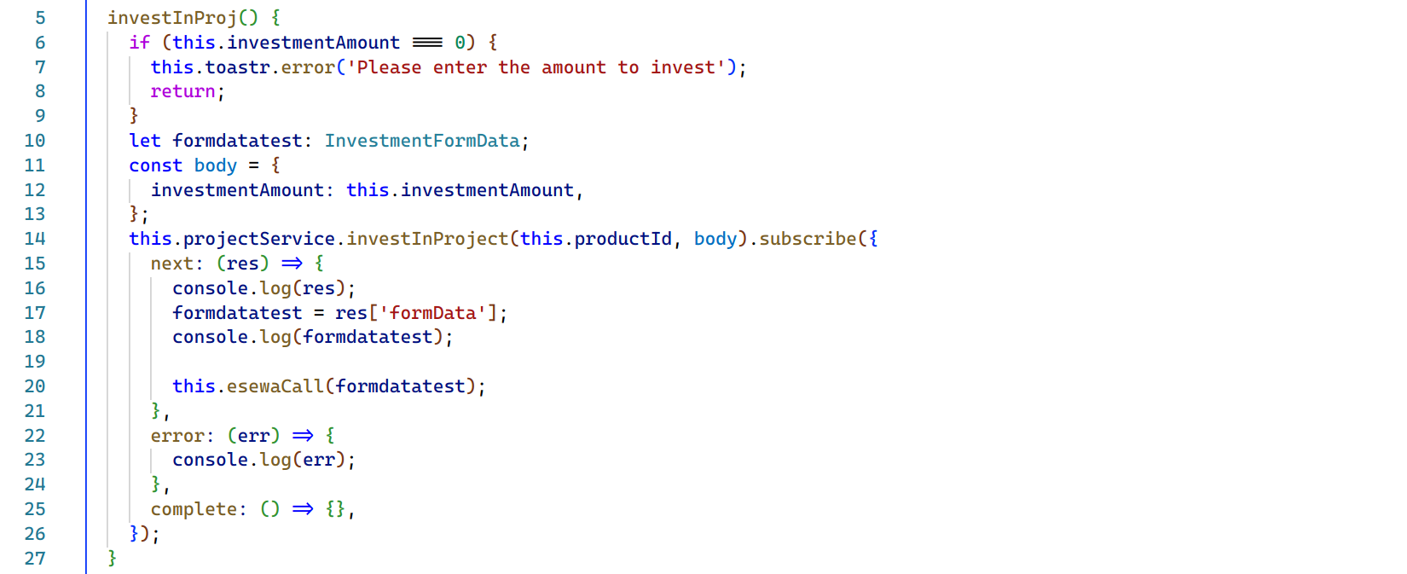

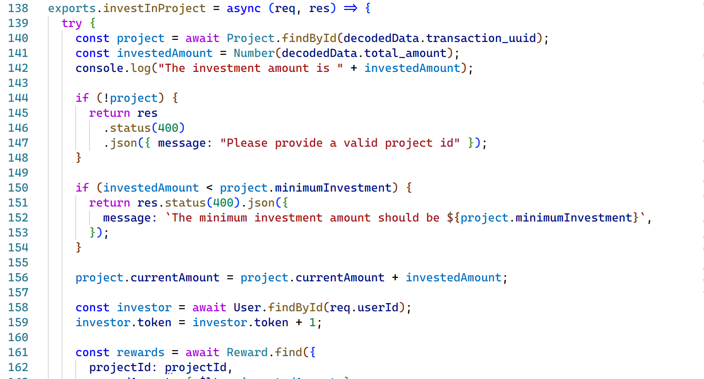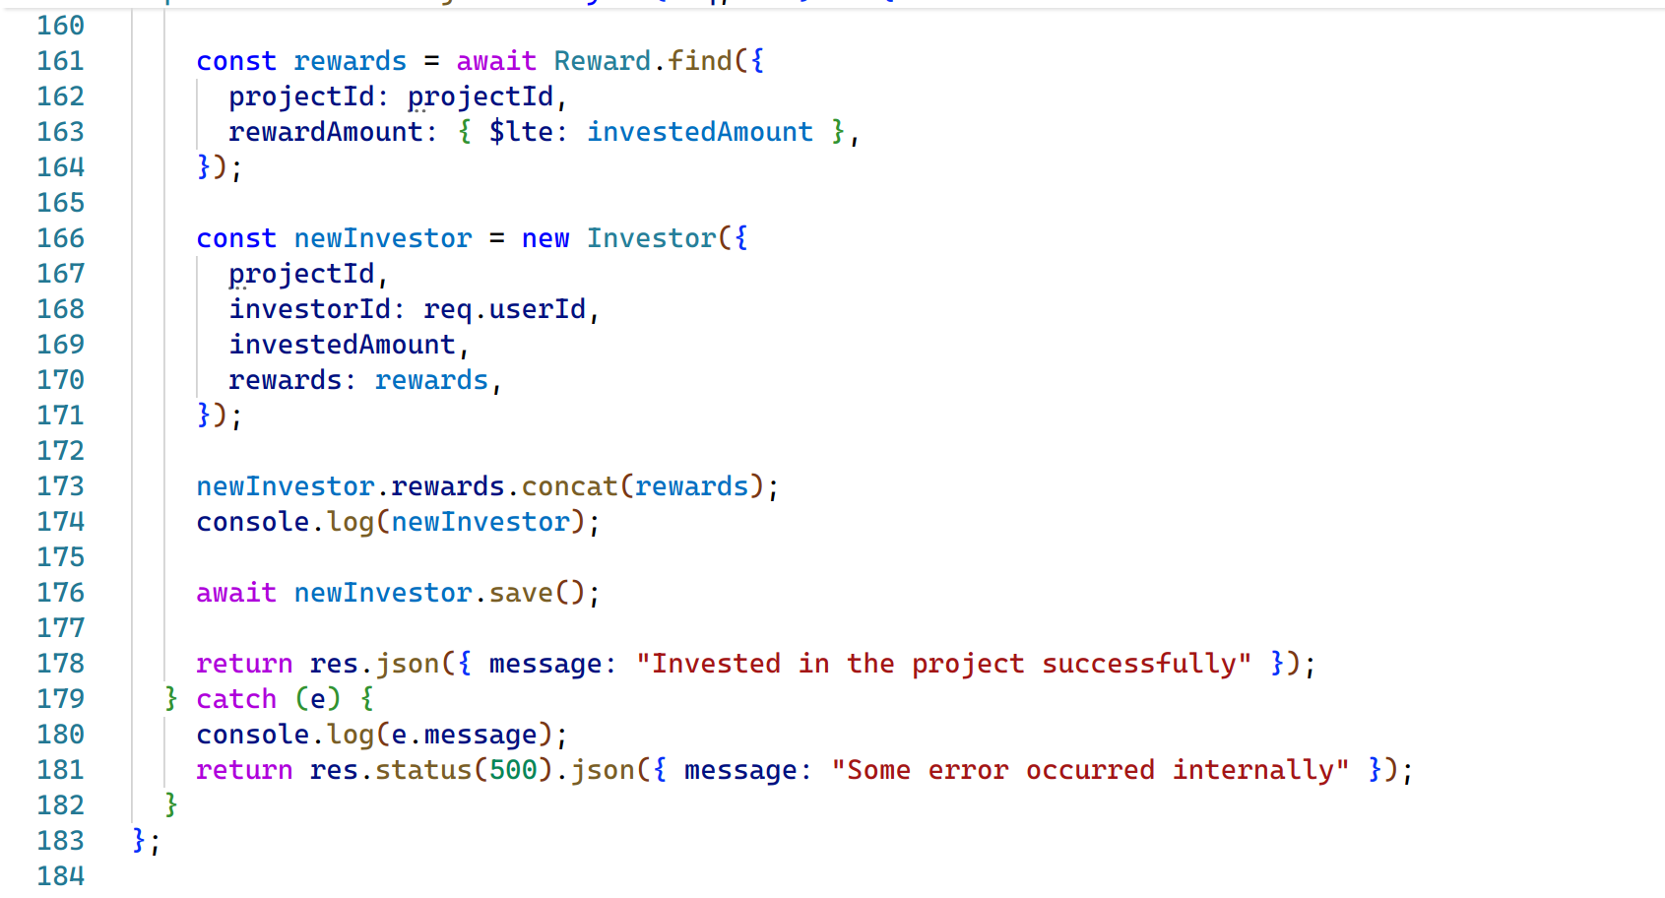Above code snippets represent the investment part of the Takeoff crowdfunding platform as we can observe, the investiInProject function in backend controller returns a link for a esewa payment gateway and creates a certain data required by the Esewa demo payment gateway in order to m make the investment part successful.

Media Assets Code Snippets

Figure 65: Code Snippets of Media Assets Upload

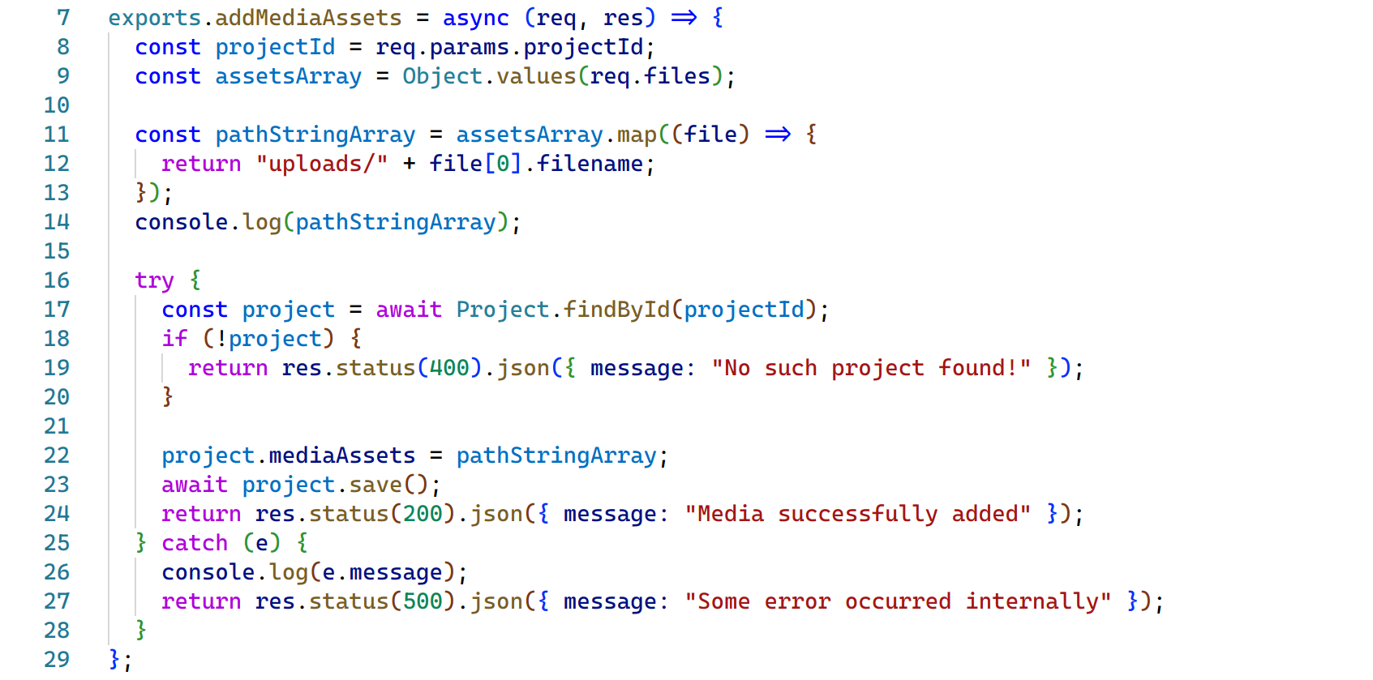

These are the code snippets of some of the important functionalities of the Takeoff Crowdfunding platform.

# **Chapter 9: System Validation**

# **Unit Test**

### ***Test Cases for Unit Testing***

Table 12: Test Cases for Unit Testing

|  |  |  |  |
| --- | --- | --- | --- |
| Test Case | Description | Test Steps | Expected Results |
| Login/Registration | Verify that user can successfully login and register into the system | 1. Provide valid user details such as name, email, and password. 2. Submit the details to the System | 1. In the registration part, User profile should be created successfully and will be redirected to Login page after Verification. 2. In login part, the user will be redirected to respective user dashboard |
| Project Creation | Ensure that a creator can create a project with all required information | 1. Provide valid project details including title, description, goal amount and other form data. 2. Upload proper media files as required. 3. Submit the project details to the system. | Project is created successfully, and the project should be visible on the platform for investors to view them |
| Investment in Project | Test whether investor can pledge towards a project | 1. Browse Available Projects. 2. Select a project of interest. 3. Choose a pledge amount and click on invest. 4. Connect investor’s esewa account with our esewa API. | Pledge is recorded successfully, and the investor receives confirmation of their contribution |
| Campaign Duration Setting | Test whether creators can set the duration of their fundraising campaigns. | 1. Create a new project. 2. Set specific data as an end date for their project | Campaign duration is set as per the creator’s specifications, and the project remains active for defined period. |
| Project Analytics Tracking for Admin | Ensure that project analytics accurately track categories which are being invested in highly. | 1. Monitor project analytics dashboard. 2. Verify that funding progress, investor engagement, and other metrics are updated in real time. | Project analytics should provide accurate and up to date information for administrators. |
| Transaction Handling | Test the measures implemented for financial transactions via Esewa. | 1. Initiate Financial Transaction 2. Verify the hashing process and secure payment is completed. | Financial transactions via Esewa are conducted securely without exposing sensitive information |
| Reward System Integration | Verify that creators can rewards to their project and backers will be given certain rewards after investment. | 1. Create rewards during project creation by creators. 2. Make a pledge towards a project that offers certain rewards. | 1. Project is created with added rewards. 2. Backers will get certain confirmation after the project with reward is successfully completed. |

## **User Acceptance Test**

### ***User Acceptance Test Forms***

Figure 66: UAT Form 1

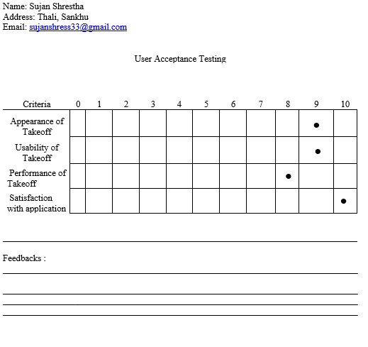

Figure 67: UAT Form 2

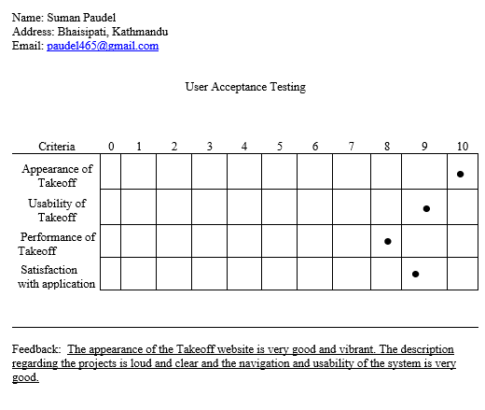

Figure 68: UAT Form 3

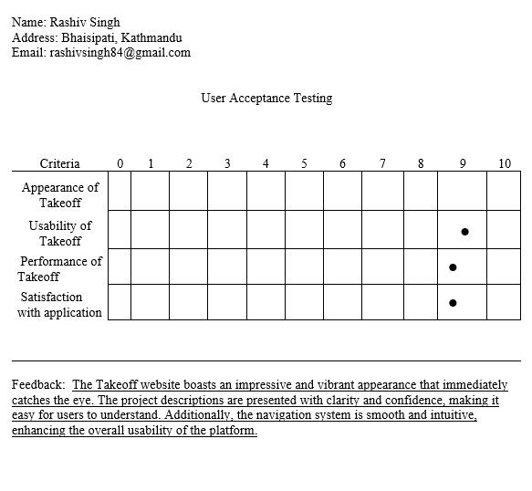

Figure 69: UAT Form 4

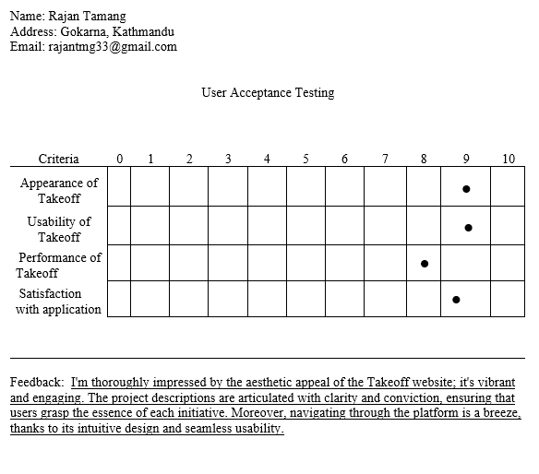

# **Chapter 10: Conclusion and Reflection**

The culmination of this crowdfunding project marks a significant milestone for developing a robust and user-friendly platform. Throughout the project’s development phase, I engaged in a thorough and critical testing and evaluation of the progress while addressing main and key components. The key components for this platform include functionality, usability, and effectiveness.

During the first phase of the project, I conducted extensive research to identify the needs and requirements of the type of users who will be engaged in such a crowdfunding platform. The groundwork of this project is done with the help of the research itself, ensuring that the platform addresses all key aspects and pertinent issues and provides solutions that resonate with the targeted users.

After the development phase, our platform’s functionality underwent a robust testing process through both unit testing and user acceptance testing (UAT), to validate the whole system. The tests that were conducted allowed us to identify and rectify any inconsistencies and bugs, ensuring that the platform operates smoothly under various circumstances. To ensure platform’s usability, we heavily focused on the user experience design, to create an intuitive and user-friendly interface which will facilitate a seamless navigation and interaction process. During the UAT, Feedback from the users was gathered in refining the user interface and optimize the platform’s usability, ultimately enhancing the performance of the platform.

At the conclusion of this project, I have successfully created a feature-rich crowdfunding platform that provides a showcasing platform for creator and investing opportunities for the backers. The system’s development initiated through investigation and research prior to and during the development phase of the system/ During the investigation and report phase, there were our further exploitation and improvement may be warranted. Specifically, additional deep research could be undertaken to gather deep insights into user preferences which would have allowed us to improve the feature enhancements and optimizations. The platform offers a intuitive set of facilities and functionalities such as campaign creation, investment opportunities, rewarding campaigns, and analytics of different project data, all of this within a very user friendly and secure environment. The successful implementation of the core features mentioned above with the successful establishment of secure transaction protocols to safeguard the transactions are some of the project’s achievements.

# **References**

Alexander Brem c, C.-F. C.-L. (2016, January 10). Strategies for reward-based crowdfunding campaigns. doi:https://doi.org/10.1016/j.jik.2016.01.010

Althoff, T. (2015, March 9). Donor Retention in Online Crowdfunding Communities: A Case Study of DonorsChoose. *A Case Study of DonorsChoose*. doi:https://doi.org/10.48550/arXiv.1503.02729

Bin Gu, L. H. (2019, June 12). Product-driven Entrepreneurs and Crowdfunding. Retrieved February 14, 2023, from https://aisel.aisnet.org/pacis2019/39

Biryukov, P. (2017). Deanonymisation of clients in Bitcoin P2P network. *Proceedings of the 2014 ACM SIGSAC Conference on Computer and Communications Security*, 15-29. Retrieved April 7, 2024

Coakley, J. (2022). Strategic entrepreneurial choice between competing crowdfunding platforms. 1794–1824. Retrieved December 10, 2023, from https://link.springer.com/article/10.1007/s10961-021-09891-0

E, R., & Wheat, J. R. (2013, February). Trends in Ecology & Evolution. *Raising money for scientific research through crowdfunding, 28*(2), 71-72. Retrieved March 1, 2023, from https://www.sciencedirect.com/science/article/abs/pii/S0169534712002984

Elizabeth M. Gerber, J. S.-Y. (2010). Why People Are Motivated to Post and. *Crowdfunding*. Retrieved December 7, 2023, from https://www.researchgate.net/profile/Pei-Yi-patricia-Kuo/publication/261359489_Crowdfunding_Why_People_are_Motivated_to_Post_and_Fund_Projects_on_Crowdfunding_Platforms/links/00463533f6db1c5c01000000/Crowdfunding-Why-People-are-Motivated-to-Post-and-Fund-

Eunjun Jung, J. H. (2022, May). Technological Forecasting and Social Change. *Effective strategies to attract crowdfunding investment based on the novelty of business ideas, 178*. doi:https://doi.org/10.1016/j.techfore.2022.121558

Gabor Kiss, M. S. (2014, January 1). Exploratory Study on Technology related Successfully Funded Crowdfunding Projects. Retrieved February 14, 2023, from https://core.ac.uk/reader/289946610

Gallemore, C. (2019, April 13). The uneven geography of crowdfunding success. *Spatial capital on Indiegogo*. doi:https://doi.org/10.1177/0308518X19843925

Gómez-Diago, G. (2015). Creativity in the Digital Age. *Communication in Crowdfunding Online Platforms*. doi:https://doi.org/10.1007/978-1-4471-6681-8_10

Gongbing Bi, Q. X. (2019, September 18). The role of crowdfunding platforms. *Decision strategies in reward-based crowdfunding*. doi:https://doi.org/10.1108/JM2-10-2018-0179

Greenbaerg, M. (2017). Administrative Science Quarterly. *Activist choice homophily and the crowdfunding of female founders*, 341-374. Retrieved April 7, 2024

Hornuf. (2018). Market mechanisms and funding dynamics in equity crowdfunding. *Entrepreneurship Theory and Practice*, 467-497. Retrieved April 7, 2024, from https://onlinelibrary.wiley.com/doi/full/10.1111/etap.12252

Jensen, L. S. (2018, October 23). Identifying challenges in crowdfunded product development. *a review of Kickstarter projects*. doi:https://doi.org/10.1017/dsj.2018.14

Jialiang Yang, G. C. (2020, September). Journal of Business Researc68. *How multimedia shape crowdfunding outcomes: The overshadowing effect of images and videos on text in campaign information, 117*, 6-18. doi:https://doi.org/10.1016/j.jbusres.2020.05.008

Kabil Nageswarakurukkal, P. G. (2018). Improving Fundraising Efficiency in Small and Medium Sized Non-profit Organizations Using Online Solutions. doi:https://doi.org/10.1080/10495142.2019.1589627

Koch, J.-A. (2016, July 15). alyzing the Drivers of Overfunding. *The Phenomenon of Project Overfunding on Online Crowdfunding Platforms*. Retrieved December 7, 2023, from https://papers.ssrn.com/sol3/papers.cfm?abstract_id=2808427

Kromidha, E. (2015, November). A comparative analysis of online crowdfunding platforms in USA, Europe and Asia. doi:10.1109/eCHALLENGES.2015.7441070

Mannan, L. (2018). EEE International Conference on Trust, Security and Privacy in Computing and Communications. *Blockchain technology in crowdfunding*, 1201-1208. Retrieved April 7, 2024, from https://ieeexplore.ieee.org/document/8456302

Michael Siering, J.-A. K. (2016, July 15). The Characteristics of Successfully Funded Projects on Crowdfunding Platforms. *Crowdfunding Success Factors*. Retrieved Dec 7, 2023, from https://papers.ssrn.com/sol3/papers.cfm?abstract_id=2808424

Mollick. (2014). The dynamics of crowdfunding. *Journal of Business Venturing*, 1-16. Retrieved April 7, 2024, from https://www.sciencedirect.com/science/article/pii/S0883902613001032

Peter Konhausner, B. S. (2021). A Comparative Perspective of Germany and China. *Application of the 4Es in Online Crowdfunding Platforms*. Retrieved December 7, 2023, from https://www.mdpi.com/1911-8074/14/2/49

Rachel E. Wheat, Y. W. (2012, November 1). *Raising money for scientific research through crowdfunding*. doi:https://doi.org/10.1016/j.tree.2012.11.001

Regner, T. (2021). an analysis of the membership platform Patreon. *Crowdfunding a monthly income*, 133–142. Retrieved December 12, 2023, from https://link.springer.com/article/10.1007/s10824-020-09381-5

Stanko, M. A. (2017, May). Research Policy. *Toward a better understanding of crowdfunding, openness and the consequences for innovation, 46*(4). doi:https://doi.org/10.1016/j.respol.2017.02.003

Stiver, A. (2013, September 1). Crowdfunding and Online Community:. *Crowdfunding and Online Community*. Retrieved February 14, 2023, from https://files.core.ac.uk/pdf/86/82977744.pdf

Winarno, A. (2018, April 13). The First International Research Conference on Economics and Business. *The Performance of Crowdfunding Models an Alternative Funding Source*. doi:10.18502/kss.v3i3.1871

Xiaochen Liu, Q. Y. (2022, December). Information & Management. *Product sampling on reward-based crowdfunding platforms, 59*(8). doi:https://doi.org/10.1016/j.im.2022.103718

Zhang, X. (2021, June). What Contributes to a Crowdfunding Campaign's Success? *Evidence and Analyses from GoFundMe Data*. doi:https://doi.org/10.23919/JSC.2021.0010

# **Appendices**

## **Turnitin Report**

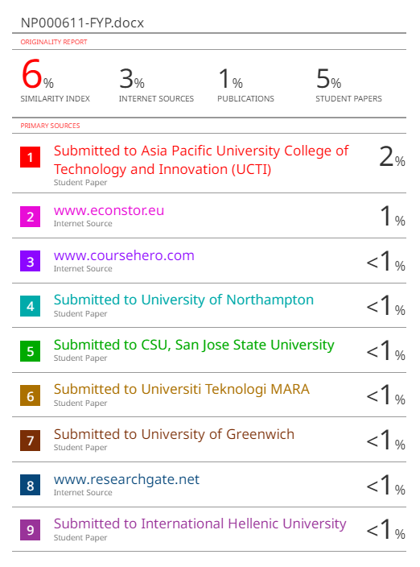

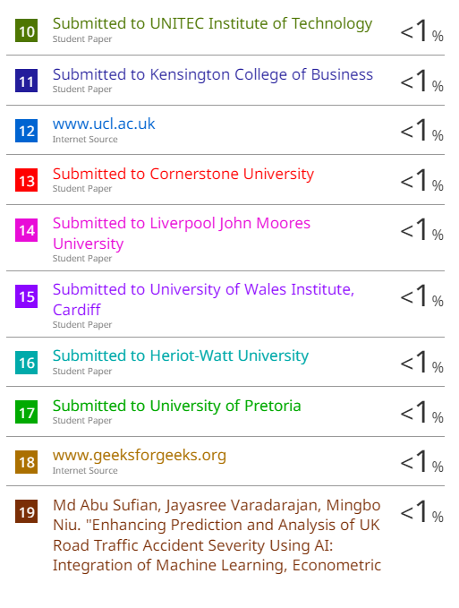

## **FYP Poster**

Figure 70: FYP Poster

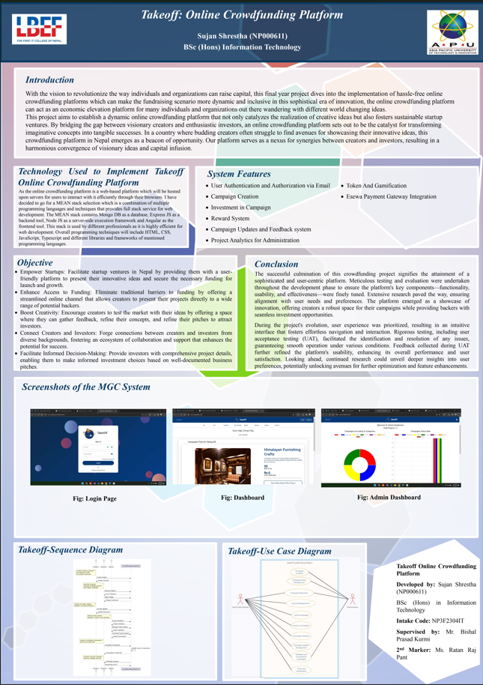

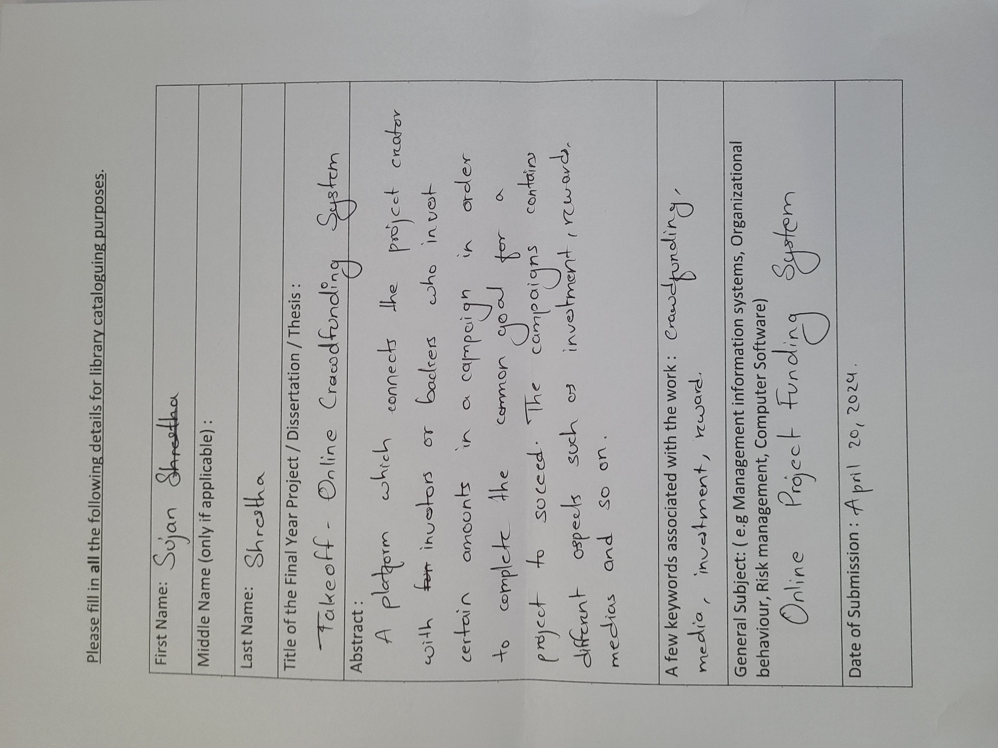

## **Meeting Log sheets**

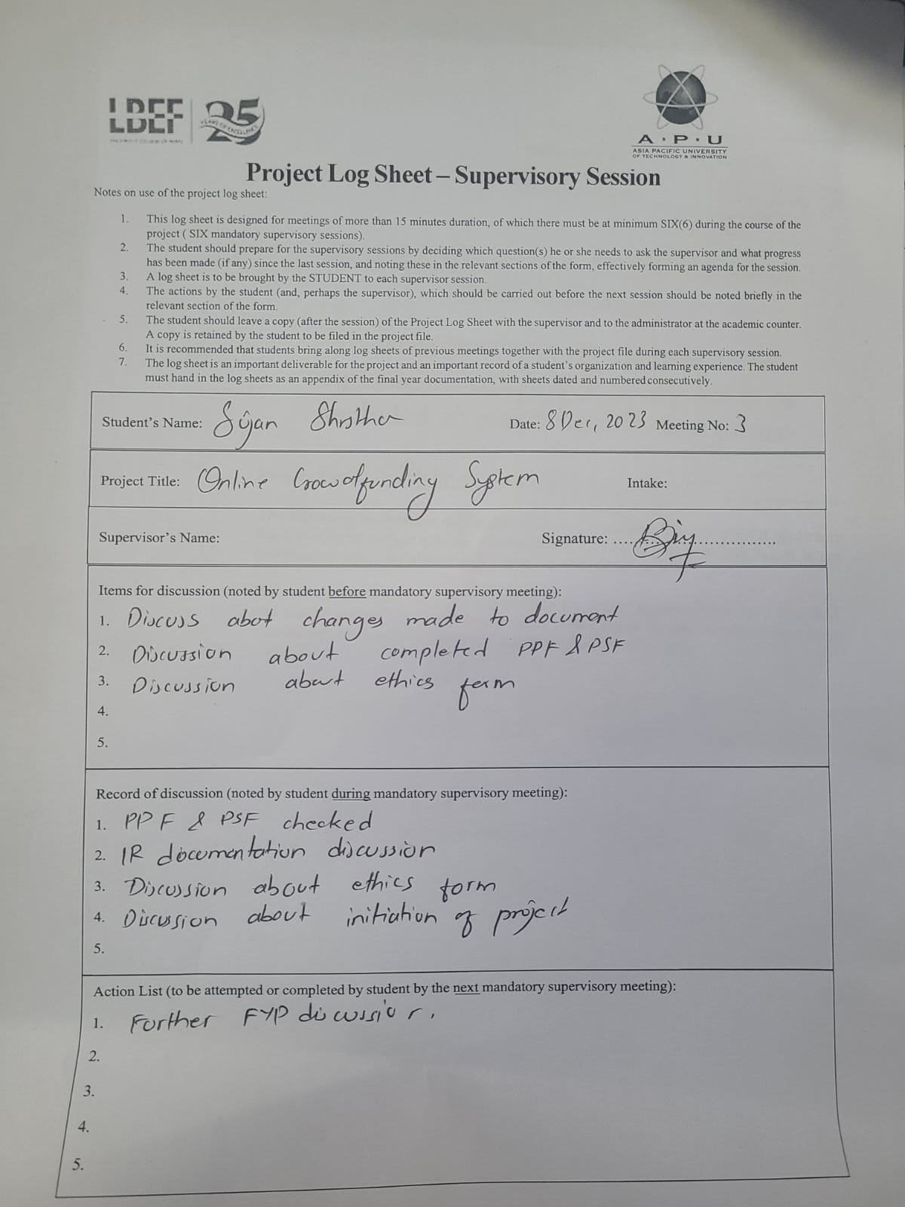

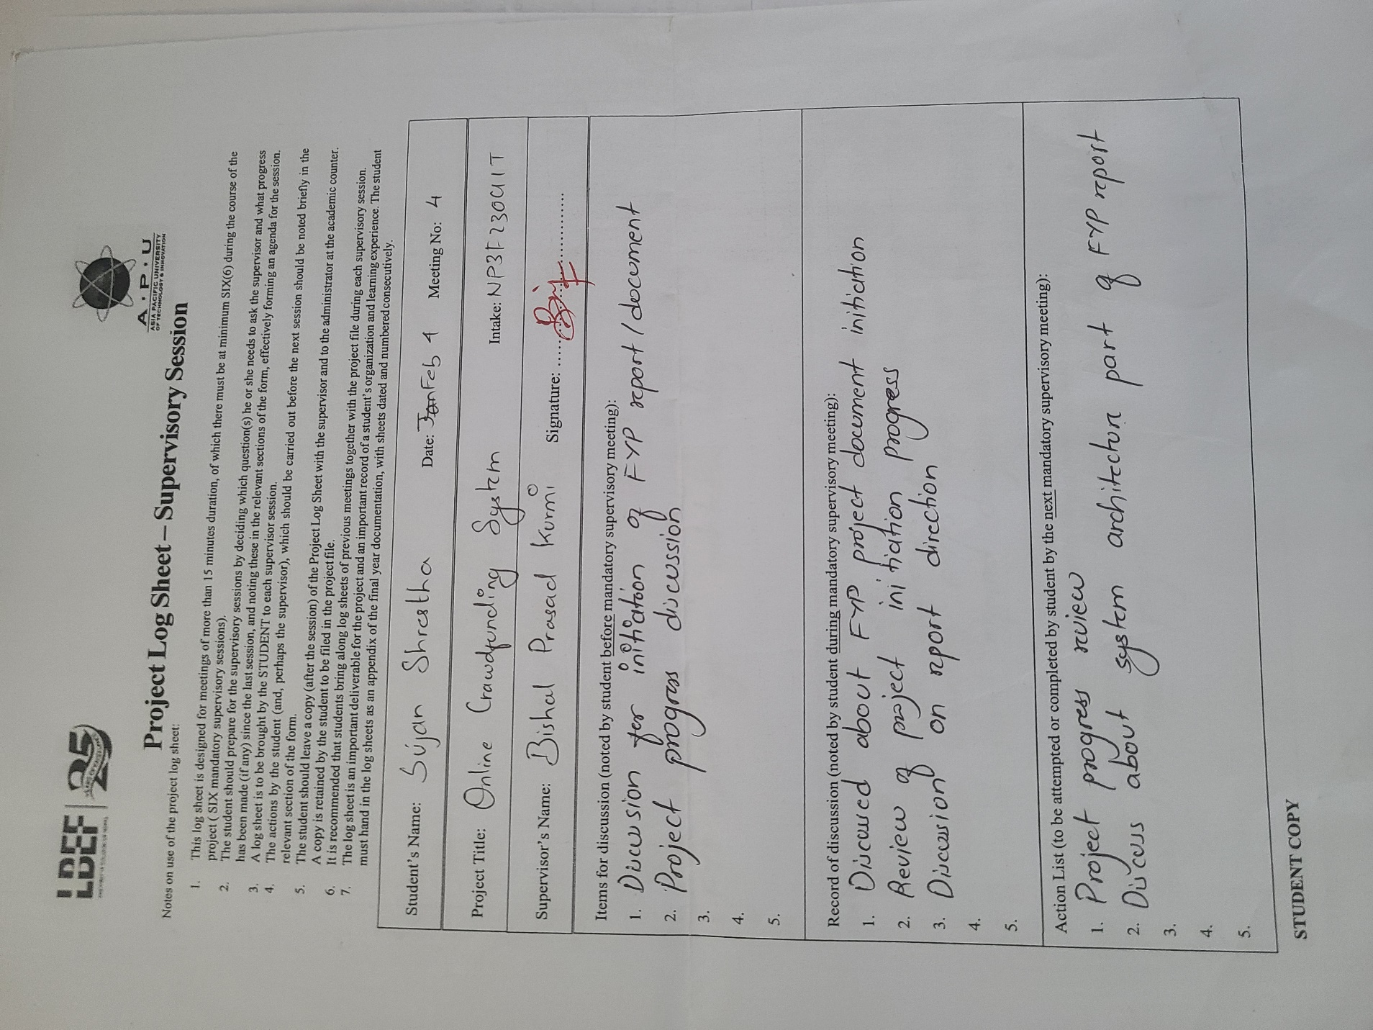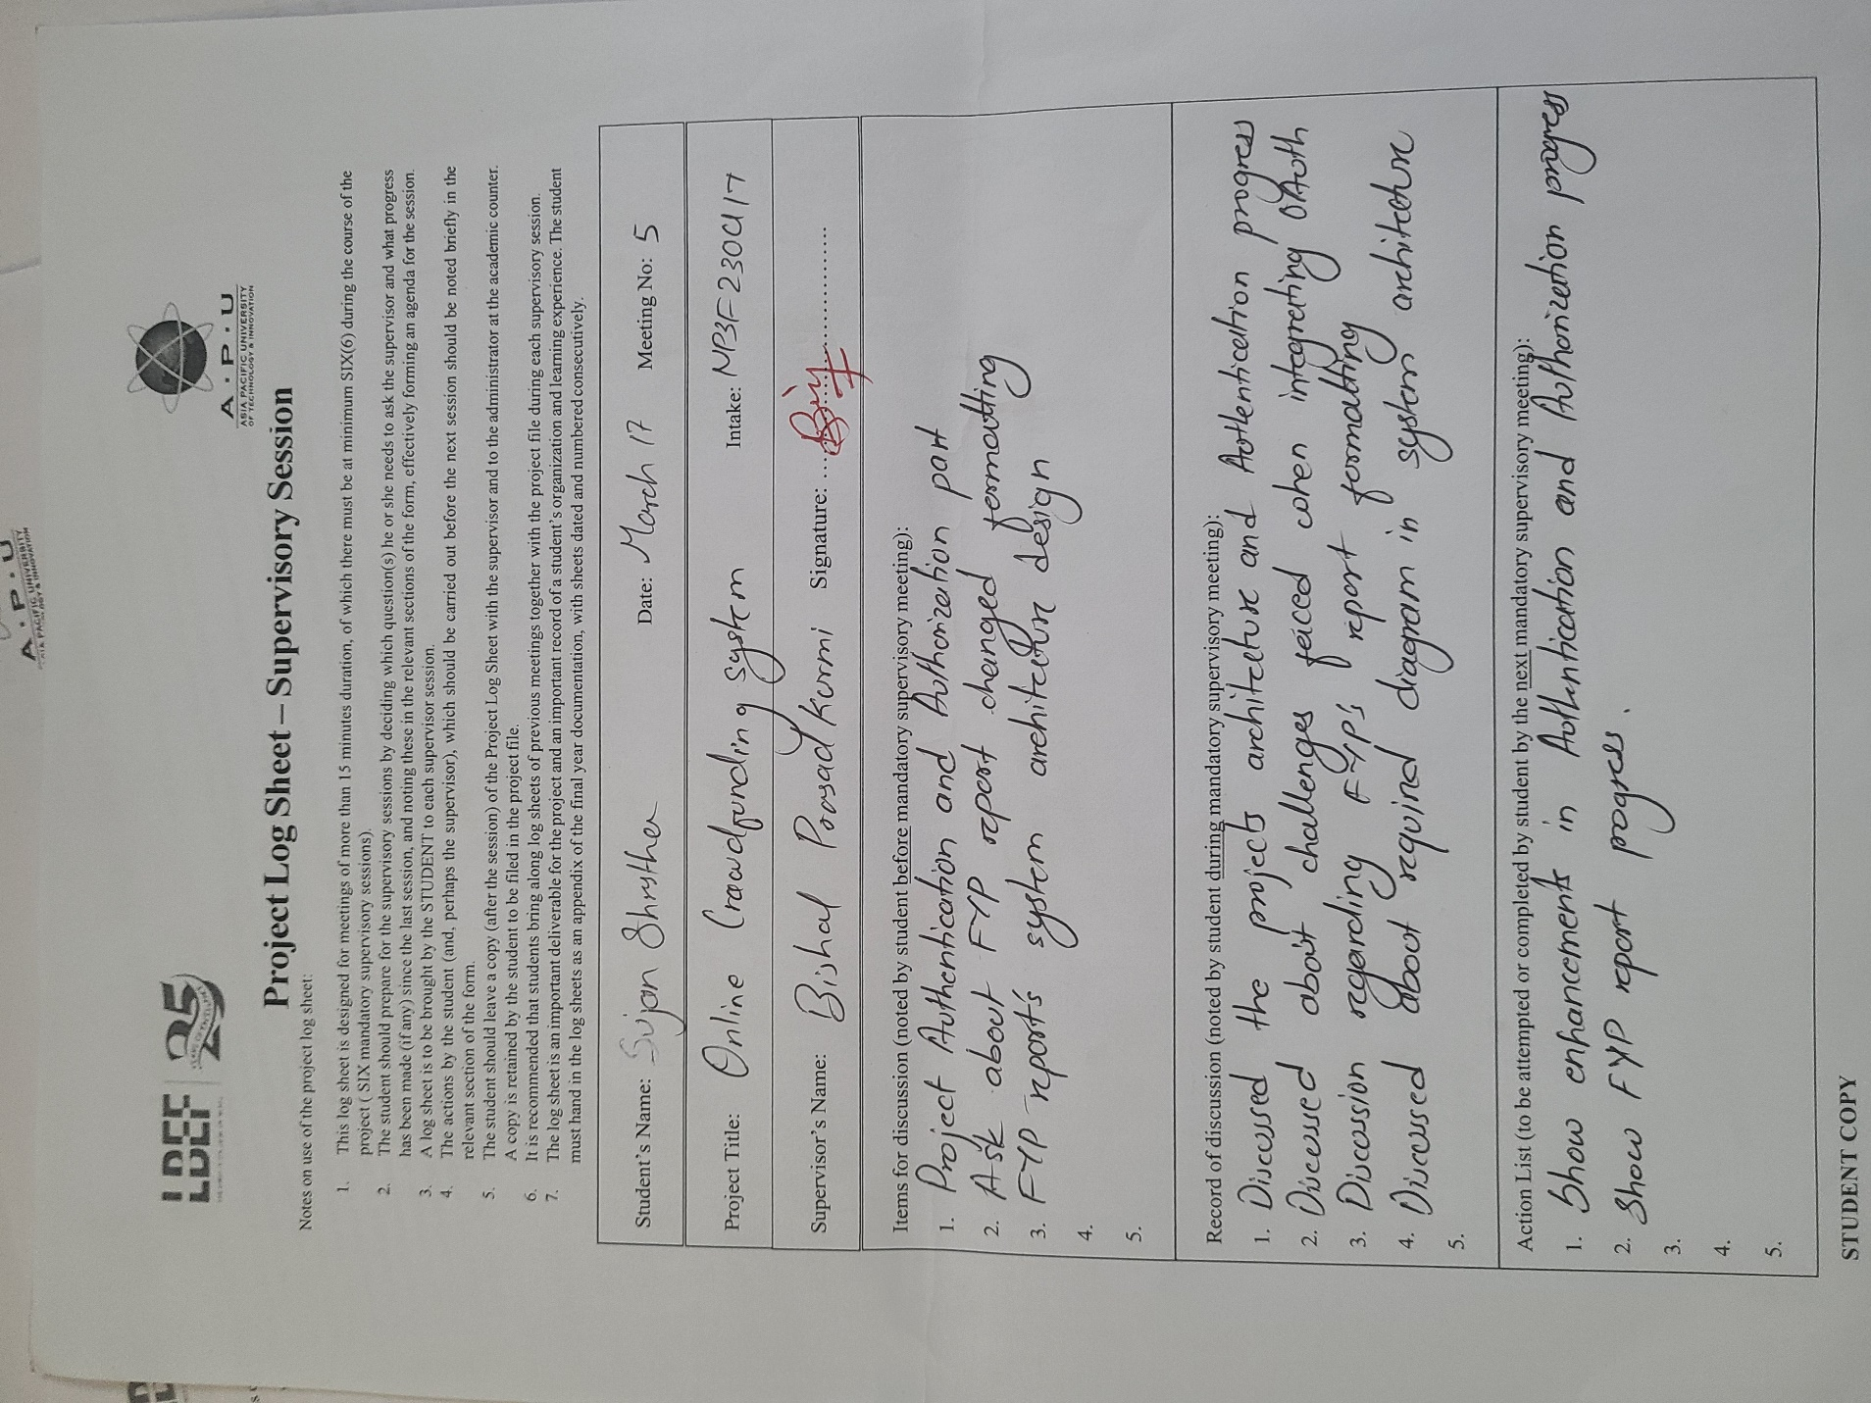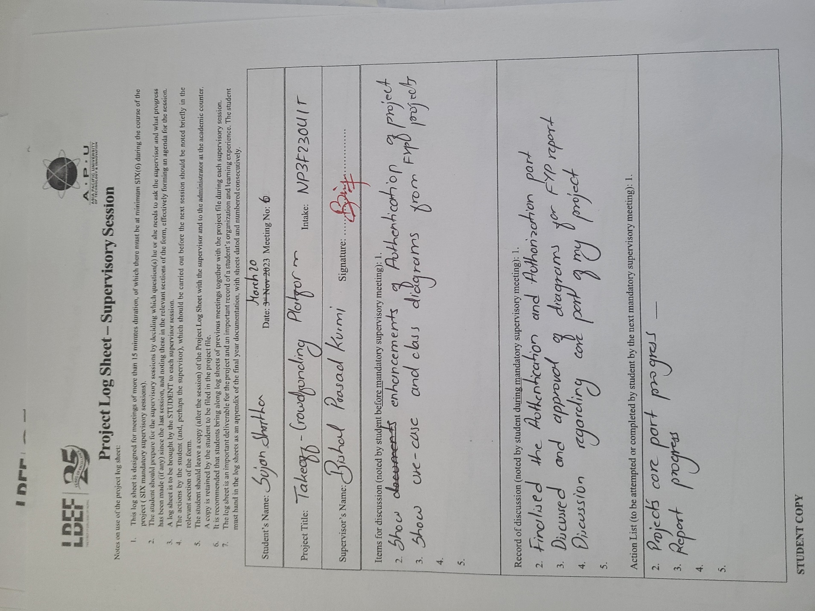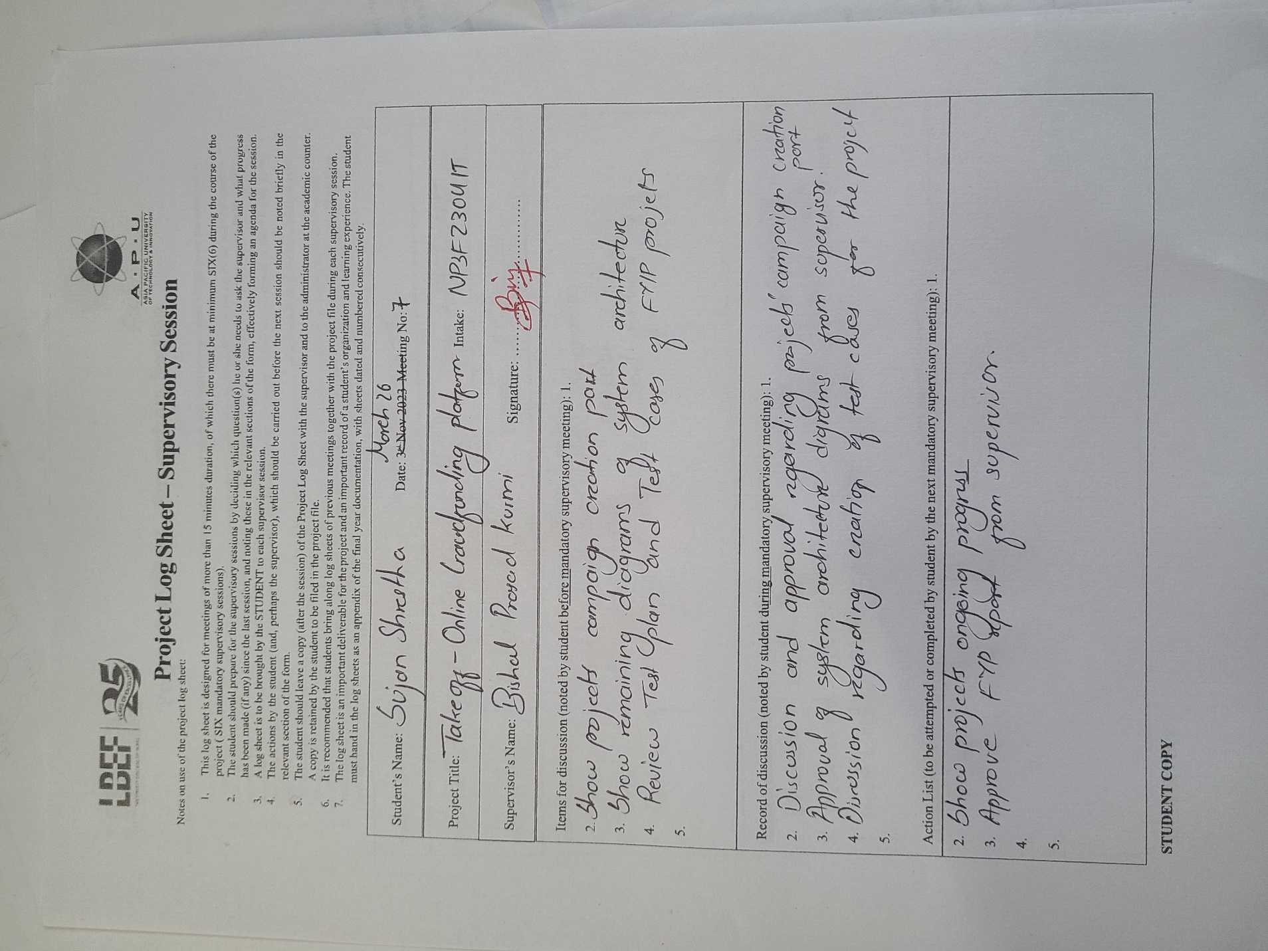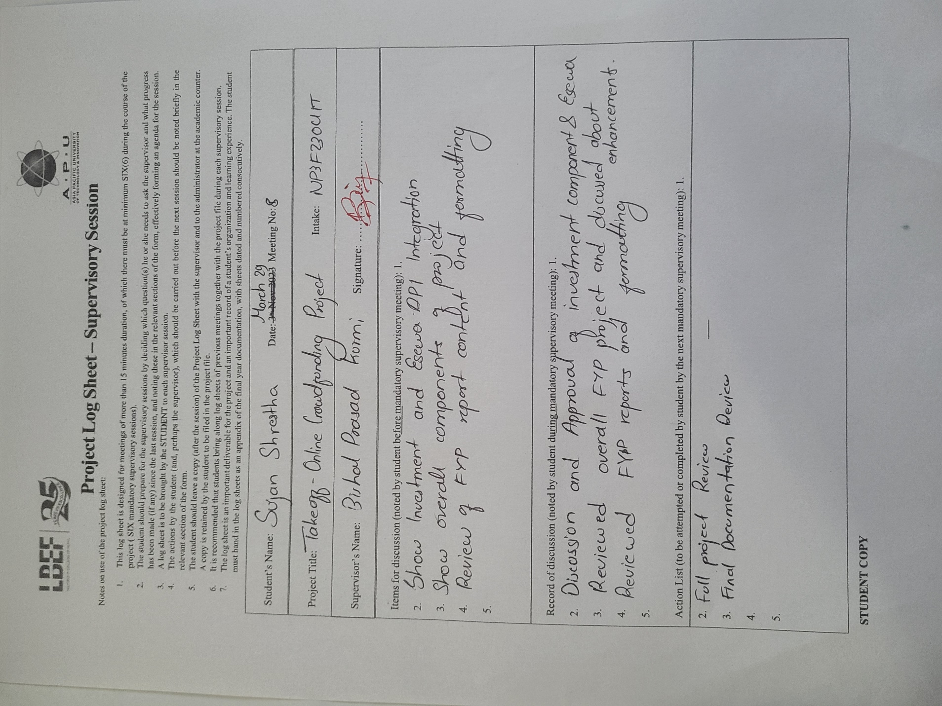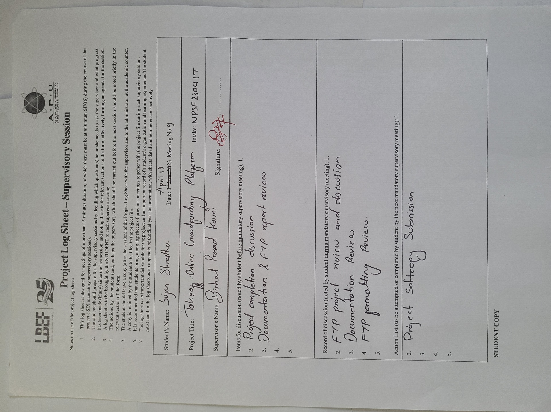

## **Project Proposal Form (PPF)**

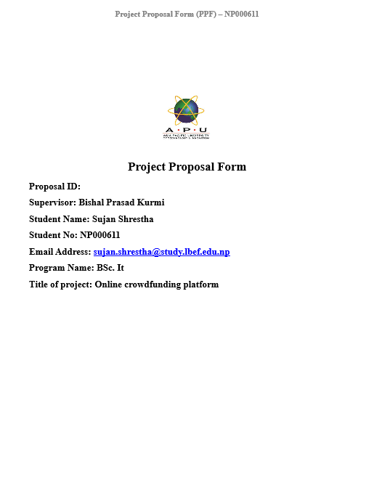

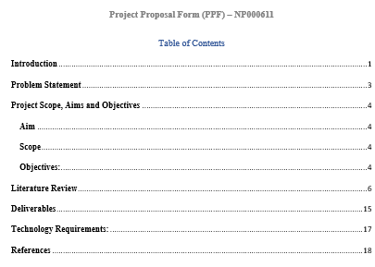

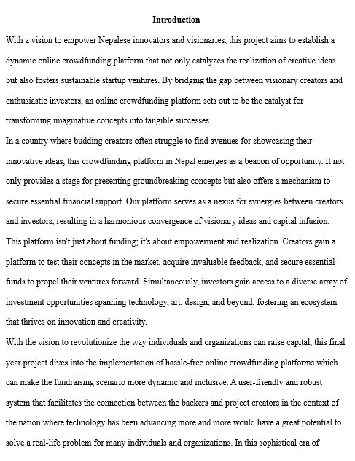

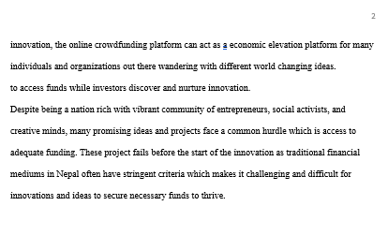

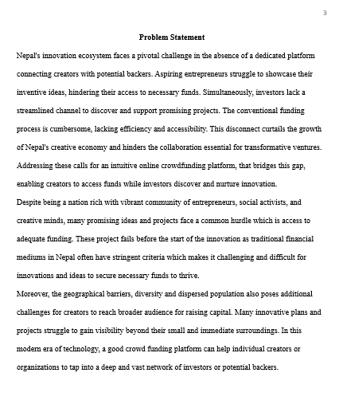

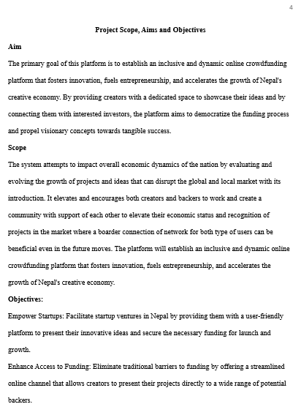

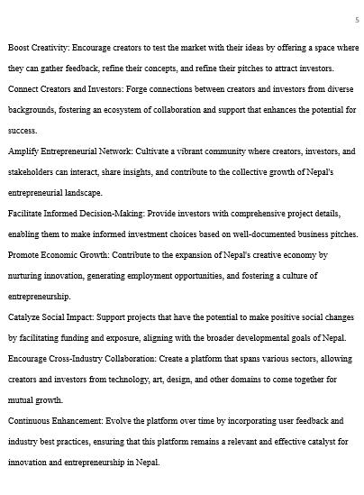

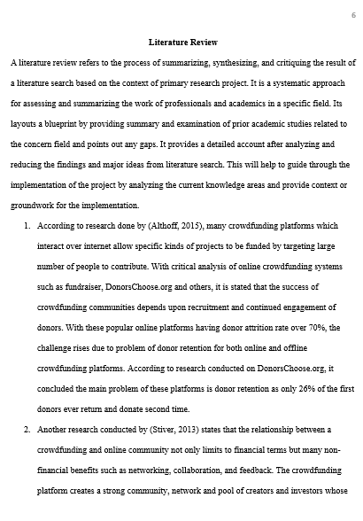

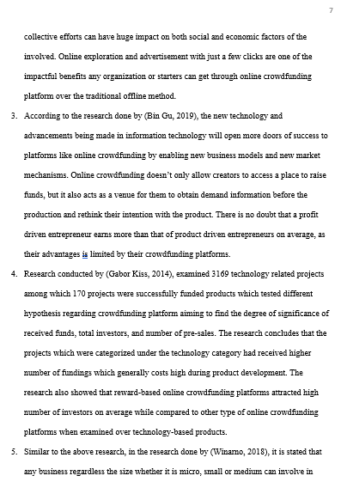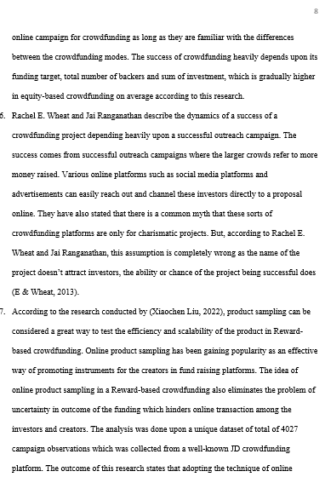

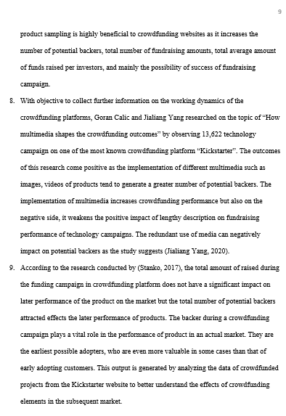

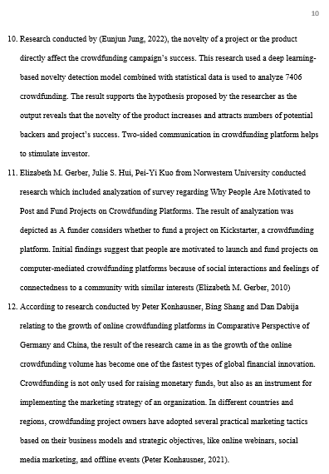

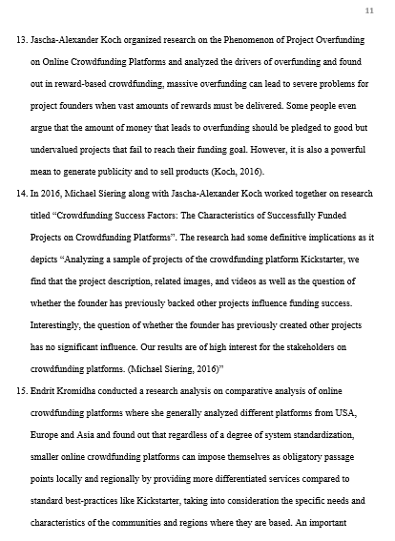

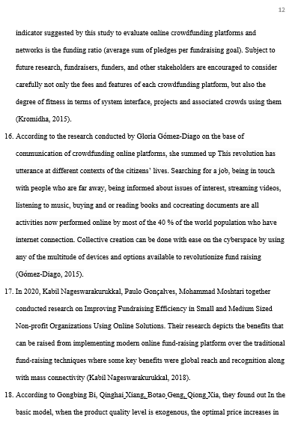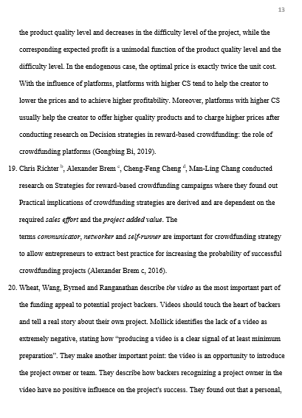

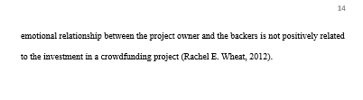

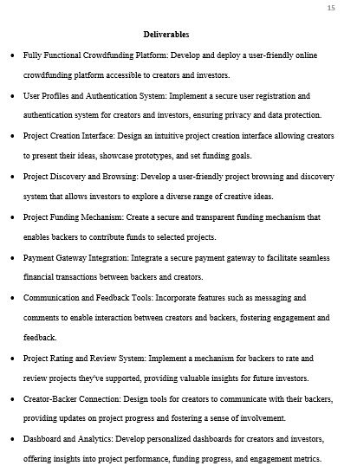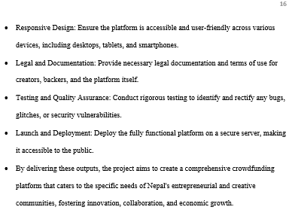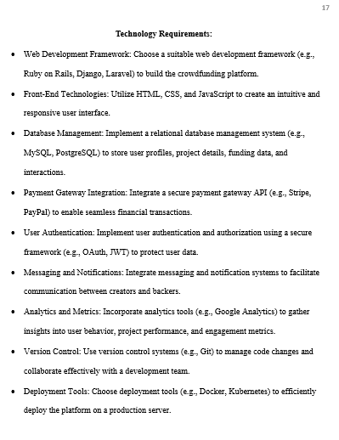

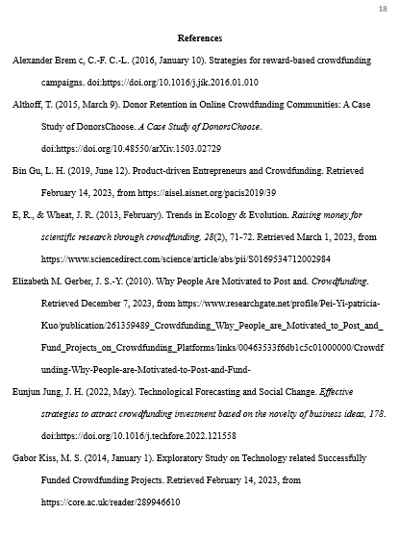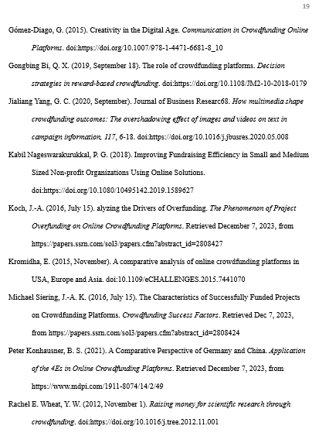

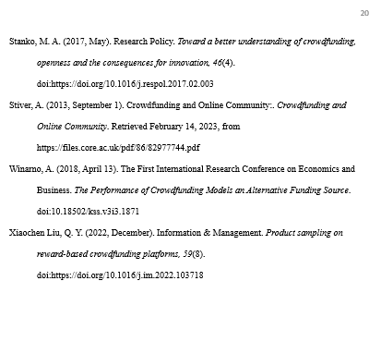

## **Project Specification Form (PSF)**

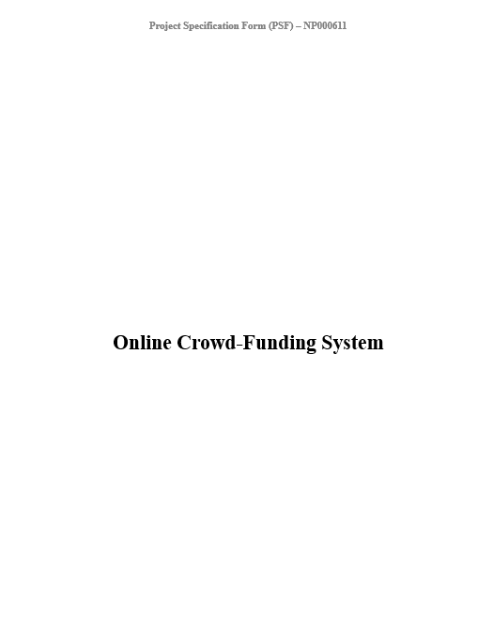

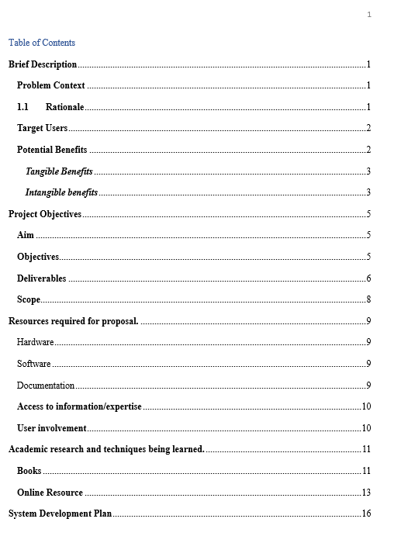

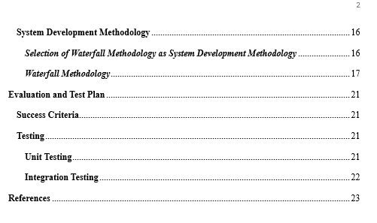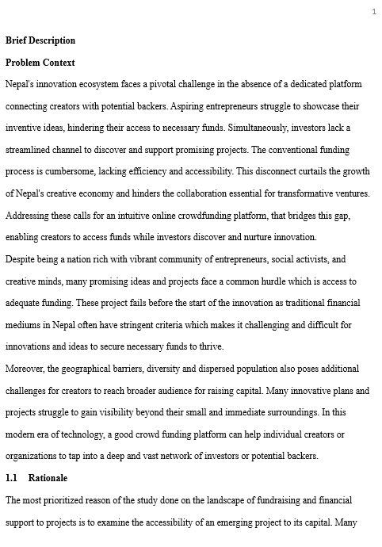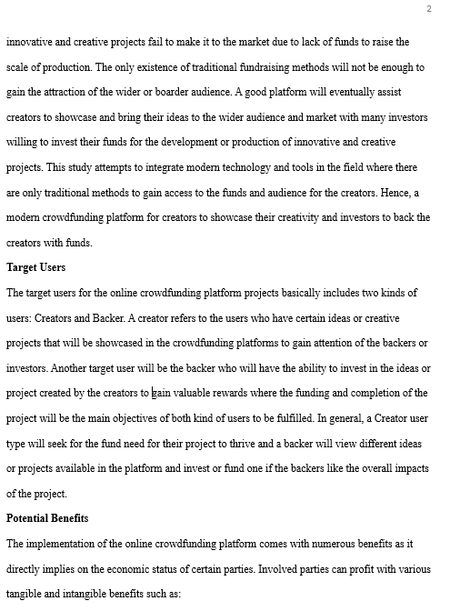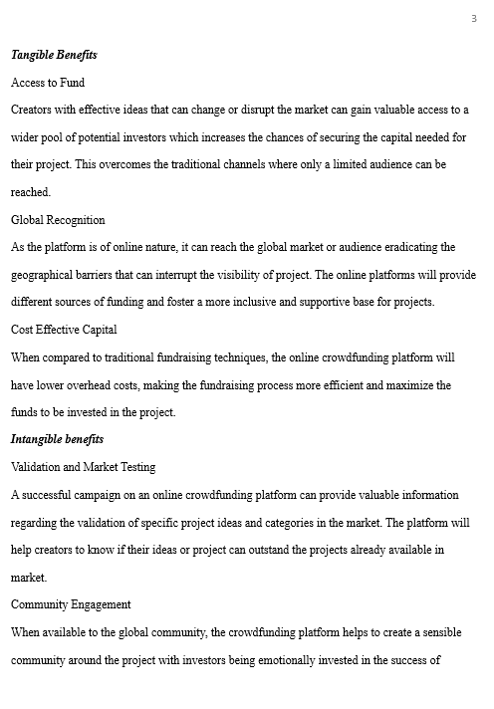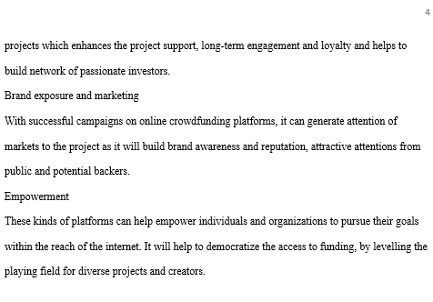

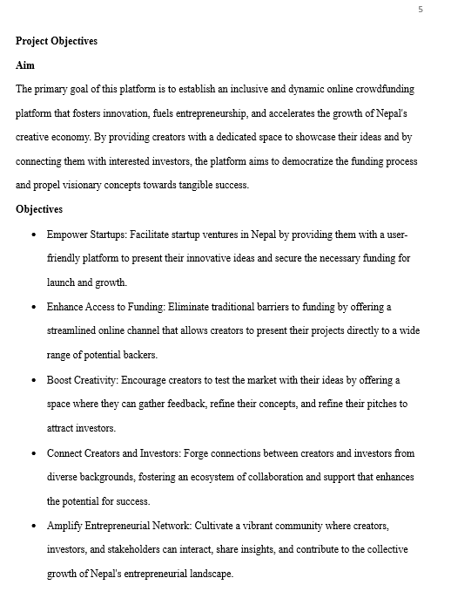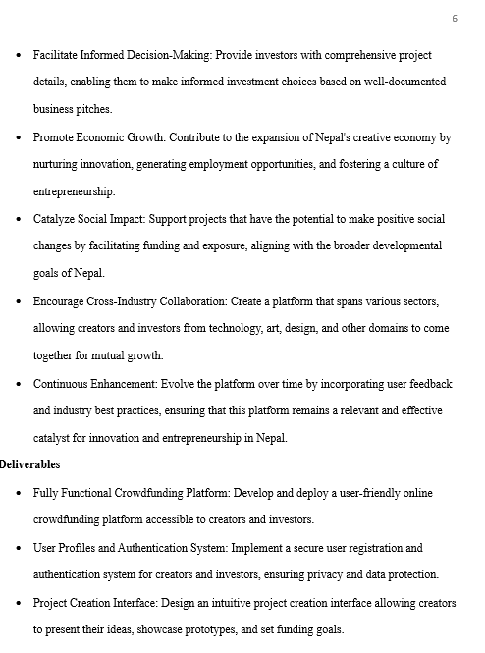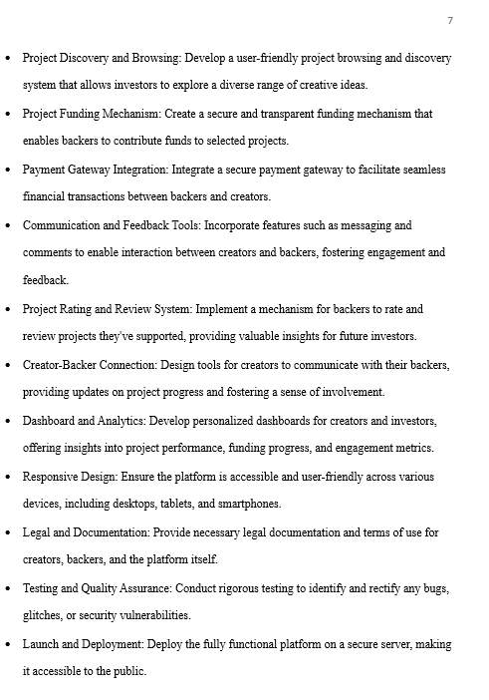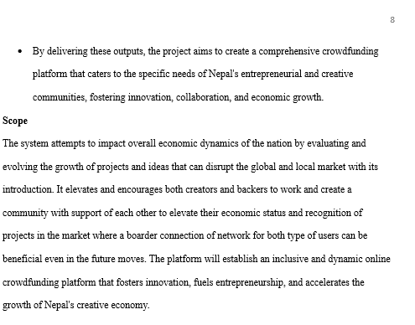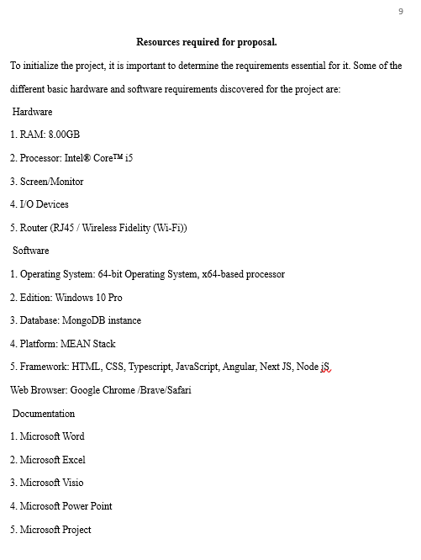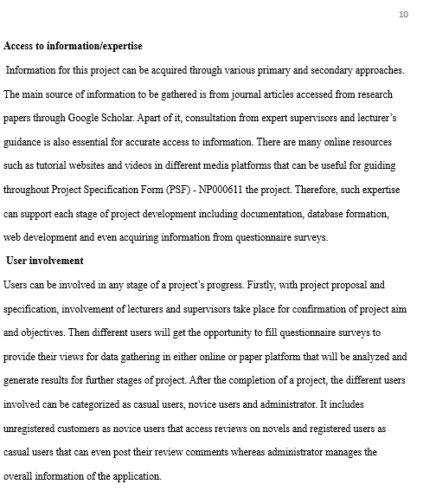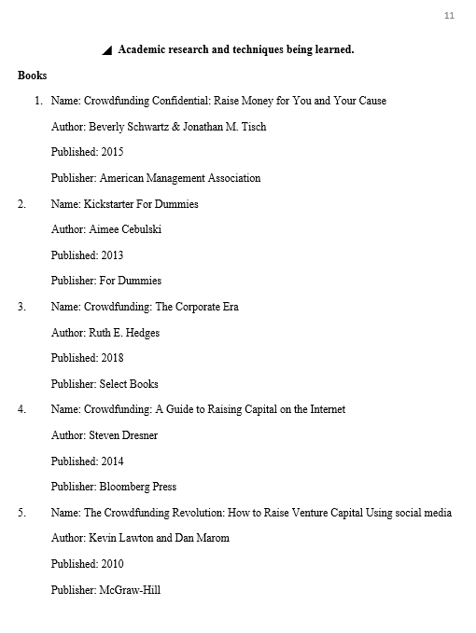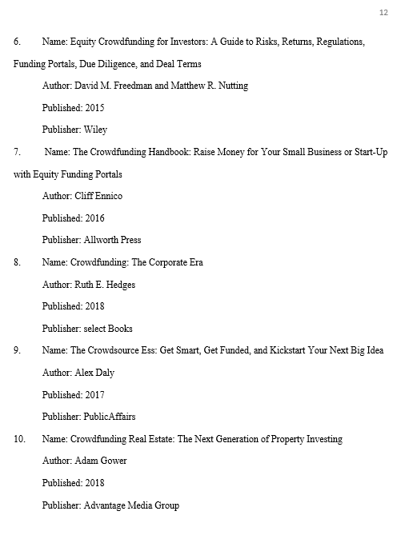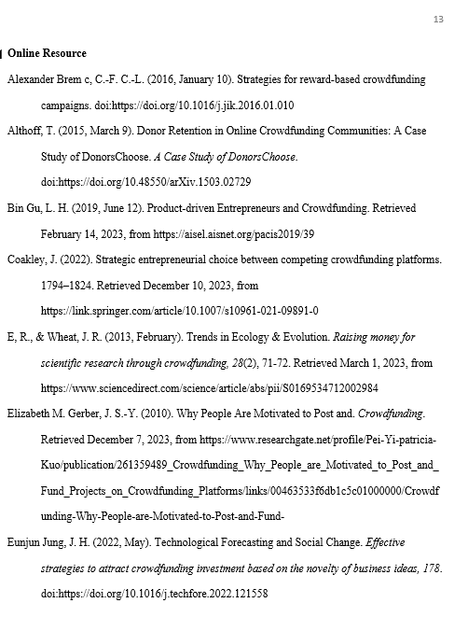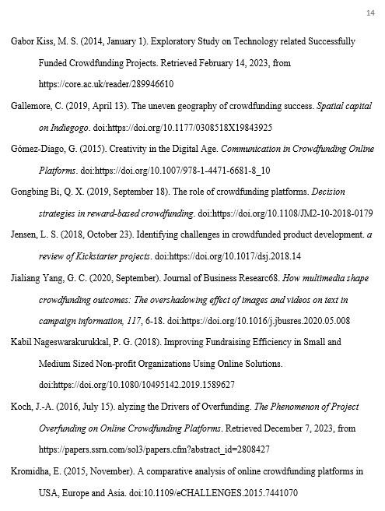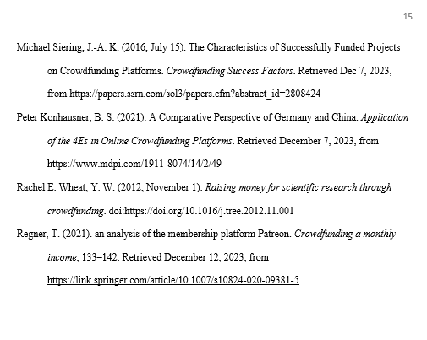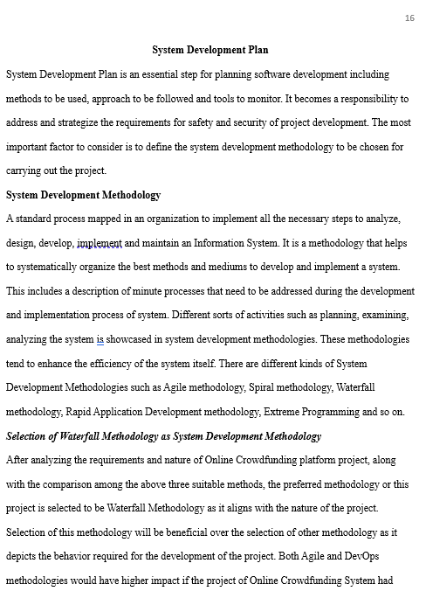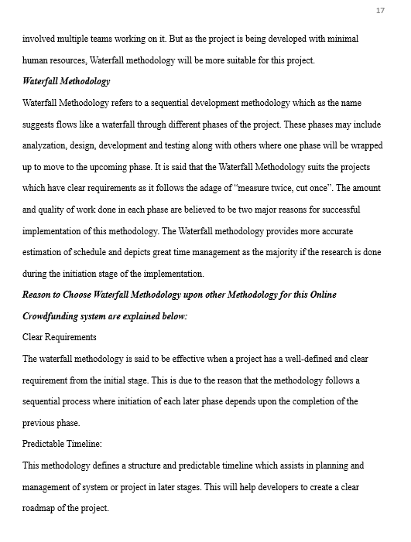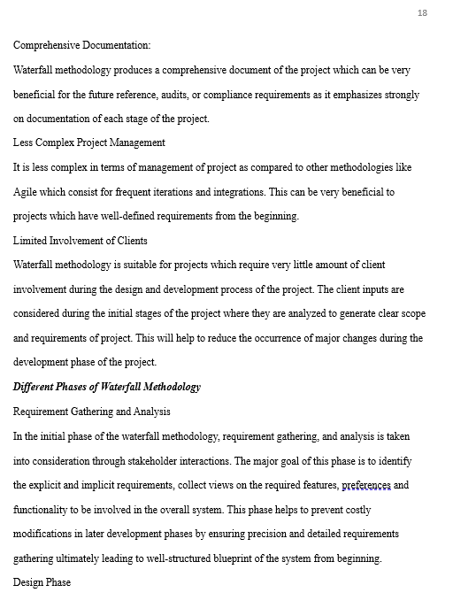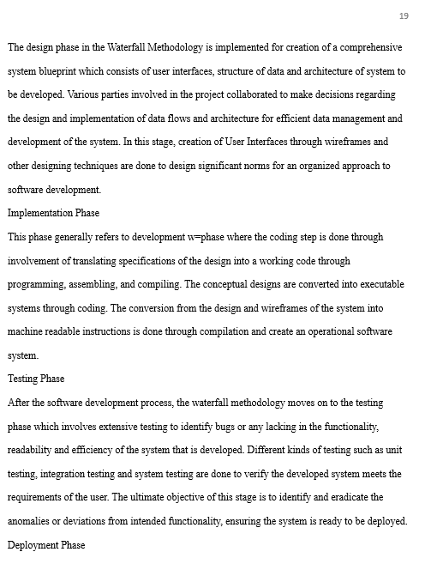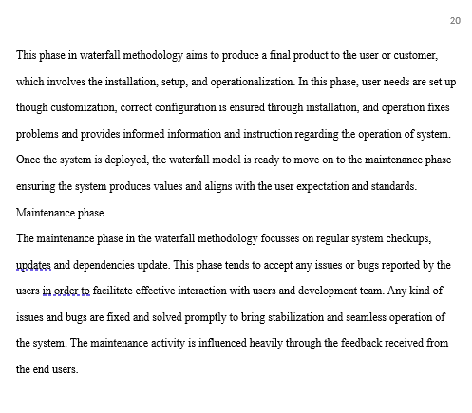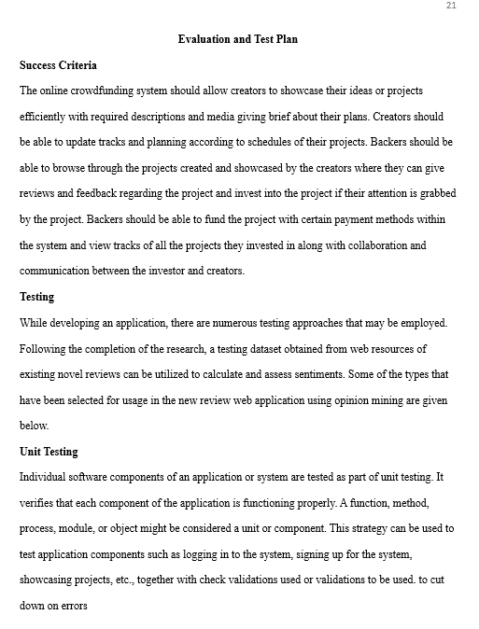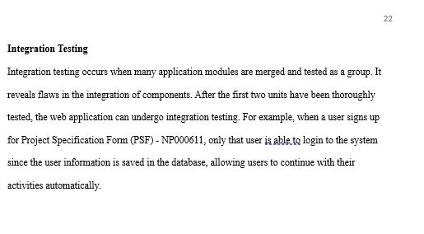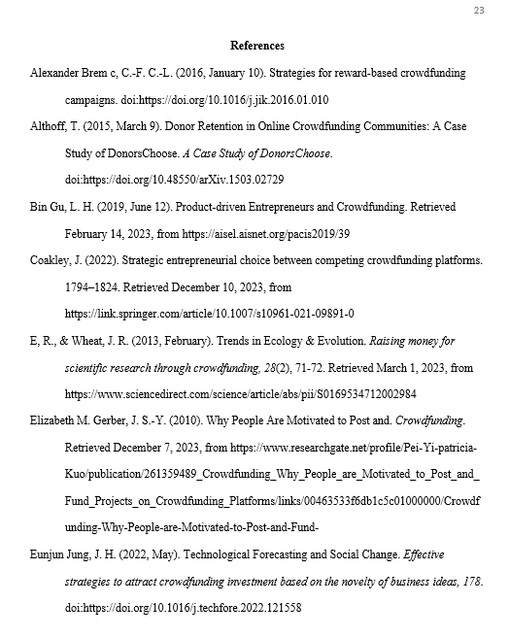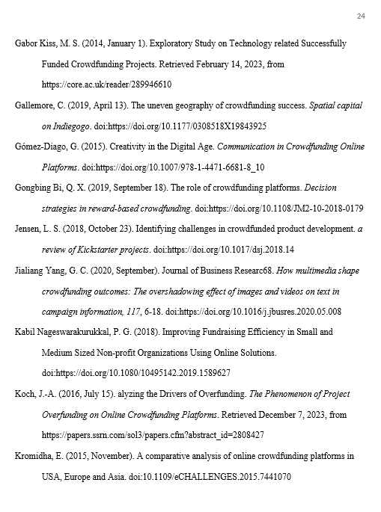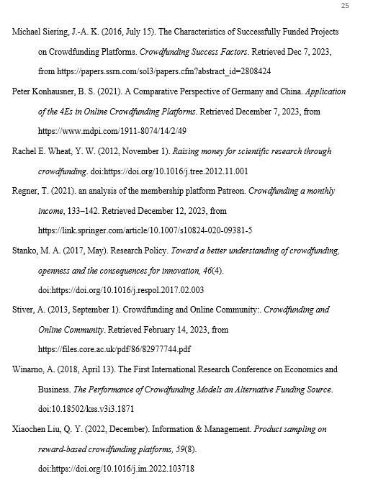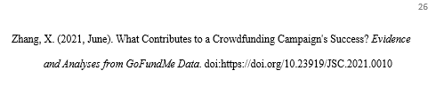

## **Ethical Form**

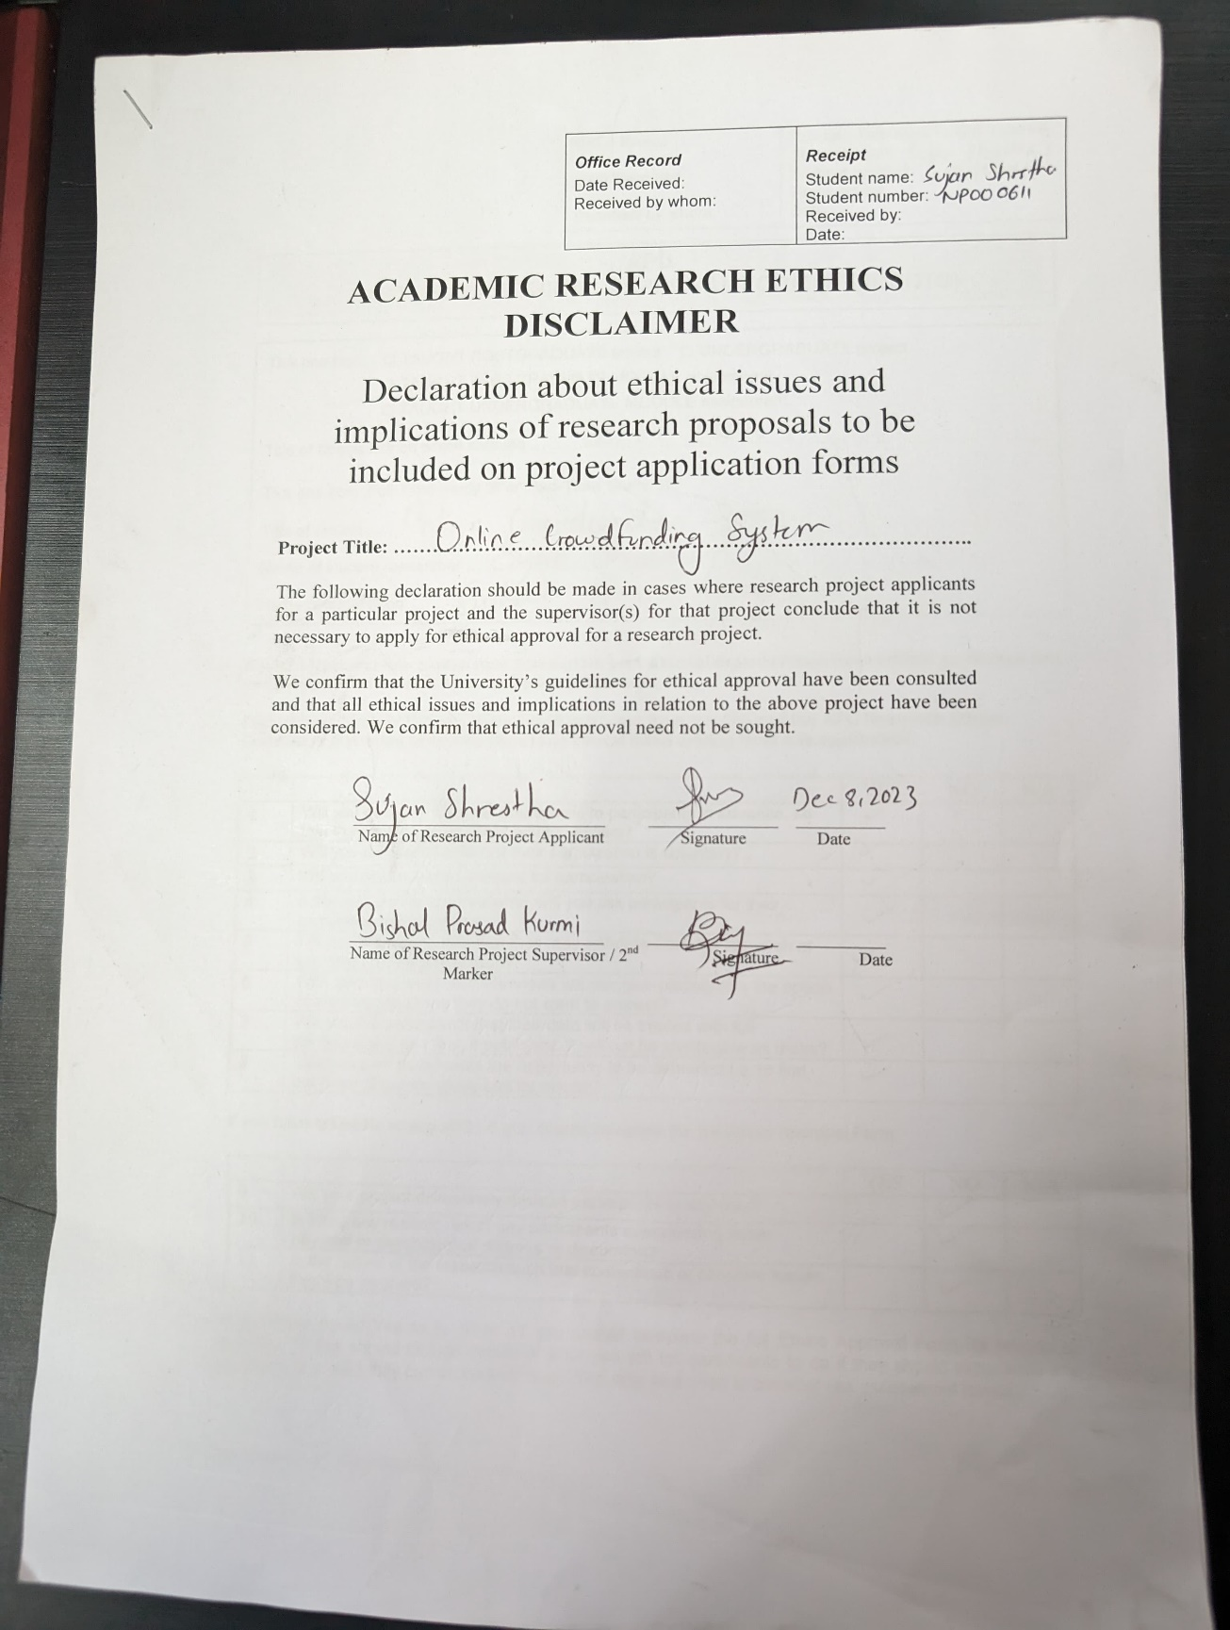

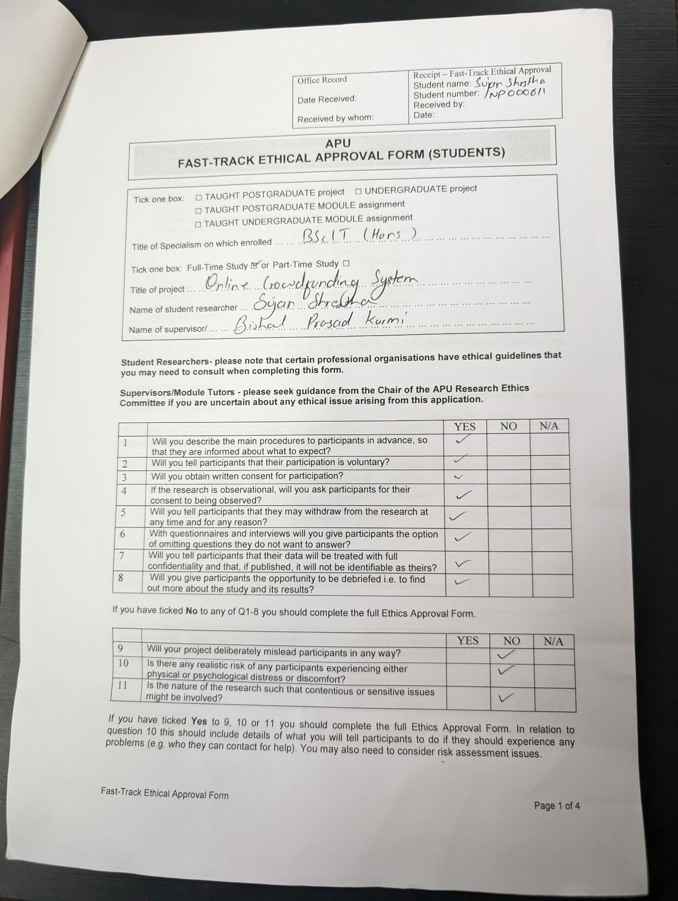

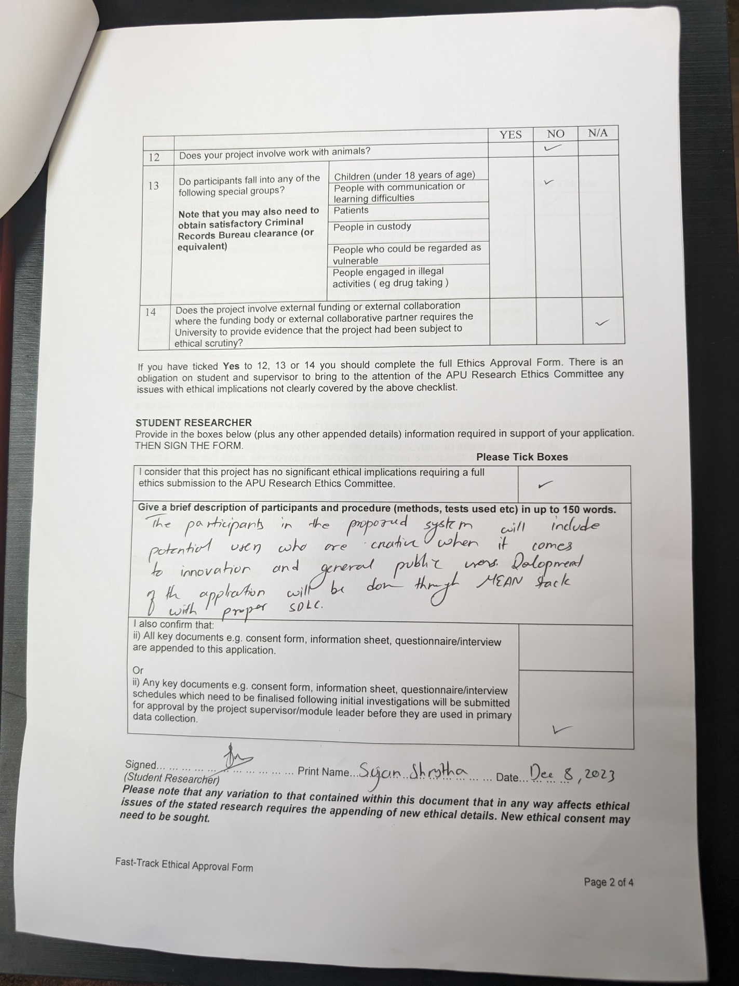

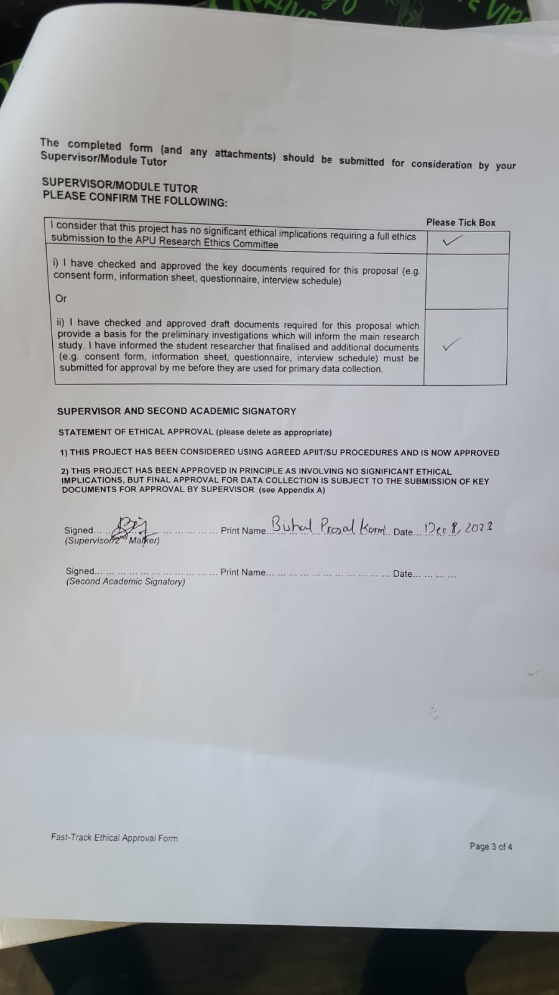

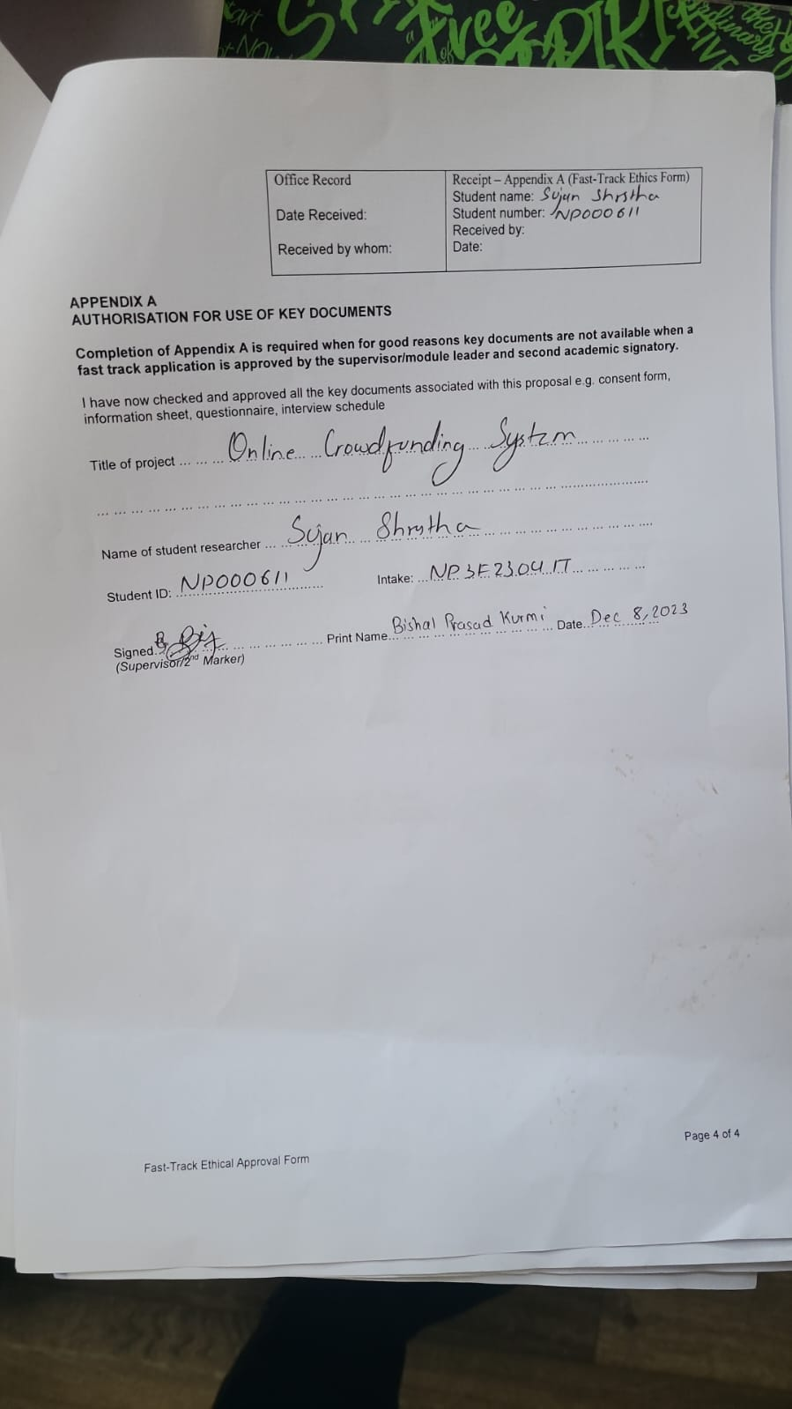

## **Gantt Chart**

